Date: February XX, 2024
To: Richmond Selectboard
From: Richmond Transportation Committee
CC: Keith Oborne, Town Planner
Subject: Pros and Cons of recommended alternatives to improve safety at the intersection of Bridge Street with Huntington, Cochran and Thompson Roads

The intersection of Bridge Street with Huntington, Cochran and Thompson Roads (THBC) is dangerous for motorists, pedestrians, and bicyclists alike because it lacks clear signage, crosswalks and sidewalks, and because of the speed at which many motor vehicles move through the intersection. Demands for improving the safety of this intersection have consistently been among the top of the lists of comments the Richmond Transportation Committee has received since its inception in 2019.

Over the past three years, with help from the Town Planners, the Chittenden County Regional Planning Commission (CCRPC) and transportation consults, the Richmond Transportation Committee has engaged in multiple planning exercises to develop and evaluate alternatives to improve the THBC intersection. Our ideal alternative, a roundabout with crosswalks, is likely too costly (>$900,000) and too disruptive (it would require acquiring land from adjacent landowners) to recommend.

In lieu of the roundabout option, the Transportation Committee presents two options for the Selectboard’s consideration: a four-way stop (figure 1); and, a mountable island in the center of the road (figure 2) both from the Richmond: Bridge Street Complete Streets Corridor Study Technical Memorandum (CCRPC, VHB, 8/4/2021). We offer the two options for the Selectboard’s consideration recogonizing that the roundabout meets all objectives but is too costly. Moreover, the status quo of leaving the intersection unchanged is both unsafe and, we believe, unacceptable.

This memo outlines the pros and cons of the two alternatives and includes comments from RTC members as well as excerpts (in italics) from the Complete Streets Study prepared for the town by the CCRPC and VHB. Estimates for the costs of the two alternatives are also provided.

Alternative 1: Four-Way Stop
Includes curbs; reduced corner radii to slow turning vehicles turning from Bridge onto Huntington and Cochran onto Bridge; crosswalks; streetlights; a speed table on Huntington Rd; and a sidewalk on the south side of Huntington Rd from the intersection to the Round Church Corners Complex.
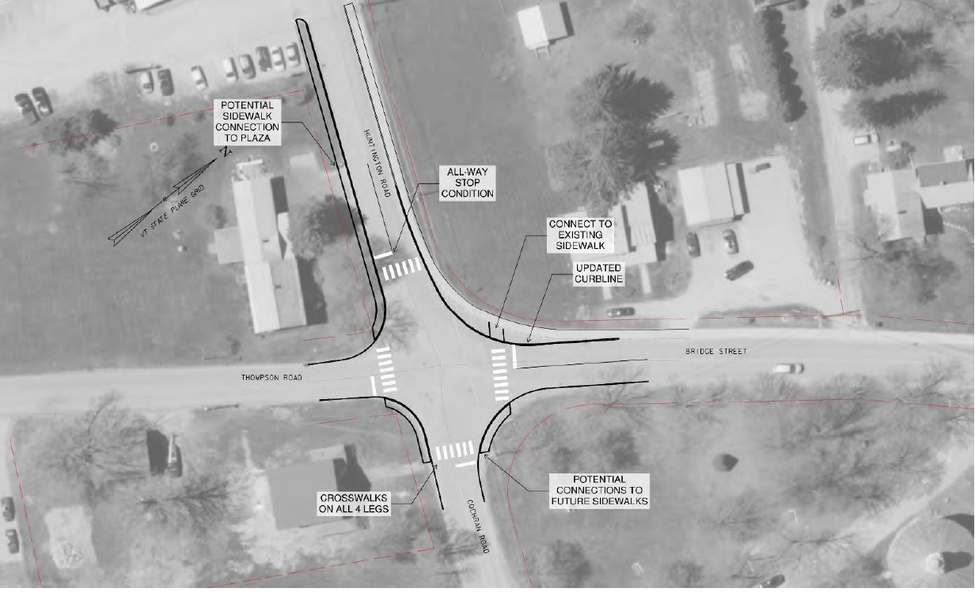
Figure 1. THBC intersection as a Four-Way Stop

Four-Way Stop - Pros
- Less expensive option.
- Easily understandable for motorists
- Safest alternative for pedestrians to cross. Ensures cars will stop and pedestrians more visible.
- It would most reliably improve pedestrian safety in crosswalks and thereby allow greater pedestrian access, including to the daycare on Thompson Rd, to Richmond Terrace, and to the commercial area on Huntington Rd. This alternative best aligns with the 2018 Town Plan goals for a walkable/bikeable community.
- It would “normalize” the intersection to a right-of-way pattern understood by all users, not just locals. This should help reduce the vehicle crash frequency (6 crashes listed between 2015-2019).
- It would reduce vehicular speeds in all directions at the intersection.
- It would most reliably improve bike safety in the intersection.
- In the AM peak hour, the delay/queue on Huntington Rd. would reduce the delay/queue on Bridge St, thus same total time to get through the rate limiting Bridge/US2/Jericho intersection but divided into two segments.
Four-Way Stop - Cons
- May be undesirable for through drivers. The Bridge St corridor serves approximately 5,400 vehicles per day. All motor vehicles would be required to stop 24hrs/day, 365 days/year, including times of day/night and times of year when few, if any, pedestrians, or bicyclists would be present.
- One neighbor expressed concern regarding the noise of trucks stopping and starting at the stop sign. Other neighbors expressed no concern over trucks and requested the four-way stop.
- Vehicle traffic would need to come to a full stop. The report estimates a shorter queue than what occurs on Bridge St. northbound in the morning and on US2 eastbound in the evening and westbound in the morning and is considered in the acceptable range by traffic engineers.

Alternative 2: Mountable Island
Includes crosswalks; curbs; sidewalks with ADA ramps; crossing flashers; streetlights; reduced corner radii to slow turning vehicles turning from Cochran Rd onto Bridge St; a yield sign for left turns from Bridge St onto Cochran Rd; and, a sidewalk on the south side of Huntington Rd from the intersection to the Round Church Corners Complex.
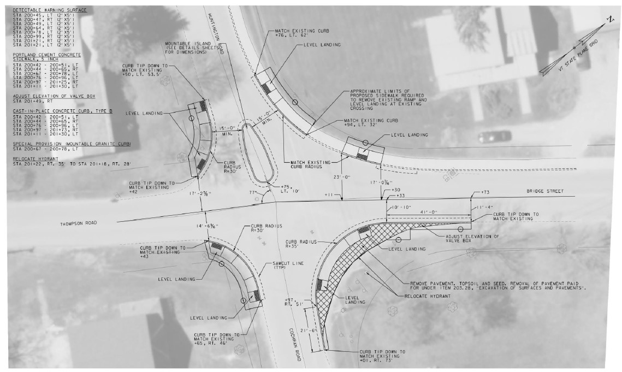
Figure 2. THBC intersection with Mountable Island
Mountable Island Alternative – Pros
- Sidewalks are helpful for pedestrians waiting to cross: currently no place to stand at some corners.
- Island is designed to slow down vehicles moving to/from Huntington Rd and Bridge St and from Huntington Rd to Cochran Rd.
- Keeps major traffic flowing between Bridge St. and Huntington Rd.
- Reduced corner radii squares off the intersection which slows cars down turning to/from Bridge St. and Huntington Rd; and squares up the approach from Cochran Rd to Bridge St.
- Slows traffic without stopping it, converts the intersection into shared-use infrastructure, provides enhanced pedestrian safety.
- A safety improvement on the current situation in that it would slow (but not stop) vehicles.
- It is much less expensive than a signalized intersection or a roundabout.
Mountable Island Alternative – Cons
- More expensive than the four-way stop and might still induce right-of-way confusion.
- Compared to a four-way stop, it is less effective in improving pedestrian and bike safety and less effective in achieving the 2018 Town Plan goals.
- It might not reliably slow traffic going straight through from Huntington Rd. to Cochran Rd.
- It does not “normalize” the right-of –way pattern of the intersection. The confusion will remain.
- The mountable center island is seen as a problem by some, although a standard VTRANS infrastructure feature.
Other Considerations for alternatives 1 and 2
- Add the bump outs to the 4-way stop (alternative 1)?
- Could crosswalks be raised, increasing visibility and acting as small speed bumps (alternative 2)?
Cost Estimates
In addition to the base proposals for these two alternatives detailed in the Complete Streets Study, the Richmond Transportation Committee recommends the following enhancements for more comprehensive safety improvements to this intersection.
Cost Estimate* | 1: Four-way stop | 2: Mountable Island
Original per VHB Technical Memo | Base Cost: $100,000  (See figure 1) | Base Cost: $72,700  (See figure 2)
Raised Crosswalks | not needed | $2,500 to $8,000ea  at Huntington Rd near Thompson Rd.
Speed table | $2,500 to $8,000ea on Huntington Rd near Farr Rd | $2,500 to $8,000ea  on Huntington Rd near Farr Rd
Sidewalk on the south side of Huntington Rd from the THBC intersection to Round Church Corners Complex | $21,000 to $30,000 | $21,000 to $30,000
Streetlights | $500 ea fixture. One or two recommended | $500 ea fixture. One or two recommended
Rapid Rectangular Flashing Beacon (crossing flashers) | not needed | ~$6,400 per unit plus installation costs of ~20,000-$30,000 each at locations per the design engineer’s recommendations
* Please note these estimates are from multiple sources and distilled to an average cost and adding an additional 15-20% contingency would also be prudent based on current trends. Final costs associated with any project are best arrived at during scoping and design at the time the project is evaluated. The following links provide cost estimates. Some are likely outdated, differential can be assumed and applied to deliberations.
- Pedestrian Hybrid Beacon Guide– Recommendations and Case Study | FHWA (https://highways.dot.gov/safety/pedestrian-bicyclist/safety-countermeasures/pedestrian-hybrid-beacon-guide-recommendations)
- Rectangular Rapid Flashing Beacons (RRFB) 2018 (https://safety.fhwa.dot.gov/ped_bike/step/docs/TechSheet_RRFB_508compliant.pdf)
- Approximate Implementation Cost for a Traffic Calming Measure (from Module 3: Toolbox of Individual Traffic Calming Measures Part 1 | FHWA (https://highways.dot.gov/safety/speed-management/traffic-calming-eprimer/module-3-part-1#3.2)
- Overview of Rectangular Rapid Flashing Beacon Cost and Effectiveness (carmanah.com)
- LED Street Light: LED Street/Roadway Light, 100 watt, 120-277V | Warehouse-Lighting.com

