Andrews Community Forest Management Plan
Richmond, Vermont
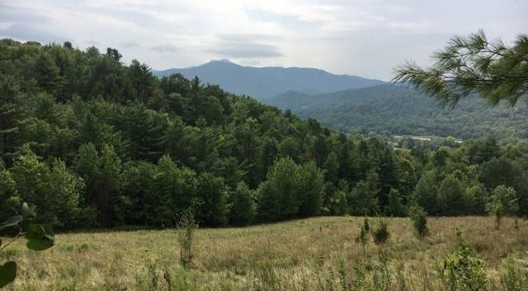
2026
Table of Contents
Management Plan
- Introduction
- General Property Description
- Governance
- Cultural History
- Ecology
- Recreation
- Forestry and Agriculture
- Education

Appendices
- General Property Description
- Governance
- Cultural History
- Indigenous Land Acknowledgement and Uses
- The ACF for People and Wildlife
- Further Reading

Management Plan

Introduction

The land
The Andrews Community Forest (ACF) encompasses 428 acres of mostly south-facing, largely forested hillsides in Richmond, Vermont. The ACF abuts 6,000 acres of forestland within the 72,000-acre Mt. Mansfield Forest Block, all within the homeland of the Western Abenaki people. Elevations of the ACF range from 400 feet at the parking lot to 1,240 feet in the northeast corner.

Much of the ACF has earned high priority rankings for conservation from Vermont’s Agency of Natural Resources. The southerly aspect supports a rich complex of upland and wetland natural communities, including several uncommon and sensitive ones. The forest is located within the homeland of the Western Abenaki people, who for generations used the forest as a source of food, timber and refuge. Subsequent generations of European settlers and their descendants developed logging roads, utility rights-of-way and recreational trails that today continue providing a wide range of users with access to the forest’s resources as well as to adjacent properties.

Acquisition, management and foundational principles
In 2018, the Andrews family enabled the Town of Richmond to create its first community forest on 428 largely wooded acres of their land. The family’s first step was to sign a conservation easement with the Vermont Land Trust (VLT) and Vermont Housing and Conservation Board (VHCB) to protect the forest’s natural resources and ensure public access in perpetuity. The family then sold the land to the Town of Richmond at a bargain price, which used funds from the Town’s Conservation Reserve Fund, VHCB, a federal community forest grant, and many private donations to make the purchase. To honor the family whose generosity made the forest’s protection and acquisition possible, the Selectboard named the property the Andrews Community Forest.
The Richmond Selectboard then appointed committees to use public and professional input to develop the forest’s interim and first management plans. The result was the original management plan, which the Selectboard approved in 2019 to serve as a “living and evolving document” responsive to the conservation agreement’s requirements, new conditions on the ground and new information on the best management practices.

That original plan opened the way for the Town to begin expanding the recreational trail network and using forestry management techniques to restore and improve the ecological health of certain areas. An agreement was reached acknowledging the Abenaki people’s right to use the Forest and contribute to its management. The ACF Committee developed vision and mission statements to serve as foundational principles for its work. As the Committee’s knowledge and experience grew, it began updating the original plan to reflect additional public input and scientific research.

In 2026 that update – this document – was approved by the Selectboard and Vermont Land Trust. It, too, is a “living and evolving” document, part of an ongoing cycle of evaluation, adjusting, planning and actions to inform future updates and revisions.

Using this plan
The ACF Management Plan is organized to give the public easy access to the goals and actions that govern and guide the various uses of the forest. Those are followed by several appendices providing key background information, including detail on the ACF’s ecological features and cultural history as well as its governance by the Town. Links to additional background material can be found on the ACF Committee’s webpage.

Public Access

The one basic, abiding rule for use of the ACF is respect – not only for other people using and enjoying it but also for the many plants and animals that make it their home and keep the Forest a forest.

The ACF Conservation Easement guarantees the public full access to the ACF according to the Easement’s terms and the provisions of the management plan. In general, access must be by non-motorized means, such as hiking, walking, snowshoeing, hunting and wildlife observation. The Easement also allows snowmobiling and non-motorized recreation such as mountain biking if consistent with the Easement’s several “Purposes” and regulated by the management plan. Forestry and agriculture must also comply with those Purposes as well as their own particular plans and State standards.

The ACF website lists the latest specific rules and guidelines for responsible, sustainable use and enjoyment of the forest. They are designed to maintain, protect and expand and perpetuate traditional uses such as hiking and hunting while also creating opportunities for newer activities such as mountain biking. The website also lists online sources for the latest information on trail conditions, including temporary closures due to user safety concerns and the need to protect trail surfaces and seasonally sensitive natural communities.

Maps of the forest are posted and available for download at the ACF and on the forest’s webpage. Many parts of the forest are steep and rugged, and it’s easy to lose one’s bearings. We urge all users to use maps, apps and GPS to find their way, stay safe and avoid the most ecologically sensitive areas.

Governance

As a municipally owned property, the Town of Richmond Selectboard is ultimately responsible for the management and stewardship of the Community Forest on behalf of all of Richmond’s citizens. Governing documents and policies include the Conservation Easement, Richmond Town Plan and several rights-of-way and agreements with abutting property owners. The Selectboard has delegated management and stewardship responsibilities to the Andrews Community Forest Committee (ACFC), which the Selectboard appoints. The Conservation Commission and Trails Committee each nominate a member and a non-member for appointment to the ACFC.

Goals
- Protect the ACF’s ecological integrity and functions while providing meaningful public recreational, educational and other appropriate community uses
- Increase the community’s knowledge and understanding of the forest and its inhabitants
- Create and execute legal agreements that allow the forest to provide an enjoyable user experience, conserve its resources, and enable utilities and other ACFC partners to carry out their necessary work in the Forest.
- Represent the Town and the needs and interests of all its residents

Actions
- Represent the Town in decisions related to management of the Community Forest, with ultimate approval of the Selectboard.
- Manage the ACF responsibly and in accordance with this Management Plan and the Conservation Easement, Richmond Town Plan and zoning regulations, and other applicable policies and legal agreements.
- Act as a liaison with the Vermont Land Trust when input or approval is needed.
- Lead the management planning process whenever updates are needed.
- Retain a trail through the lower portion of the pasture to link the gravel utility road to the part of the Woods Road within the ACF, obtaining permission as necessary from the landowner of 1147 East Main Street
- Establish and post rules and guidelines for visitor uses of the ACF that support the provisions of the Conservation Easement and the ACF Management Plan.
- Provide regular opportunities for public education and enjoyment in the forest itself, and for engaging with the committee in the planning and management of this community-owned property.
- Work with VELCO and GMP to understand and select vegetation management strategies in the powerline rights-of-way which are safe, effective, and environmentally responsible.
- Communicate with the public about grazing plans or powerline management activities that may influence the public’s experience on the property.
- Manage public use during powerline work or grazing periods to mitigate public safety hazards.
- Update this plan at least every ten years to keep it current with the forest’s and community’s changing needs, and evolving science and technologies.

More information
See Appendix B, Governance.
Cultural History

Richmond is located within Ndakinna (in-DAH-kee-NAH), the homeland of the Western Abenaki people, also known as the Original People. They have a unique connection to this land and have been its traditional caretakers for hundreds of years, at least since the last Ice Age.

European settlers arrived in the Richmond area in the 1770s. Starting around 1800, the current forest was farmed by a succession of owners. Evidence of their ownership can be seen in stone foundations, cellar holes and walls scattered throughout the forest. In 1923 the land was purchased by Clarence Andrews. For the next decades it supported a dairy farm, timber harvesting and a country inn. Hunters, hikers and snowmobilers were welcome on the property. It remained in the Andrews family until 2018, when its surviving owners, four sisters, sold it at a below-market price to become Richmond’s first community forest.

Goals
- Recognize and broaden awareness of the cultural history of the forest and its context within and beyond Richmond.
- Protect remaining cultural features.
- Honor and respect the Abenaki people through responsible forest management and sustainable land uses.
- Continue to expand and enhance the information known about the forest’s human history.

Actions
- Protect and highlight remaining cultural features in the forest.
- Incorporate traditional Abenaki ecological knowledge into our management practices
- Add interpretive signage about Gray Rocks Farm* in the forest, especially at historic sites.
- Encourage future research and study of the forest’s cultural history, particularly with local schoolchildren.
- Conduct and record interviews with community elders who remember Andrews Farm.
- Place buffers on main trails located near cultural resources; consider access to cultural resources via spur trails.
- Work with the Andrews family to host programs and tours about the cultural resources of the farm.

More information
*See Appendix C, Cultural History and Appendix D, Indigenous Land Acknowledgement and Uses
Ecology
These goals and actions address the ACF from three ecological perspectives — landscape, community and species — following the organization of the Vermont Agency of Natural Resources publication Conserving Vermont’s Natural Heritage. See Appendix E, The ACF for People and Wildlife, for background information about this section.

Landscape-Level

Goals
- Maintain the ACF’s ecological integrity, biodiversity and functionality, including its status as “High Priority” and “Priority” interior forest and connectivity components of Vermont Conservation Design.
- Preserve interior forest health and connectivity to support black bears, bobcats, moose, fishers, ovenbirds, hermit thrushes and other deep-forest species.
- Protect neighboring properties’ landscape-scale ecological integrity and pursue opportunities to conserve and connect wildlife habitats.
- Protect soils, natural vegetation, water quality and natural climate change resilience through measures shown to control erosion and prevent washouts from soil disturbances on all slopes. Restrict the disturbance of any soil or duff layers on slopes over 35 percent. Monitor existing trails on those slopes for damage and erosion, and take restorative measures that could include closures.

Actions
- Designate Southern and Northern Management Zones within the forest. These zones are separated by an east-west corridor composed of the former VAST trail and the powerline corridor. Specifically, the dividing line follows the northernmost edge of either the former VAST trail or the powerline corridor.
- Maintain hiking, hunting, skiing, snowshoeing, birding, wildlife observation and other types of low-impact recreation north of the former VAST trail, utilizing suitable existing forest roads where possible. Expand recreational opportunities south of the former VAST trail to include new and improved trails for mountain bikers, casual walkers, runners, elderly residents and school groups. (see Section F, Recreation Management).
- Work with the County Forester to implement the ACF Forestry Management Plan and enhance the ACF’s interior forest and wildlife connectivity values.

- Control the spread of invasive species through their removal and replacement with native vegetation.
- Develop a plan to reduce wildlife mortality along Route 2 crossings.
- Use public signage and events to educate visitors about ACF’s ecological role.

Community Level

Goals
- Maintain the relative isolation and integrity of rare upland natural communities (e.g., Dry Oak Forest) to support the conservation needs of bears, bobcats, wild turkeys, hermit thrushes and other deep-forest, far-ranging species.
- Protect wetland and aquatic habitats, including vernal pools, for diverse species such as salamanders and wood frogs.
- Facilitate connectivity between upland and wetland habitats.

Actions
- Promote food, cover and structural diversity for terrestrial and aquatic species in upland and wetland natural communities.
- Work with County Forester, UVM resources and professionals to ensure adequate amounts of shade and coarse, woody debris in streams and wetlands.
- Assess and develop plans addressing these major challenges to the ACF’s natural communities:
  - Invasive species
  - Tree and plant diseases
  - Climate change
  - Human impacts
- Use signs and outreach tools to inform and involve the public in conserving the ACF’s natural communities and the ecological processes and benefits they support.
- Monitor the health of the ACF’s natural communities and habitats:
  - Involve ACFC and public volunteers in a program combining field visits, camera and audio traps, and consultations with experts.
  - Utilize black bear, bobcat, and wild turkey as indicators of the overall biodiversity and health of the ACF.
  - Monitor wildlife activity utilizing cameras, microphones, etc. Seek advice on the monitoring plan from resources such as the Vermont Fish and Wildlife Department.
- Maintain or enhance conditions for wildlife in and among the ACF’s natural communities:
  - Utilize best management practices, including hunting, to manage the deer population.
  - Protect mast-producing areas from disturbances during fruiting and wildlife foraging seasons.
  - Monitor forest health and quantitative/qualitative changes to its habitats (see Appendix C).
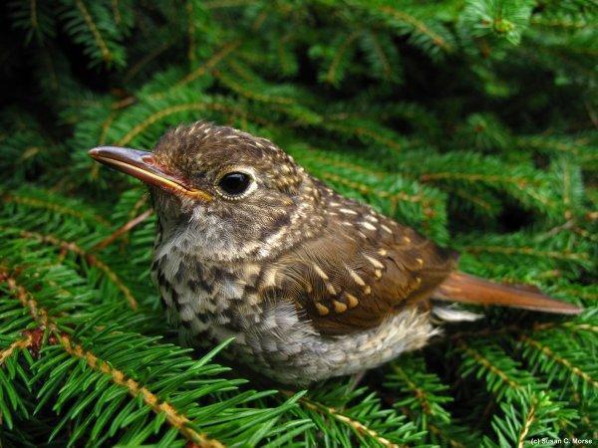
Species Level

Goals
- Conserve rare, threatened, and endangered species by integrating updated information into management plans.
- Maintain the functionality of mature softwood cover for wildlife wintering and ensure nearby food sources.
- Promote the health and viability of mast-producing trees and shrubs.
- Enhance early successional habitats to diversify species and age structures.
Figure_: Hemlock stands shield deer and other wildlife from winter snows and winds, and also provide nesting spaces for interior forest birds such as the hermit thrush.

Actions
- Engage ecologists to survey proposed trail routes and infrastructure areas for rare species within 50 feet of their sides and adapt conservation plans accordingly.
- Maintain at least a 70 percent canopy within hemlock stands to preserve their utility as wildlife wintering areas by blocking enough wind and snow.
- Maintain oak and other mast requirements of black bears, wild turkeys, white-tailed deer and other species. Avoid disturbing soft- and hard-mast stands areas during fruiting and foraging seasons.

More information
See Appendix E, The ACF for People and Wildlife

Recreation

Andrews Community Forest Committee manages recreation with care to balance community interest in recreational opportunities with protection of the forest’s ecological health. Outdoor recreation has long been and remains a highly valued tradition throughout the forest. With careful planning, we can offer meaningful access to nature while protecting the forest’s most sensitive ecological features. Trails can fragment habitat and connectivity at certain scales, types, and volumes of use.

Goals
- Provide inclusive, accessible recreational opportunities for hikers, walkers, bikers, hunters, runners, nature observers, skiers, snowshoers, and others of all ages and abilities.
- Accommodate potentially conflicting recreational activities through strategies such as spatial zoning, seasonal scheduling, and tailoring approaches to the specific nature of each activity.
- Promote trail connectivity to neighboring properties where ecologically appropriate and with landowner agreement.
- Seek input from relevant community groups, town committees and the general public about decisions related to recreation to promote a culture of shared stewardship and education.
- Design trails to highlight the forest’s beauty while protecting wildlife corridors, riparian zones, steep slopes, vernal pools, and other ecologically sensitive features.

Actions
- Promote recreational use on existing trails/skid roads and limit the creation of new trails except as needed to 1) bypass wet, steep, ecologically sensitive or otherwise unsuitable stretches of existing trails, 2) connect trail segments interrupted by acts of nature or forest management activities, 3) connect to trails on adjacent land where ecologically appropriate.
- Site, build and maintain trails in keeping with this document’s trail approval process and development parameters, and utilize the best practices from the Vermont Agency of Natural Resources guides, Vermont Town Forest Stewardship Guide and Vermont Town Forest Trail Design Guide. Trail work will only be performed at the direction of the ACF committee.
- Minimize trail density by consolidating trail footprints.
- Develop and implement a plan for monitoring and responding to major changes in natural resources, trail conditions, and human traffic.
- Utilize rest periods for monitoring after new trail development.
- Restrict motorized traffic to comply with the easement.
- Avoid constructing and maintaining trails in or near ecologically sensitive areas, buffering those locations from human disturbances as specified below in the Trail Development Parameters.
- Designate two distinct management zones within the forest: a southern zone and a northern zone. These zones are separated by a boundary that follows an east-west corridor composed of the former VAST trail and the powerline corridor. Specifically, the dividing line should follow the northernmost edge of either the former VAST trail or the powerline corridor.
- Designate trails in the northern zone as pedestrian only. Limit dogs and mountain bikers to the southern zone. Re-evaluate designations as usage data are collected and organized regarding mountain bikes, and amend the management plan accordingly.
- Minimize trail stream crossings and avoid encroachment on riparian buffers. Site, build, and maintain bridges, culverts and boardwalks in accordance with best practices to maintain water quality and prevent erosion.
- Monitor trail use and wildlife activity utilizing cameras, microphones, trail counters, sign-in sheets, etc. Seek advice on the monitoring plan from resources such as the Vermont Fish and Wildlife Department.
- Adapt management of recreational trails as dictated by user volumes and their ecological impacts and using closures or reroutes where appropriate.
- Create and maintain a positive working relationship with adjoining property owners in efforts to coordinate ACF's management goals with theirs.
- Implement additional seasonal and weather related closures in designated areas to protect wildlife wintering areas, nesting/breeding sites, mast stands, wildlife connectivity routes, and fragile soils.
- Create and maintain an up-to-date kiosk and signage with trail maps, safety guidance, regulations, and seasonal advisories (e.g., trail closures, wearing blaze orange, etc). Install signs at all trailheads and property access points. Include Indigenous land acknowledgments and use Abenaki names where appropriate.
- Keep the public informed about trail conditions through the town website, Front Porch Forum, Times Ink! and other outlets.
- Inspect trails and infrastructure on a yearly schedule and after major storm events. Track and respond to changes caused by human use and natural events.
- Collaborate with the Richmond Trails Committee and other volunteers to help steward the trails by scheduling volunteer work days.
- Establish an ACF contact email for the public to report trail maintenance needs, user conflicts, or wildlife concerns.
- Maintain an up to date ecological resource map to guide decision-making and educate trail users.
- Maintain a record of trail approvals, construction information, and any special stipulations or stewardship needs.
- Create a Risk Management Plan to maximize safety for users (i.e., evacuation routes, emergency protocols, appropriate trail design for multiple users to share trails safely, alerts for when all hunting seasons are allowed move to recreation)

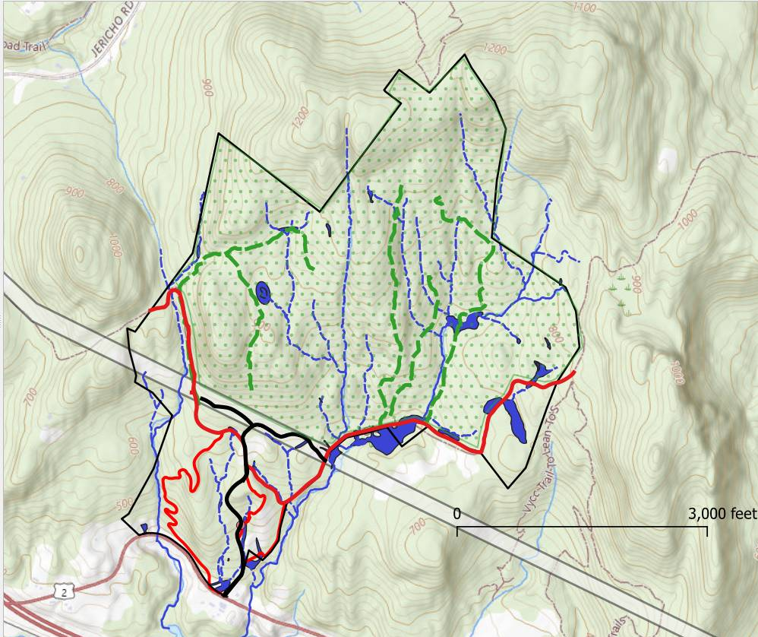
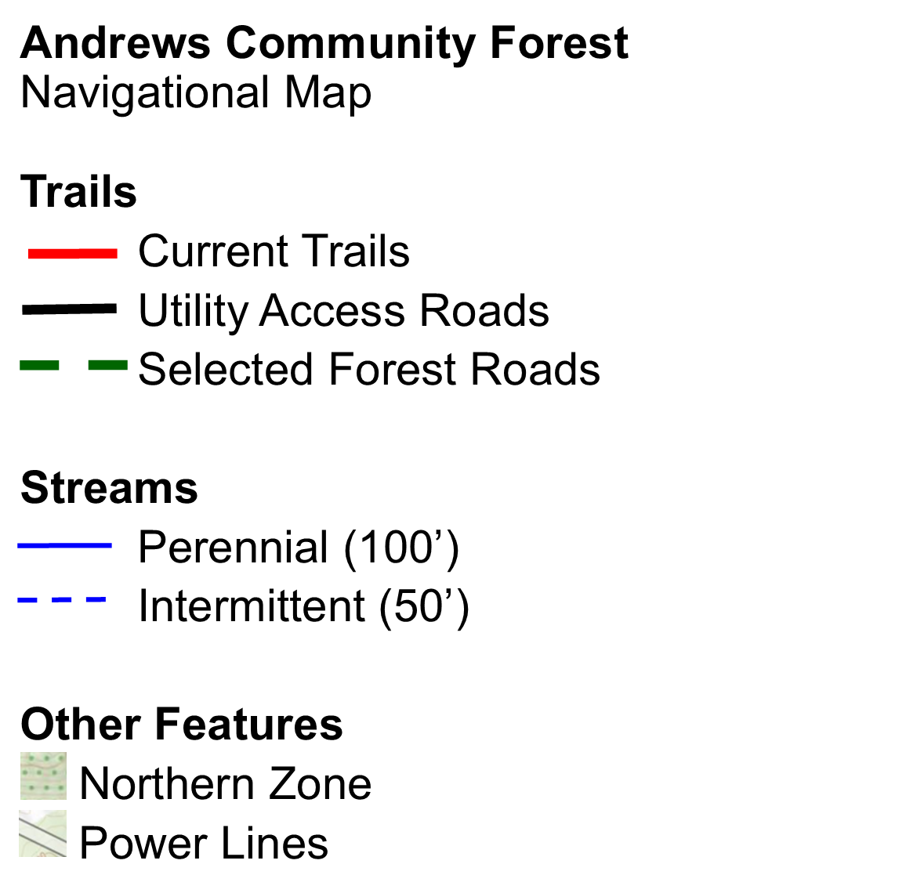

Trail Development Parameters
The following parameters ensure protection of sensitive areas and wildlife, and promote responsible trail building. Trail development must follow the Vermont Town Forest Recreation Planning Natural Resources Guide.

Wildlife Habitat Connectors
- Identify, map and maintain major wildlife linkages to support habitat connectivity.
- Prohibit any new trail construction within a 300 foot strict buffer zone around these habitat connectors. Exceptions may be allowed if in compliance with the Trail Deviation Review Process.

Riparian Areas
- Avoid trail development within riparian zones (of perennial and intermittent streams) to protect water quality and aquatic ecosystems.
- Where stream crossings are unavoidable, they must be minimal and perpendicular to the watercourse, and:
  - Use bridges and boardwalks to cross streams.
  - Ensure proper crossing height to cover full bank width and provide adequate debris clearance beneath.
- Buffer requirements from top of bank:
  - Perennial - 100 feet
  - Intermittent - 50 feet

Wetlands & Vernal Pools
- Prohibit trail development in and avoid trail development around wetland natural communities and vernal pools to protect habitat integrity and ecological functions.
  - Class III: 50 foot buffer
  - Class II: 100 foot buffer
  - Vernal pools: 300 foot buffer
- Close trails within 300 feet of Class II Wetlands in the spring (March 1st - May 31st) to protect vital habitat during periods of heightened wildlife vulnerability.

Ledges and Talus Slopes
- Prohibit trail development within 100 feet of broken ledge and talus formations due to ecological sensitivity and erosion concerns.
- Protect likely bobcat denning sites with 300 foot buffers.

Slope Guidelines
- Prioritize soil integrity and erosion control.
- Expedite and simplify new trail development by prioritizing new trails on terrain with slopes less than 20% as identified in the map in Appendix D, page 4 (VT ANR Map).
- Avoid trail development on slopes greater than 20%.

Sensitive Natural Communities
Protect sensitive natural communities (see easement EPZs) identified in ecological surveys by enforcing a 300 foot buffer for:
- Dry Oak
- Dry Red Oak–White Pine
- Dry Oak–Hickory–Hophornbeam
- Red Pine

Hemlock Stands
In the northern zone, close trails within Hemlock stands and the 300 foot buffer around them during winter months (December 1st - April 30th). This protects the critical roles these areas play in sheltering deer and other species from harsh weather.

Forestry Reserve Zone
The ACF Forestry Management Plan (page 5) sets aside several parts of the ACF as “Zone 3” – defined as “essentially a reserve zone” where the forest is permitted to “grow and develop without human interference.” The parameters above protect most of these areas. However, in reserve zone areas not covered above, and per the Forestry Management Plan: “Recreational and forest management trails may cross this zone if no viable alternative exists to access a portion of the ACF, but should generally avoid these areas.”

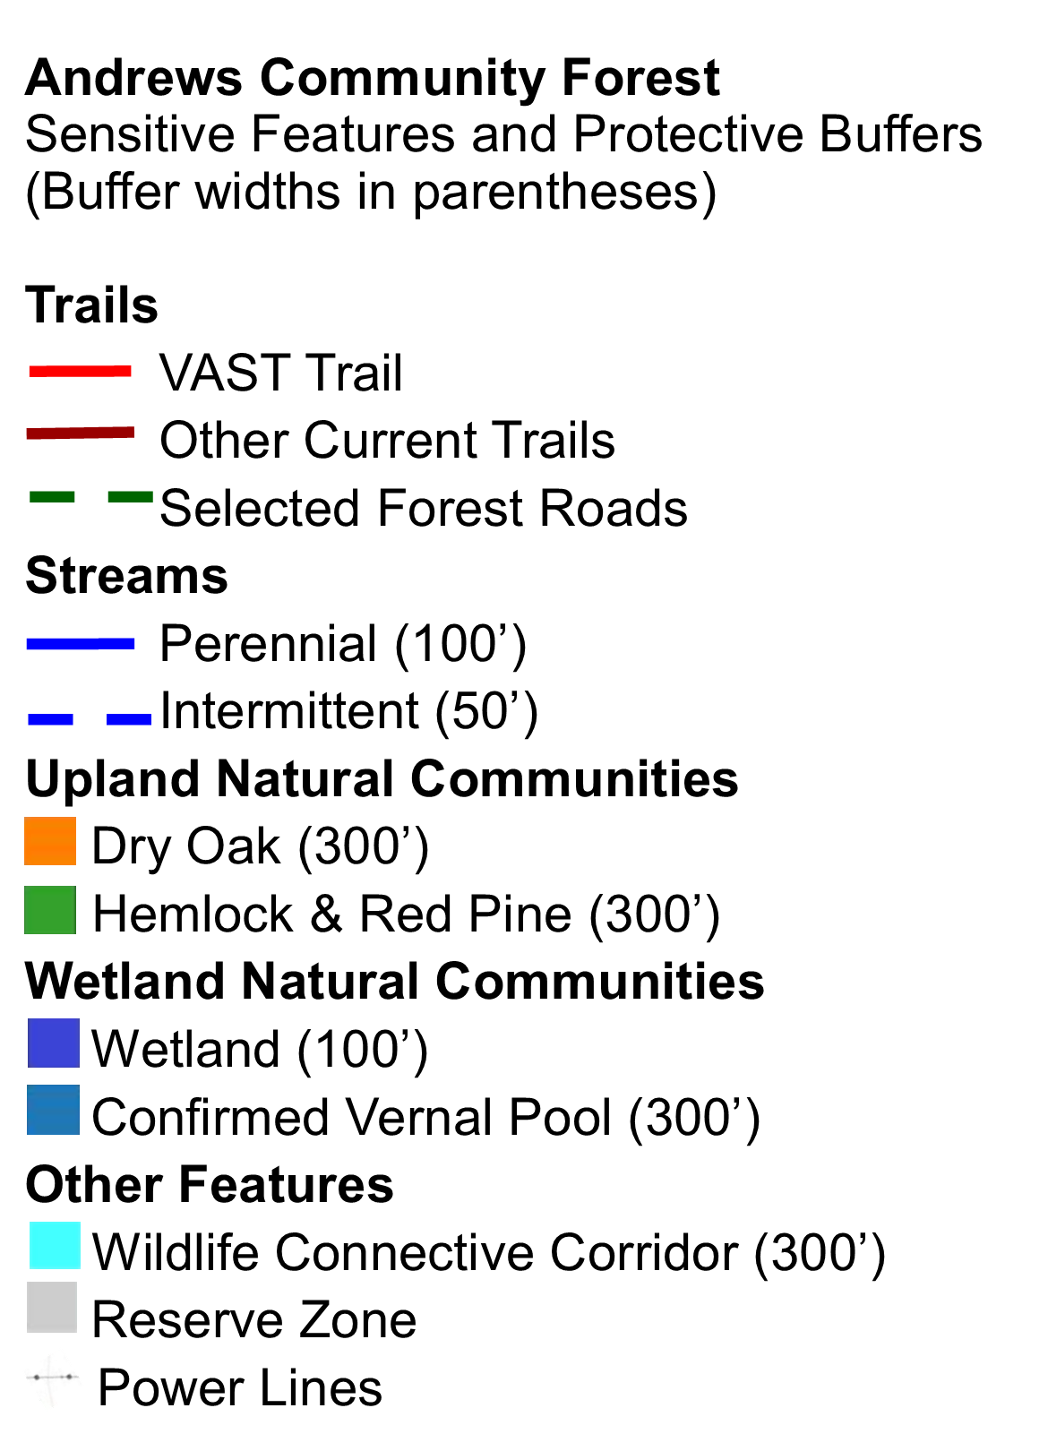
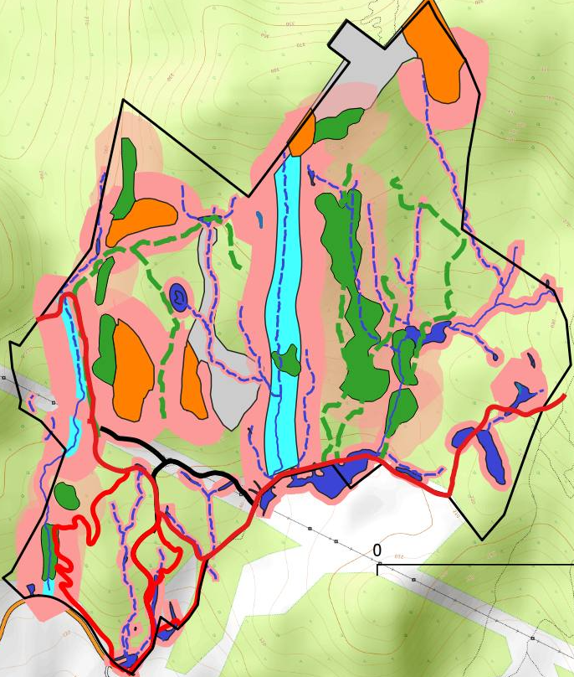
Sensitive area map of ACF, with buffers in pink

Trail Impact Evaluation Period
New trail proposals are considered carefully and at deliberate intervals during defined planning windows. After any new trail or major reroute, that area of the forest enters a minimum three-year rest period to allow evaluation of impacts to soils, vegetation, and wildlife before additional projects are considered. The focus remains on maintaining and improving the existing trail system, while exploring new trails only when they clearly align with recreational and ecological management goals.
- Rest period: No new trail approvals in the affected area for at least three years after construction or reroute.
- Exceptions: Safety concerns, environmental protection (e.g., erosion or drainage repairs), or legal/funding requirements.
- Goal: Keep the pace of trail development thoughtful and balanced so the forest can rest, heal, and remain ecologically resilient over time.
- Consistency: This approach is consistent with how other Vermont community and state forests manage trail planning—using multi-year rest periods and limited review windows to ensure ecological recovery and careful stewardship.

Trail Approval Process
All new trail development in ACF must adhere to the trail approval process. This ensures compliance, transparency, ecological responsibility, and community engagement. This is a sequential list of steps that must be completed in order.

1) Document the Need, Purpose, and Identify Proposed Route
Requests to the committee should include:
- Clearly define the intended use, users, purposes, and estimated financial cost and funding sources of the proposed trail
- Explain how the proposed trail supports goals in the ACF Management Plan and aligns with the easement's permitted uses
- Justify the proposed trail based on community interest, accessibility improvements, estimated cost, and/or trail connectivity needs
- Identify the proposed trail using existing forest roads or skid trails where possible
- Show the proposed trail on the provided Sensitive Area Map
- Adhere to the Trail Development Parameters to ensure compliance with protecting forest integrity, wildlife habitat, and wildlife connectivity
- What is the intended audience for the trail?
  - Is the trail intended for pedestrians, bikes, etc
  - What user ages, abilities, and interests would be targeted?

2) Preliminary Committee Review
- The proposed trail should then be brought to the ACF committee for consideration and preliminary approval
- The trail proposal documentation from step 1 must be submitted to the committee prior to to committee review
- Committee will evaluate trail proposals and base decisions and recommendations in alignment with B6.1 Recreation Goals and Actions

3) Expert Review, Flagging, and Final Map
The applicant and committee will coordinate to:
- Engage an experienced trail designer to flag the preliminary route
- Engage a practicing botanist, wildlife biologist or other qualified, practicing ecological professional to walk the flagged route and fifty feet on each side to identify rare, threatened, and endangered native species or wetlands that could be disturbed by trail construction or usage
- Provide opportunities for members of the ACF Committee to walk the proposed trail
- Adjust the route as needed to avoid:
  - Rare, threatened, and endangered species
  - Fragile soils and erosion-prone terrain
  - Conflicts with known wildlife usage
  - Sensitive areas as outlined in the Trail Development Parameters
- Map the finalized proposed trail route, respecting the protective buffers around ecologically sensitive areas

4) Committee Review and Public Input
- Present the proposal to the ACF Committee for further review
- ACFC will invite input from the following groups:
  - Richmond Trails Committee
  - Richmond Conservation Commission
  - The general public (e.g., through meetings, notices, and comment periods)
- Consider abutting landowner input when appropriate

5) Regulatory and Legal Compliance
- Ensure compliance with the Conservation Easement and Richmond Zoning, State, and Federal regulations
- Prepare supporting documents:
  - Final trail map
  - Erosion and sediment control plans (if necessary)

6) Approval and Permitting
- Submit finalized proposal for formal approval by:
  - The ACF Committee
  - The Richmond Selectboard

7) Construction and Stewardship
- Construct the trail using best practices outlined in the Vermont Town Forest Stewardship Guide and Vermont Town Forest Trail Design Guide
- Coordinate with volunteers, professional builders, and the Trails Committee
- Establish a monitoring and maintenance plan with reporting and adaptive management based on use and impact
- Maintain a record of the trail project, including proposal, design, construction, and stewardship activities.

Trail Deviation Review Process
This process allows for limited and carefully considered adjustments to recreational trails adjacent to sensitive natural areas. Deviations may be used to address site-specific safety or terrain challenges, and should be minor, purposeful, and protective of core habitats.

Definitions/Limitations
Trail Encroachment: A trail’s encroachment distance may not reduce the buffer width by more than 20%. The buffer width is the distance from the sensitive area to the outer edge of the buffer (see diagram).

Fragmentation Area: The combined total area of all trail encroachments on a buffer zone shall not exceed 5% of that original buffered area. Any buffer separated from the original zone by the encroaching trail is considered to be fragmented from the original buffer (see diagram).

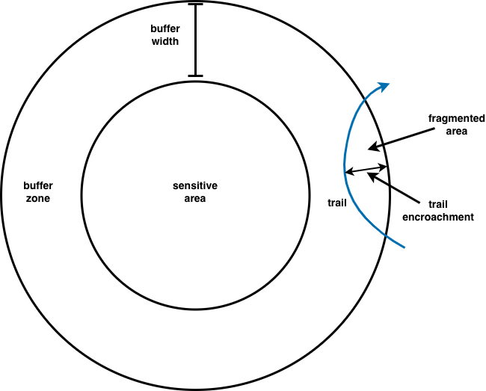
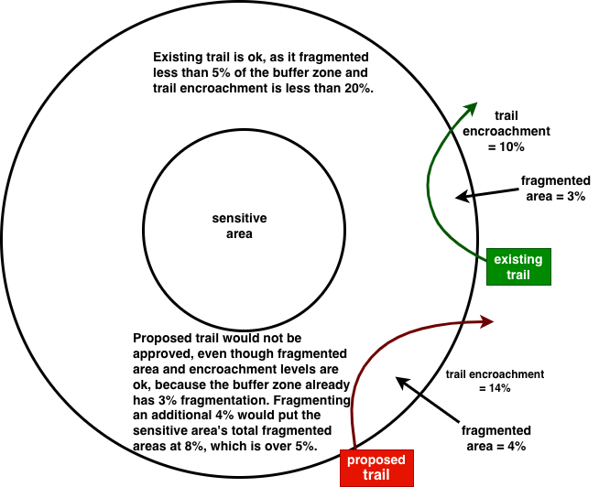

Require a Justification Statement
Where ZOI trail deviations are proposed, requester shall include a justification statement indicating:
- Why the deviation is necessary (e.g., terrain constraints, trail connectivity need, user safety)
- What alternatives were considered and why they were rejected
- Ecological impact mitigations. Specifically, note the ways in which the remaining management variables noted in Meredith Naughton’s Wildlife & Recreation are taken into account by the proposal. These include: trail consolidation, trail use volume, recreation activity type, species specific management/impacts, education, seasonal closures, and trail construction impacts and timing.

Trigger an Enhanced Ecological Review
Require a review by a qualified ecologist and/or wildlife expert that includes:
- Site walk of the deviation area
- Assessment of potential impacts (wildlife, soil, hydrology, etc)
- Recommendations for:
  - Buffers or reroutes
  - Seasonal restrictions
  - Infrastructure (e.g., boardwalks, signage)
  - Monitoring requirements and impact assessments

Committee Decision and Conditions
The ACF Committee will vote to approve or deny the proposed deviation, or request modifications and resubmission of the proposal.

Potential Recreation Partnerships
- Audubon Vermont
- Community Senior Center
- County Forester
- Neighboring landowners: Maple Wind Farm, VYCC, etc
- Richmond Conservation Commission
- Richmond Land Trust
- Richmond Mountain Trails/Vermont Mountain Bike Association (VMBA)
- Richmond Trails Committee
- Scouts
- UVM Community Forest Program
- UVM Field Naturalist Program
- Vermont Fish & Wildlife Department
- Vermont Land Trust
- Western Abenaki Tribes and Richmond Racial Equity

More information
See Appendix E, The ACF for People and Wildlife

Forestry and Agriculture

Forest management in the ACF is guided by a Forestry Management Plan under the direction of the County Forester. It is aimed at improving the ACF’s ecological diversity and resilience to climate change, invasive species and other factors, as well as serving as a model for sustainable forest management. It uses a ‘zone’ approach that classifies parts of the forest into one of three management styles to collectively achieve the overall objectives.

Goals
- Follow the Forestry Management Plan (updated in 2025) to manage forestry activities that improve forest health, wildlife habitat protection and wildlife diversity.
- Protect natural communities as well as the ecological processes that sustain them. Retain soil integrity, water quality, natural species composition, natural disturbance regimes and natural hydrology.
- Recognize that forest management in the form of the periodic harvesting of timber is an important part of land conservation, maintaining the working landscape, and supporting the forest products economy in Vermont.
- Manage the ACF to sustain plant and wildlife species of special cultural importance to indigenous peoples. (When forest management incorporates traditional practices by engaging indigenous foresters and culture keepers, it offers the opportunity to educate the community about historical and contemporary Indigenous forest stewardship practices.)

Actions
- Utilize multi-aged silvicultural treatments over the majority of the property.
- Avoid creating new permanent openings or wide (> 20 feet wide), roads and trails.
- Utilize management guidelines that enhance the value of the forest for a variety of deep forest species such as bear, fisher, and a variety of songbirds is recommended.
- In Ledge, Talus, and Ridges area, a forested canopy should be maintained over these rock habitats that occur in a forested matrix. Maintain a 100’ buffer from treatments to broken ledge and talus that provide concealment cover for wildlife.
- Mast Stands: Use forest management activities that promote the establishment, maintenance, and persistence of these species within the Forest.
- Update natural community mapping as more on-the-ground data becomes available.
- All forestry activities shall incorporate steps to retain soil integrity, water quality, natural species composition, natural disturbance regimes, and natural hydrology; Identify and control exotic species with the Forestry Management Plan.
- Deer Wintering Areas: The Hemlock and Hemlock-Northern Hardwood forest communities on the parcel could be managed specifically to enhance the conifer overstory and hemlock regeneration.
- Employ forest management for timber on municipal lands as a demonstration of responsible, and sustainable forest management, educating residents of Richmond and beyond in how to harvest forest resources in a sustainable way. See Forestry Management Plan for harvest dates.
- Hold educational events around forest management activities to inform the public about the rationale and best practices of sustainable forest management.
- Maintain contact with indigenous tribal foresters to contribute to future forest management planning and activities. In collaboration with indigenous partners, identify culturally important species (e.g., black ash) and the stewardship practices needed to sustain them, to inform future forest management activities.

Agriculture
Parts of the ACF include open pastures used by previous owners for grazing livestock. The ACF Conservation Easement permits agricultural operations where the forest has already been cleared. The neighboring Maple Wind Farm now owns much of the former Andrews Farm’s crop and grazing lands. The exceptions are ACF’s “lower meadow” and an additional meadow along the utility right-of-way. In addition, Maple Wind Farm has a right-of-way into the ACF from the neighboring farmyard to Maple Wind’s upper meadow. The Town has a right-of-way over the northern edge of that meadow. The ACF’s major east-west trail, the former VAST snow machine route, uses those rights-of-way, as does farm machinery.

There may be opportunities in the forest for a community garden/orchard, and agricultural education and demonstration projects. The ACF Committee will remain open to proposals for alternative uses of the agricultural lands, and it appreciates maintaining a long-term, mutually beneficial agricultural partnership.

Goals
- Recognize the importance of agriculture in Richmond and Vermont’s heritage and continue to allow agricultural uses that are compatible with other management goals.
- Develop agreements with Maple Wind Farm or other farm entities to allow coexistence of agriculture and public access.

Actions
- Promote opportunities for agriculture education and demonstration on the parcel, perhaps in conjunction with Maple Wind Farm or other agricultural entities with a vested interest in the property.
- Work with the Maple Wind Farm to ensure compatible shared use of these two roads and rights-of-way.
- Accommodate a high tensile electric fence around the grazing areas to allow for public access to the meadows when the pastures are not in use for grazing and access to be closed when the pastures are in use.

Potential Agriculture Partnerships
- Maple Wind Farm
- Richmond Farmers Market
- Richmond Community Kitchen
- The Farm at VYCC
- NOFA Vermont

Education

The Andrews Community Forest provides the community with the opportunity for formal and informal educational experiences that interpret Richmond’s natural and cultural history, creating an exciting opportunity to enrich community life. Throughout the ACF land-use planning process, residents expressed a strong interest in a dedicated wild space to learn about the natural world, especially within their town forest.

The ACF committee supports the development of safe, enriching, and inclusive learning adventures through thoughtfully crafted educational materials, signage, programs, partnerships, and infrastructure.

Richmond's three public schools, numerous preschools, day care centers, homeschool programs, senior center, nearby colleges, VYCC, and the general public will all benefit from a community environmental education hub based in the ACF.

Regional Models for Success
The Green Mountain Audubon Center, Shelburne Farms, Birds of Vermont Museum, North Branch Nature Center, and Krusch Nature Preserve serve as regional models of how natural areas can support both professional and self-guided learning about natural and cultural history. These sites offer valuable examples for creating similar impactful educational infrastructure in Richmond.

Educational Goals and Actions
The ACF offers many advantages for educational programming, including location, available parking, and overall accessibility. These elements make the ACF an ideal site for guided programs, habitat stewardship projects, outdoor recreation lessons, and working lands management workshops.

Below is a list of goals and actions. Goals 1-3 should be considered high priority, while goal 4 is of moderate priority. The following goals guide the development of educational initiatives in the ACF.

Goal 1
Provide education opportunities to local schools and community groups.

Actions
- Develop a self-guided tour with interpretive materials for teachers to use on field trips.
- Improve kiosk content and digital resources (maps, audio, data collection tools, photographs) to support educational programming.
- Facilitate educational programs about the natural and cultural history of the ACF, including forestry and habitat stewardship projects.
- Partner with educators to design field trips that align with school curricula.
- Provide safety information, procedures, and emergency access.
- Post to Times Ink!, Front Porch Forum, the ACFC webpage and social media information about the ACF’s natural and cultural history, and efforts to protect and enhance its natural communities and other habitat features.

Goal 2
Recognize and honor Indigenous connections to the land.

Actions
- Dedicate a portion of the kiosk to sharing the history of Abenaki use and care of the land.
- Host programs and events that include speakers knowledgeable about Indigenous perspectives (e.g., book groups with authors; partnerships with UVM, VYCC, and the Richmond Free Library).
- Seek guidance from Indigenous leaders, cultural organizations, and community members to inform the naming of trails and natural features to reflect Abenaki heritage.

Goal 3
Increase access to nature-based programming for the general public.

Actions
- Provide education and updates about ACFC’s efforts to preserve its species and habitats.
- Host events such as bird walks, guided hikes, nature programs, and mountain bike and snowshoe clinics.
- Lead seasonal guided walks that highlight natural history, forestry, and habitat stewardship.
- Seek partnerships for citizen science efforts.

Goal 4
Support environmental literacy through infrastructure and interpretation.

Actions
- Design signage, maps, and displays to help visitors understand the forest’s ecological systems and human history.
- Ensure accessibility and inclusivity are prioritized in all signage.

Challenges
These considerations should inform the planning and implementation of education infrastructure and programming:
- Steep terrain and trails limit accessibility
- Limited parking capacity
- Lack of pedestrian access (most visitors will need to drive or bike)
- An unusually large tick population

Potential Education Partnerships
- Abenaki Nation of Missisquoi
- Birds of Vermont Museum
- Camels Hump Middle School
- Chittenden County Forester
- Community Senior Center
- Essex Technical School
- Green Mountain Audubon Center
- Mount Mansfield Union High School
- Radiate Art
- Richmond Conservation Commission
- Richmond Elementary School
- Richmond Land Trust
- Richmond Racial Equity Group
- Richmond Recreation Committee
- Scouting America
- Summer Camps (MMMUSD, MMMUSD Part 2, Our Community Cares Camp) • Green Mountain Orienteering Club
- The Nature Conservancy
- The Nulhegan Band of the Coosuk Abenaki Nation
- UVM Field Naturalist Program
- UVM Ecological Planning Lab Extension Program
- UVM Environmental Studies Program
- UVM Rubenstein School of Environment and Natural Resources
- Vermont Agency of Natural Resources
- Vermont Coverts
- Vermont Land Trust
- Vermont Master Naturalist Program
- Vermont Youth Conservation Corps (VYCC)

Appendices
A. General Property Description
B. Governance
C. Cultural History
D. Indigenous Land Acknowledgement and Uses
E. The ACF for People and Wildlife
F. Further Reading

General Property Description

The Andrews Community Forest is a 428-acre largely forested parcel just outside Richmond Village in Chittenden County. The property is a diverse forestland with two small meadows. It has an abundance of hard-mast stands, predominantly oak and beech, that serve as important habitat for many species of wildlife. The forest includes several patches of Dry Oak Forest, Dry Red Oak-White Pine Forest, and Dry Oak-Hickory-Hophornbeam Forest, which are uncommon natural communities in Vermont. The property also has patches of dense hemlock, and those pockets, combined with its low elevation and southerly aspect, reportedly make it a heavily used winter deer yard. Recent timber harvesting and blowdown events have created patches of young forest and early successional habitat in the west and south of the property.

Overall, this forest, especially as part of a larger, connected forest block, is a well-conserved wildlife habitat. The forest is one of eight large parcels that originally inspired the Chittenden County Uplands Conservation Project (CCUCP). The CCUCP is a landscape-scale conservation effort with over a dozen partners working to conserve ecologically and culturally important forest blocks and habitat connectors between and alongside Camel’s Hump State Park and Mount Mansfield State Forest. The Andrews Community Forest abuts 6,000 acres of forestland that itself is part of the 72,000-acre Mt.Mansfield Forest Block. This largely conserved forest block is a critical wildlife corridor and has been ranked in the top 3% of the state’s wildlife habitat blocks by the Vermont Department of Fish and Wildlife.

In terms of water resources, the forest has several headwater streams that flow into the Winooski River and then on to Lake Champlain. The property also includes a small beaver pond and wetlands and at least two vernal pools. The quality of these water resources is directly related to the health of the surrounding forest.

There is a long history of timber management in the forest, as the Andrews family actively managed the forest. From 2011 - 2018, timber management occurred on a western portion of the property. Western areas were previously logged in 2001-2003 and eastern areas were logged in 1994-1997 by well-respected Richmond/Huntington loggers Mark and Bruce Moultroup. Going forward, the forest is capable of providing timber and other forest products into the future. Many forest management roads (also called “logging roads,” or “skid trails”) from previous logging operations still exist on the forest,
and despite drainage and other sustainability issues, may serve as a component of a multi-use recreational trail network. The use of these trails for recreation should not compromise or preclude their utility as forest management roads into the future.

In 2018, the Town of Richmond, with the assistance of Vermont Land Trust, purchased this 428-acre, largely wooded parcel from the Andrews family to create a new community forest. Simultaneous with the sale, a Conservation Easement was conveyed to both the Vermont Land Trust and the Vermont Housing and Conservation Board to protect the property’s natural resources and ensure public access in perpetuity.

Along with the existing logging roads, the forest has potential for a future recreational trail network. The former VAST trail running east to west through the forest connects to existing trails on neighboring properties. There are existing hiking trails on the VYCC property to the east and a public multi-use trail was recently constructed on privately owned land abutting the forest to the northwest.

Other uses of the property have included Maple Wind Farm agriculture and grazing, and The Vermont Electric Power Company (VELCO) and Green Mountain Power (GMP) power lines that cut across the property.

Sources

Documentation about the ACF and its surrounding lands is available via State resources updated with new information provided by the Vermont Agency of Natural Resources (ANR) through its 2024 Vermont Conservation Design initiative and updated BioFinder web site (together with continuing updates by VCGI (Vermont Center for Geographic Information. Specific ACF and local sources include Arrowwood’s Science to Action assessment (see “Richmond/Huckleberry Hill”), Arrowwood’s Andrews Community Forest Ecological Trail Planning Project Summary Report and the UVM Field Naturalist Report. These recognize key landscape features and the wildlife and ecology. These resources also inform decisions regarding Forest uses in general and as stipulated by the Forest Easement, the Richmond Town Plan and other governing documents, regulations and policies.
Governance

The forest is managed by the Andrews Community Forest Committee (ACFC), appointed by and advising the Richmond Selectboard.

ACFC Vision
The Andrews Community Forest will serve Richmond as a thriving ecosystem where conservation, education, and recreation harmoniously coexist. Through sustainable management practices, we aim to preserve the forest's ecological integrity and contributions to its forest block, while providing opportunities for local community engagement, environmental education, innovative forestry practices, and outdoor recreation. Together, we strive to create a model of responsible land management where generations connect with and enjoy nature, share in the Forest’s stewardship, and foster a deep appreciation for the rich biodiversity and cultural heritage of our region.
ACFC Mission
The ACFC’s mission is to manage the ACF to uphold the Purposes and other directives of the Conservation Easement as well as those found in applicable local, state and federal policies and mandates. We will:
1. Protect its productive forestland, wildlife habitats, biological diversity, natural communities, riparian buffers, wetlands, soil and water quality, and native flora and fauna, along with the ecological processes that sustain them.
2. Keep the ACF available for public use and enjoyment, including non-motorized, non-commercial recreational, educational, and other appropriate community uses.
3. Conserve the ACF’s open space values and scenic resources for current and future generations
4. Guide the Forest’s management through open, public discussions and decision-making.

The ACFC Bylaws describe the Committee’s structure and operating procedures. They may be found at this link.

Management Plan Background
The Andrews Community Forest Committee (ACFC) is charged by the Richmond Selectboard for meeting the priorities and goals outlined in the ACF Management Plan and the directives of the Selectboard and Town Manager. Upon purchasing the property in 2017, the Selectboard established an Interim Community Forest Steering Committee to develop an initial and then a full management plan for the Forest. The Interim Plan was approved by the Selectboard in March of 2018, and the first full management plan, with maps and appendices, was approved in November of 2018. In 2021 the ACFC began revising the first Plan in response to consultant recommendations for a new trail plan. An early draft was presented to the public in March of 2023. As membership of the ACFC changed, work continued to incorporate additional public input and expert recommendations, with the current, updated revision being approved by the Selectboard on ________, 2026.

More information on the management plan development process can be found here (link will be added).

Legal Agreements

Conservation Easement
Management of the Andrews Community Forest is directed by the “Grants of Development Right, Conservation Restrictions and Public Access Easement,” a legal conservation agreement between the Town, the Vermont Land Trust (VLT) and the Vermont Housing and Conservation Board. The purposes of the easement are to conserve the property’s natural resources, ecological processes, and open space values; provide for non-motorized, non-commercial recreation and education; and involve the public in the management of the property.

VLT acts as the primary easement steward. As such, VLT conducts annual monitoring to ensure activities on the property are consistent with the terms of the easement. The easement steward is also the Committee’s primary contact at VLT for reviews and approvals of proposed actions which are not contemplated in the management plan.

The easement requires a management plan and any future changes to the management plan must be reviewed and approved by VLT. Section 1.B. of the Conservation Easement dictates what information the management plan must include. Public input is required by any updates to the Plan.

Agricultural Agreement
Maple Wind Farm is the adjoining landowner, and its property includes the remaining acres of the original Andrews farm. Maple Wind Farm has historically used eight acres of what is now the community forest for grazing cattle. For 10-16 days in some years, 30 adult bovines and 30 calves would graze on the ACF’s lower meadow and the meadow by the Vermont Electric Power Company (VELCO) powerline. Both parties are interested in continuing this arrangement and will explore the possibility of a long-term agreement, which VLT must approve.

“Woods Roads” Access and Utility Easements
This section summarizes three recorded Warranty Deeds and two surveys that describe 25-foot-wide rights-of-way for “woods roads” (some being the former VAST trail). This text is intended to help the Town manage access, maintenance expectations, and neighbor coordination; it does not replace the recorded land records or surveys. The numbered “Books” are available in the Town of Richmond’s land records.
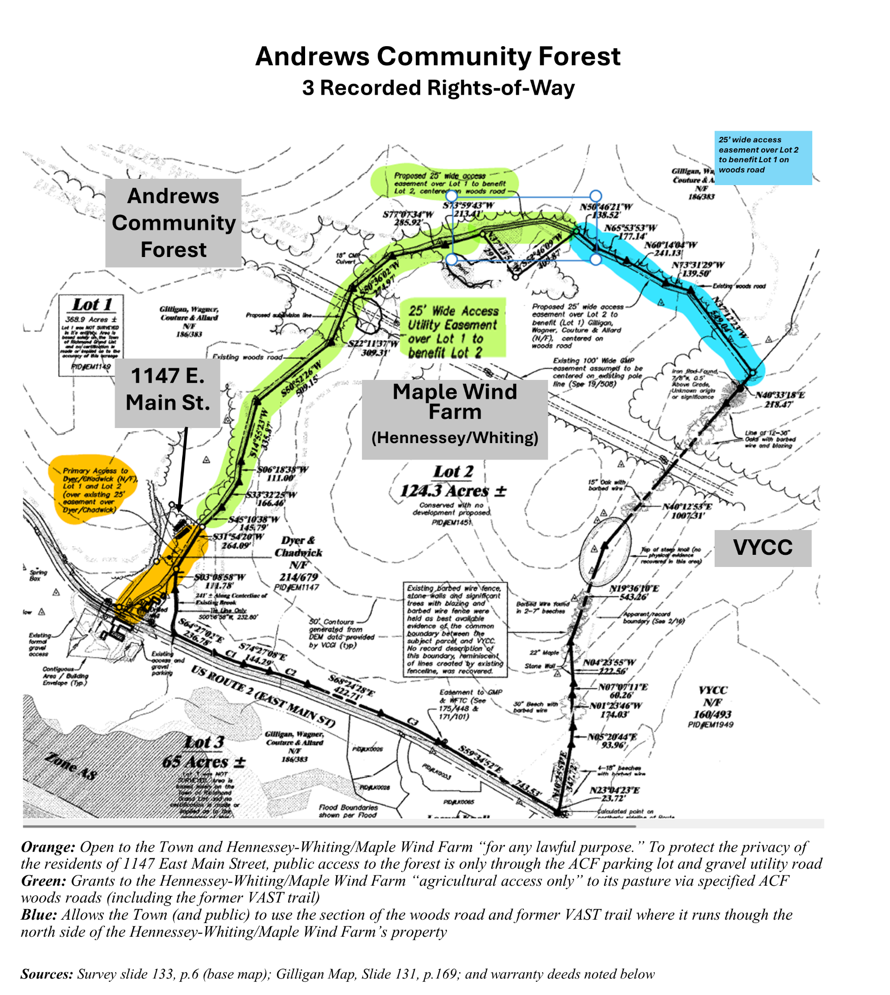

1) Warranty Deed: Andrews family → M. Dyer & H. Chadwick (2.58-acre homestead lot) – Book 214, p. 679
- What this deed covers: The 2.58-acre homestead lot commonly known as 1147 East Main St., Richmond.
- Right-of-way described: A 25-foot-wide, non-exclusive access and utility easement of the Woods Road across the homestead lot. It benefits the Andrews family’s remaining lands at the time of the conveyance (today including the Town’s ACF parcel and the neighboring Hennessey/Maple Wind parcel, as shown on the surveys).
- On-the-ground location: Shown on the surveys as the Woods Road/right-of-way crossing the homestead parcel.
- Improvement and cost sharing: The deed notes the road may be improved within the 25-foot width. Initial improvements are to be paid by the Grantor(s)’ (Town and Hennessey) chain of title; after that, costs are to be shared based on use between the Grantee (homestead lot), owner’s chain of title and the Grantor’s chain of title.

Utilities: Because the easement includes “utility,” access for power utilities is granted, even though the Town and utilities now typically use the adjacent improved utility access road as part of their legal right to access all properties crossed by their lines.

2) Warranty Deed: Andrews family → Town of Richmond (ACF) – Book 243, p. 652
- What this deed covers: The Andrews conveyance to the Town that forms the Town’s Andrews Community Forest (ACF) parcel. (The deed references the survey which notes an area of 368 acres, ; while the Vermont Land Trust Recorded Easement, Schedule A describes the parcel as 428 acres, more or less, due to additional acreage used by the Andrews family being added at the time of sale.)
- Right-of-way #1 (benefits Hennessey/Maple Wind): The deed references a 25-foot-wide easement/right-of-way for agricultural purposes only over the Woods Road that the Andrews family granted to the Bruce & Elizabeth Hennessey Trust (see Deed #3 below, Book 219, p. 132).
  - Where it is on the ground: The surveys show this agricultural right-of-way as the Woods Road along the eastern boundary of Town (ACF) land, extending north from the Town boundary with the 1147 East Main St. 2.58 acre lot until it connects to the north with another 25-foot right-of-way described below.
  - Maintenance: This deed does not state who maintains this right-of-way. For management purposes, maintenance expectations should be coordinated in writing with affected neighbors and users.
- Right-of-way #2 (benefits the Town/ACF): The deed also references a separate 25-foot-wide easement/right-of-way for all lawful purposes over and along an existing Woods Road on Hennessey Trust land, for the benefit of the Grantor (now the Town of Richmond).
  - Where it is on the ground: The survey depicts the Woods Road on Hennessey Trust land (often labeled Lot 2). From the survey pin at the northeast corner of the small triangular Town parcel (often labeled Lot 1), the Town’s 25-foot-wide right-of-way runs east along/near the boundary between Lots 1 and 2.
  - Maintenance: This deed also does not state who maintains the Woods Road right-of-way. For management purposes, any roadwork should be planned with the neighboring landowner and documented (scope, timing, cost sharing, and standards).

3) Warranty Deed: Andrews family → Bruce & Elizabeth Hennessey Trust (124.3 acres and 65 acres) – Book 219, p. 132
- What this deed covers: The Andrews conveyance to the Hennessey Trust (including the 124.3-acre parcel and the 65-acre parcel referenced in the management plan records).
- Why it matters for Town forest management: This deed is referenced by the Town’s ACF deed (Book 243, p. 652) when describing shared/overlapping 25-foot rights-of-way in the Woods Road area.
- Rights-of-way to look for in the deed and on the surveys: (1) the 25-foot-wide right-of-way limited to agricultural purposes (associated with the Woods Road along the ACF eastern boundary), and (2) the Woods Road corridor where a 25-foot-wide right-of-way is described as being available for all lawful purposes for the Town’s benefit (as referenced in the Town deed).
- Maintenance: If the deed does not assign maintenance responsibility, treat maintenance as a coordination item: agree in advance on how routine upkeep and any improvements will be handled, and keep the agreement with the Town’s ACF management records.

Powerline Rights-of-Way
Vermont Electric Power Company (VELCO)
A 150-foot wide VELCO right-of-way runs through the community forest. VELCO has road access to the right-of-way on occasion for maintenance and repairs to the powerline. In 2018, VELCO improved a road from the forest entrance on Route 2 to the powerline; they used the upper landing area to stage their work. Following this work, they re-seeded the landing and the road above the landing, and installed waterbars on the road below the landing. At certain periods, VELCO may need to close some or all of the forest to perform larger projects on the powerline. ACFC should coordinate with VELCO to prepare for such events and fully inform the public of the closure.

Green Mountain Power
Green Mountain Power has a 75-foot right-of-way adjacent to the VELCO right-of-way in the same powerline corridor. Within this corridor, Green Mountain Power manages vegetation. The Committee will work to better understand the vegetation management goals and practices, the landowner’s (Town’s) rights, to advise the Selectboard to make an informed decision about vegetation management within the powerline corridor, and alert ACF visitors to the activities.

Management Plan Updates
This management plan is intended to be a living and evolving document as the Town continues to grow its understanding of the Forest’s needs, functions and changing conditions. The Town should make management decisions based on the latest information combined with the resource management objectives. In addition, the Town should be continuously gathering new information to guide future management decisions and update this plan at a minimum of every ten years. The Committee will annually discuss whether an update to the Management Plan is needed, and to employ aspects of this “adaptive management model.”


Any changes to the Management Plan must be reviewed and approved by the Selectboard and VLT, and any activities on the property which are not contemplated in the management plan must be reviewed and approved by the Selectboard and VLT stewardship staff to ensure compliance with the Conservation Easement.
Cultural History

Indigenous Heritage
Richmond is located within Ndakinna (in-DAH-kee-NAH), the homeland of the Western Abenaki people, also known as the Original People, who have a unique connection to this land and have been its traditional caretakers since at least the last Ice Age. For hundreds of generations before the European colonists arrived and applied their own borders and labels, the Western Abenaki people lived and worked on this land, stewarding resources in an ecologically sustainable way. Given that ACF lies along important east-west and north-south transportation and trade routes, other tribes are likely to have visited the forest as well.

Abenaki oral tradition and written accounts, historical resources, and archaeological studies of prehistoric sites in Richmond inform our understanding of how the ACF landscape has been stewarded and its continued importance to Indigenous people of our town and region. General resources include books such as those by Wiseman (1995, 2001), an Abenaki elder and scholar, and Haviland and Power (1994), as well as numerous online resources. Appendix 3 in Wiseman (2001) lists many written, video, and museum resources regarding Abenaki cultural history.

Specifically for the Richmond area, archaeological studies in the 1990s near the bridges in Jonesville over the Huntington and Winooski rivers have yielded valuable physical evidence of occupation and forest use by Indigenous peoples before colonization (Thomas et al. 1995; Doherty et al. 1996). These sites were radiocarbon dated to approximately 1040 AD (near Winooski bridge) and 1500 AD (near Huntington bridge), and thus considered to represent the Middle to Late Woodland period. The sites show that animals “including black bear, deer, beaver, porcupine, muskrat, fisher, mink, skunk, cottontail, red squirrel, and chipmunks were taken for both meat and pelts. Various nuts, including butternut, hickory nuts, beech nuts, and acorns from red oak” were also collected and processed for consumption and storage (Thomas et al. 1995). Diverse tree species were used for firewood at the Huntington River site, including beech, maple, birch, red pine, eastern hemlock, elm, eastern hophornbeam, eastern cottonwood, red pine, and possibly alder. No evidence of maize was found at these sites, even as maize, beans, and other plants were being cultivated at that time along the Winooski River closer to Lake Champlain. Thomas (2008) surmises that these Jonesville sites were seasonal encampments occupied between September and late December/early January to collect and process forest resources.

Such findings suggest that the forests where ACF is now located were largely stewarded and used for hunting and gathering, rather than agriculture. This pattern concurs with broader geographical accounts of Abenaki practices, such as Wiseman (2001:27), who stated that the Abenaki “… had smaller seasonal camps along most rivers eight thousand winters ago” and described gathering and hunting activities in the uplands.

The Jonesville archeological digs also uncovered the dramatic environmental changes that occurred as a result of forest clearing by European settlers (Thomas et al. 1995). The alluvial terrace on the Huntington River, which the Abenaki families occupied over 500 years ago, had developed slowly over thousands of years with minimal flooding evident in the analysis of sediments. In contrast, during the 19th and early 20th centuries, catastrophic flash flooding became more common as upland and riparian forests were cleared for farming. Thomas (2007:9) noted that “between roughly 1810 and 1880, four to seven feet of sand, gravel, and even small cobbles were deposited on the terrace surface.” These extraordinary floods covered or destroyed most evidence of precontact use and settlements. More recently, as abandoned farmland grew back to forest, flooding has declined. “Since the early decades of the twentieth century, less than eight inches of alluvium have been deposited on the terrace surface next to the Huntington bridge, and most of this was probably due to the great flood of 1927” (Thomas 2007:10).

Plants and Animals of Special Cultural Importance for Western Abenaki
A number of forest species were and continue to be of special cultural importance to the Abenaki people, and as such deserve special management consideration. Among tree species, these include black ash (Fraxinus nigra, also called brown ash and maalakws in Abenaki) used for basketry, and white birch (Betula papyrifera, also called canoe birch, its bark called wigwa in Abenaki) for canoes, homes, and containers. Unfortunately, black ash populations are currently highly threatened by the emerald ash borer, which is already present in Richmond. Butternut (Juglans cinerea, in Abenaki pagon or bagon) were among the trees highly valued for food, medicines, materials, and dyes (Haviland and Power 1994; Wiseman 1995b, 2001). This culturally important species is also threatened. The butternut canker fungus, first found in Vermont in 1983, now infects nearly all butternut trees causing dieback and often death. Maple sugaring (Pkwamhadin – “gathering of maple sap” (Chenevert 2021)) was an important seasonal activity among the Western Abenaki, one which was taught to colonists (Cotnoir n.d.).

Thomas (et al. 1995:61-64) lists the uses by the Abenaki of some thirty species of trees and shrubs abundant in the mixed deciduous forests of Vermont, many of which are found in ACF. Wiseman (1995a, 1995b, 2001) describes a wide range of forest plant species that were and are collected for construction materials, food, medicines, and dyes by Abenaki people. In Appendix 2, Wiseman (2001) lists many forest plants used in Abenaki herbal medicines by the maladies that they treat. A complete list of culturally important species found now or in the past at ACF would be valuable to develop for use by the ACFC in management decisions and educational materials. Ideally, such a list would be compiled, and important species prioritized, in partnership with the Abenaki people.

Before colonization, the Abenaki likely hunted and trapped a wide range of animal species for food and pelts in the forested landscape where ACF is now located. Thomas et al. (1995:65-75) describes the traditional uses of the 11 species of animals found at the Huntington River site. Wiseman (2001) describes the relationship and importance of many species to the Abenaki, as well as how they were traditionally hunted and used. The acts of hunting and fishing, as well as the resulting food, skins and other usable body parts (e.g., bones and sinew), remain culturally important for many Indigenous peoples. As mentioned for forest flora above, it would be valuable to develop a prioritized list of ACF’s animal species of cultural importance in consultation with Abenaki partners, including uses, stewardship, and both Abenaki and scientific names.

Abenaki language and the ACF
The Western Abenaki language, which is in the Algonquian family of languages, is considered critically endangered by UNESCO (2010). It is a descriptive language based on root words specifying physical qualities. For example, the region’s largest river is named Winoskisibo – built from Winos means onion, ki means land, and sibo means river. Thus the Winooski River is named for the ramps and other wild onions which were known to grow in abundance along its shores. Maintaining the Abenaki language and culture is deeply connected to the Abenaki homeland and its stewardship. For example, Cotnoir (n.d.), a citizen of the Nulhegan Band of the Coosuk Abenaki Nation, wrote that “…sugaring still functions as a time for our community members to gather and connect with the woods and one another. Through sugaring, we continue to cultivate a working relationship with the land, while practicing our language – Western Abenaki.”

Conservation efforts, such as the ACF, can inadvertently contribute to the erasure of Indigenous presence when introducing and perpetuating nonnative place names and management practices. Conversely, the ACF can support the revival of the Western Abenaki language and culture by supporting the use of Abenaki language for places, practices, flora, and fauna in the naming of trails, educational materials, and signage. If ACFC decides to go beyond that list, Abenaki culture keepers should be consulted.

History After European Settlement
European settlers arrived in the Richmond area in the 1770’s. “Gray Rocks Farm,” as it was formerly known, was placed on the National Register of Historic Places in 1996 “because of its dual architectural and agricultural significance” (Longstreth 2007). The farm exemplifies the growth and development of dairy farming in 19th and 20th century Vermont. The land that is now the Community Forest was largely the farm’s pasture and woodlot, and most of the farmland and remains of the historic farm’s agricultural buildings are on land now owned by Maple Wind Farm and protected by an agricultural conservation easement The farmhouse and immediate yard are privately owned.

The existing forest parcel, along with 212 additional acres, was first farmed by James Butler, beginning around 1800. He constructed a farmhouse, blacksmith shop, and an English barn before selling the property to Asa Rhodes in 1813. The property remained in the Rhodes family for over a hundred years, passing from father to son.

The 1850 agricultural census indicates that the Rhodes farm was primarily a dairy farm, with 45 cows producing 1,800 lbs. of butter and 15,000 lbs. of cheese annually. As was common in Richmond at the time, the farm also had other livestock – horses, chickens, sheep, and swine. The Rhodes also harvested 125 tons of hay and 200 lbs. of maple syrup annually and grew many different crops: corn, oats, rye, potatoes, peas, and beans.

Over the years, ownership passed first to Asa’s son, Cornelius, and then to his son Edward, around 1900. The farm continued to grow and ultimately thrived as the market for butter and cheese expanded. Given the farm’s success, in 1917, Edward reconstructed the English barn into a large U-shaped barn that more than doubled the space available for the cows. The new barn also added space for horses, a granary, and a milk house and he added a silo for storing cereals elsewhere on the property.

In 1923, Edward Rhodes sold the farm to Clarence Andrews, and he and his descendants continued dairying operations on the property until 1978. The Andrews also operated a successful inn, the Gray Rocks Inn, from 1928 to 1941. Ina Andrews, Clarence’s wife, ran the inn, cooking three meals a day for guests from Massachusetts, New York, and Connecticut. During this period, the Richmond area was full of small inns for travelers looking to experience the idyllic countryside. The tourism business was vital to the Richmond economy and an important period in the town’s history.

Clarence’s sons Kenneth and Everett ran the farm together after their father’s death. Upon Kenneth’s passing, Everett and his wife, Mary Jo, took over operations, and also sold firewood and hay from the property. They built a rustic cabin on the northern portion as a deer camp which they used into the 1990s. Only two 1950s automobiles remain.

Everett and Mary Jo raised four daughters on the land – Abigail, Amy, Jennifer and Kate. After ending farming operations, the family generously facilitated the transfer and conservation of the property. What had largely been the farm’s timberland, pastures and places of childhood exploration and adventures became Richmond’s first community forest.

In 2018, Angus Cummings, a UVM student, interviewed several of the Andrews sisters and other townspeople familiar with the recent history of the parcel for his thesis. It includes historical photos of the site contributed by the Andrews family.

Remaining Historical Sites and Features
Today, all that is left of the many farmstead buildings on the community forest parcel are two former farmstead sites with stone foundations. One foundation is on the northwestern side of the property, near the VAST trail. The other remaining foundations are near the end of the eastern farm road. One remaining foundation, set slightly apart, was either a springhouse or a small barn. The adjacent, private parcel to the east, was also part of Gray Rocks Farm and the Andrews Farmstead. The 1813 farmhouse and barn remain there, just outside of the town-owned forest property. In 2013 Maple Wind Farm bought 189 acres from the Andrews family largely below Route 2, which is conserved by an agricultural use easement On January 13th, 2014 the barn located across the street from the ACF entrance, burned down from an electrical fire. Maple Wind Farm rebuilt the barn in the same location in 2014.
References

Baas, J.; Dupler, K.; Smith, A.; Carnes, R. An assessment of non-consumptive recreation effects on wildlife: current and future research, management implications, and next steps. California Fish and Wildlife, Recreation Special Issue; 62-73; 2020. https://nrm.dfg.ca.gov/FileHandler.ashx?DocumentID=178954&inline
Cotnoir, Alexander W. (n.d.) An Abenaki History of Maple https://abenakitribe.org/maple-syrup. Chenevert, Brian. 2021. Maple sugaring among the Abenaki and Wabanaki Peoples. https://abenakitribe.org/maple-syrup
Cummings, Angus B. 2019. Farm to Forest: The Andrews Community Forest. University of Vermont senior thesis. Archived at: https://hdl.handle.net/20.500.14849/1520
Doherty, Prudence, Robert Florentin and Peter A. Thomas. 1996/Revised 1997. Phase I and II Archeological Studies Richmond BRZ 1445(18) Richmond, Vermont. Submitted to Vermont Agency of Transportation.
Haviland, William A. and Marjory W. Power. 1994. The Original Vermonters: Native Inhabitants Past and Present. University of Vermont. Hanover and London: University Press of New England.
Longstreth, Julie. 2007. Everett and Mary Jo Andrews’ Farm. in Riggs, H.W. et al. Richmond, Vermont: A History of More Than 200 Years. Richmond, VT: Richmond Historical Society. https://rfl.kohavt.org/Record/67654
Thomas, Peter A., 2007. Richmond’s ancient past, in Riggs, Harriet (ed). 2007. Richmond, Vermont: A History of More than 200 Years. Richmond Historical Society. Submitted to Vermont Agency of Transportation. https://rfl.kohavt.org/Record/186593
Thomas, Peter A., Robert Stone, Nanny Carder and Robert Florentin. 1995. Archaeological Site Identification Evaluation and Mitigation pf VT-CH-619 for Richmond TH 2407, Richmond, Chittenden County, Vermont.
UNESCO. 2010. Atlas of the world's languages in danger. https://unesdoc.unesco.org/ark:/48223/pf0000187026
Wiseman, Frederick M. 1995a. Gift of the Forest: The Abenaki, Bark and Root. Abenaki Educational Series, Handbook No. 1. Vermont: Ethan Allen Homestead Trust.

Indigenous Land Acknowledgement and Uses

Background

For the development of the Land Acknowledgment, the accompanying usage rights, and the signage and naming suggestions, the following process and expert guidance were engaged:
August 2021: Scott Silverstein and Alexis Latham of Richmond Racial Equity contacted the ACF committee and joined the 8/28/21 meeting to discuss Abenaki access to the forest for hunting, gathering and perhaps holding gatherings, as well as the potential trail naming and interpretive signage. Over the following months and to the present, Scott and Alexis served as leaders and advisors to ACF on this part of the plan revision. They facilitated contacts with Abenaki leaders and culture keepers while leading a collaborative process that resulted in the ACF land acknowledgement, designated use rights, naming and signage proposals and related provisions in Appendix D of this revised plan. They consulted with Jesse Bruchac and Kerry Wood, both tribal citizens, as well as culture keeper Annette Urbschat regarding Abenaki language recommendations for signage and trail names.
October 2021: Chief Don Stevens of the Nulhegan Band of the Coosak Abenaki Nation joined the 10/25/21 ACF meeting to share perspectives on ACF land acknowledgments, Abenaki use rights, and related components.
January 2022: Wording for the Appendix containing the Land Acknowledgment and related components was warned, discussed and final edits discussed by ACF members and the attending public at the 1/6/22 ACF meeting.
January 2022, Rebecca Roman of the Vermont Land Trust reviewed acknowledgment wording and use rights as related to the conservation easement and shared comments at the ACF 1/31/22 meeting.
January 2022: Chief Richard Menard of Missisquoi Abenaki Nation joined the 1/31/22 ACF meeting to share perspectives on the Land Acknowledgment and related components. Appendix D was approved by the ACF Committee on January 31, 2022, and is now also incorporated in the appropriate sections of this draft management plan.
July 2022: Rebecca Rouiller of Radiate Art Space, which sponsored the murals of Abenaki culture and language on the Town Center building, agreed to allow use of mural images in ACF signage. Research and consultation with Abenaki artists went into creating those murals, which were dedicated in a traditional ceremony led by Abenaki culture bearer Charles Delaney Megeso.

Part 1: Statement of Land Acknowledgement

Andrews Community Forest is located within Ndakinna (in-DAH-kee-NAH), the homeland of the Western Abenaki people, who have a unique connection to this land and have been its traditional stewards for millennia. For many generations before the European colonists arrived, the Abenaki people harvested animals, nuts, plants, berries, fiber, and timber in these forests, without degrading their ecological health. The Indigenous people who preceded the colonists created an extensive system of trails throughout the Green Mountains that attest to the extended relationships between the Abenaki people and other tribes, who also used these forests, and who took refuge here as the settlers drove them from their homes.

The Town of Richmond acknowledges that we have access to this land because it was taken without consent and that our ability to make decisions about its management rests on this historic injustice. The Andrews Community Forest therefore acknowledges the Abenaki people’s rights to use this land in perpetuity, and welcomes the Abenaki people as partners in our forest management. We aim to honor and respect the Abenaki people through responsible forest management and sustainable land use. We will strive to incorporate Traditional Ecological Knowledge into our management practices to foster a healthy forest community, and restore a healthy balance between our needs and the needs of the nonhuman people (see footnote below) of the forest. We say their name, and we name trails using the Western Abenaki language, to remind us that the Abenaki people are the Original People of the Dawnland, Ndakinna , out of respect for their culture and special relationship to the land, and to acknowledge their historic and ongoing contributions to our community.

Shorter Land Acknowledgement (to appear on kiosk, access points, trail maps, etc.):

The Andrews Community Forest is located within Ndakinna, the unceded homeland of the Western Abenaki People, who have a unique connection to this land and have been its traditional stewards for millennia.

Part 2: Indigenous Land Use Agreement

The Andrews Community Forest (ACF) Management Plan hereby affirms the following rights in perpetuity for persons of Indigenous ancestry:

1. Hunting and fishing rights for those holding the appropriate license (available free from the Vermont Fish & Wildlife Department to registered tribe citizens).
2. Rights to collect fungi, plants, and plant parts in a sustainable manner.
3. Use of the land for gatherings and ceremonies, including the erection of small, temporary structures relevant to ceremonies.

All collections shall occur within the following parameters:

- All gathering shall occur in a sustainable manner that ensures populations are the same size or larger the year following each harvest. (copied from Abenaki Gathering Agreement, Green Mountain Audubon Center)
- Only hand tools will be used during hunting and gathering activities. (copied from Abenaki Gathering Agreement, Green Mountain Audubon Center)
- Amounts harvested shall be able to be carried out by the person(s) collecting, in bags or baskets. Wheelbarrows, wagons or other wheeled or non-wheeled carts or devices may not be used to transport harvests on and from the ACF without prior permission of the ACF Committee. (adapted from Abenaki Gathering Agreement, Green Mountain Audubon Center)
- No species listed on federal or state endangered, threatened, or Species of Special Concern lists may be collected on the land. Persons of indigenous ancestry shall consult federal and state lists before each harvest to ensure that these species are not harvested. If such a person is unsure if a plant they wish to collect is on the list, they should further consult with the ACF Management Committee prior to collecting. (adapted from Abenaki Gathering Agreement, Green Mountain Audubon Center)
- Use of harvested items for limited commercial purposes by tribal citizens, such as selling hand-woven baskets or herbal remedies, is permitted with prior notice to the ACF Committee.
- Tribal citizens harvesting on the land may verbally identify their tribal affiliation and reference this agreement. (copied from Abenaki Gathering Agreement, Green Mountain Audubon Center)
- The ACF Management Committee may prevent collection from lands where the safety of ACF users may be impacted or in areas deemed ecologically sensitive. Such restrictions will be clearly posted at forest access points and on the ACF website. (adapted from FirstLight Power gathering agreement)

Part 3: Abenaki Tribal Citizen Advisor to the ACF Committee

In order to incorporate Indigenous perspectives and traditional ecological knowledge into ACF management, the ACF Stewardship Committee will seek to fill at least one of its seats with an Abenaki tribal citizen.

The ACF Committee will also consult with an Abenaki tribal citizen with relevant expertise to advise on revisions of the ACF Comprehensive Management Plan, revisions of the ACF Forest Management Plan, and additional management activities as deemed appropriate. The ACF Committee will secure funds to compensate this consultant through town, state, or federal grants, and commits to advocating for the creation of a paid Abenaki Consultant position at the state or regional level.

Part 4: Proposed Trail Names and Educational Signage

Using Indigenous names is an important step towards addressing the erasure of Indigenous presence from the landscape. This section provides suggestions for naming and educational signage that has been reviewed by Abenaki tribal citizens and language experts.

The Western Abenaki language is a spoken language and was not recorded in writing prior to European contact. It is a descriptive language, based on root words specifying physical qualities, and frequently several words can have the same meaning. For instance, the following are all valid names for the Winooski River:

winoskisibo - onion land river (winos means onion, ki means land, sibo means river)
winoskitekw - onion land river (tegw or tego means wave)
winoskitegok - at the onion land river (the -k at the end is the locative, so it describes the location, at the..)

This Western Abenaki language learning app includes audio clips of words spoken by heritage speakers: https://app.memrise.com/course/5625272/western-abenaki/

In addition, regional dialects, differences in transliteration, and the historical forced suppression of Abenaki culture by US governments all contribute to some disagreement over the “correct” translation of many words. The following names proposed for ACF trails have been vetted by language experts Jesse Bruchac and Kerry Wood (both tribal citizens), as well as culture keeper Annette Urbschat, to be “correct” for a large portion of speakers of the Western Abenaki language.

Proposed Trail Names
Ôwdi Asban (Raccoon Trail)
Ôwdi Awasos (Bear trail)
Ôwdi Maahlakws (Ash Trail)
Ôwdi Mos (Moose Trail)
Ôwdi Nolka (Deer Trail)
Ôwdi Pezo (Lynx trail)
Ôwdi Sedi (White Cedar Trail)
Ôwdi Segôgw (Skunk Trail)
Ôwdi Sibosis (Brook Trail)
Ôwdi Wajo (Hill Trail)
Padosan (Coming on foot - said as the sun goes up in the sky)

Trail Sign Examples

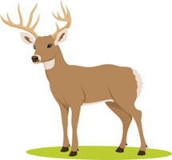

Ôwdi Nolka
(on-oo-dee nol-kah)

Deer Trail

Ôwdi Nolka
(on-oo-dee nol-kah)

Interpretive Sign Example

Maahlakws (ma-ala-cous) - Ash Tree
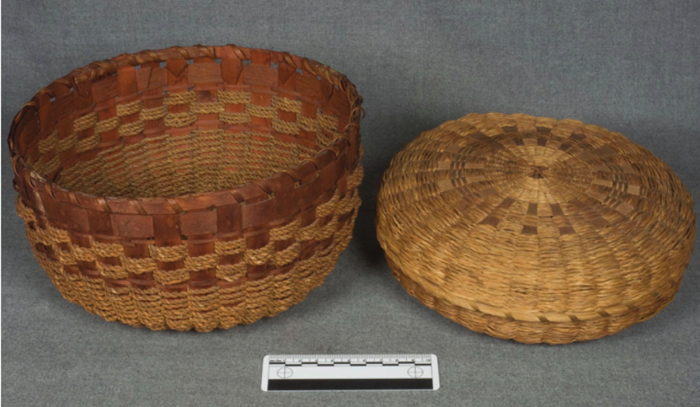

"Gloosekap came first of all into this country, into the land of the Wabanaki, next to the sunrise. There were no Indians here then. And in this way he made men: He took his bow and arrows and shot at trees, the basket trees, the ash. Then Indians came out of the bark of the ash trees.”

-Wabanaki creation story told by Molly Sepsis, published in Algonquin Legends by Charles G. Leland
Baskets are a fundamental part of the culture and traditions of the Wabanaki, who believe that basket making is a skill that has been passed from weaver to weaver, generation to generation, uninterrupted for thousands of years.
The Wabanaki made splint baskets of specific shapes and sizes to gather and prepare food and trap fish, both before and after European contact. Post-contact, many tribal people used basket making as a way to make a living outside of non-native towns and cities.
Wabanaki baskets are made primarily from long, thin strips of wood, or splints, of the brown ash tree. Known as the “basket tree,” the brown ash is considered sacred to many of the native peoples of the northeastern United States and Canada. The wood of the ash tree is also both strong and flexible, making it particularly well suited for weaving durable containers.
The emerald ash borer critically threatens the long-term survival of ash trees today.
Sources:

Mundell, Kathleen. North by Northeast: Wabanaki, Akwesasne Mohawk, and Tuscarora Traditional Arts. Tilbury House Publishers, 2008. Print. (page 29)
(from https://dawnlandvoices.org/collections/exhibits/show/along-the-basket-trail/overview)

“Essay: Wabanaki Basket Weaving.” Hood Museum of Art, Dartmouth College. (from https://www.naaer.hoodmuseum.dartmouth.edu/essay-wabanaki-basket-weaving)
Sample images may be copyright protected.

References

Bruchac, Jesse. “Pronunciation of Ndakinna.” Middlebury College. https://www.middlebury.edu/about/land-acknowledgement/-pronunciation-of-ndakinna-

Calloway, Colin G. The Western Abenakis of Vermont, 1600-1800: War, Migration, and the Survival of an Indian People. University of Oklahoma Press. 1990.

Doherty, Prudence et al. “Phase 1 and 2 Archaeological Studies, Richmond BRZ 1445(18).” Consulting Archaeology Program, University of Vermont, Report No. 137. February 1996.

Thomas, Peter A. et al. “Archaeological Site Identification, Evaluation and Mitigation of VT-CH-619 for Richmond TH 2407.” Consulting Archaeology Program, University of Vermont, Report No. 135. December 1995.

Wiseman, Frederick Matthew. The Voice of the Dawn: An Autohistory of the Abenaki Nation. UPNE 2001.

Western Abenaki language videos: http://westernabenaki.com/videos.php
The ACF for People and Wildlife:
Conserving Ecological Integrity; Expanding Recreational Uses and Enjoyment

Meeting Community Interests and Responsibilities
The Andrews Community Forest has long offered many benefits to Richmond residents and visitors. For millennia it has provided food, shelter and other vital needs for local populations of people and wildlife alike.

Today the ACF’s rich resources continue serving our population’s health, safety, recreational, educational, aesthetic and other interests in many ways, and in keeping with key responsibilities of our town:
- The ACF Conservation Easement specifically requires the Town of Richmond to “provide for non-motorized, non-commercial recreational, educational and other appropriate community uses” within the ACF.
- The Easement also requires the Town to “conserve productive forestland, wildlife habitat, biological diversity, natural communities, riparian buffers, wetlands, soil productivity, water quality and native flora and fauna…and the ecological processes that sustain these natural resource values…”
- The 2026 Richmond Town Plan calls for using “best management practices” to “Protect natural communities such as wetlands, streams, native species, soil health, and ecological processes on town-owned land” as we also “support opportunities for outdoor recreation.”

These equivalent responsibilities reflect Richmond's long-standing commitment to both land conservation and outdoor recreation. For generations, Richmond residents have valued access to natural areas for hiking, hunting, wildlife observation, and other outdoor pursuits. These activities support physical and mental health, build community connections, and foster environmental stewardship. The Andrews family's tradition of welcoming the public onto their land, ultimately formalized through the conservation easement, recognizes these activities as community benefits to be actively provided and sustained.

Achieving Balance
The ACF was conserved with two key purposes: to protect ecological integrity and to provide recreational opportunities to the community. The conservation easement explicitly requires both, reflecting the community's recognition that a healthy forest and meaningful public access can be complementary, not competing, values. To achieve this, the Town has sought, largely through the ACFC, a clear understanding of these responsibilities and how each can be achieved in concert with the other.

For example, early in the process the Town surveyed town residents to learn their preferences for allowed activities in the ACF. The ten most favored, in order of preference, were hiking, running, hunting, snowshoeing, skiing, bird- and wildlife-watching, picnicking, biking and dog-walking. Later input focused on expanding mountain biking use in the ACF, including building connections to abutting trail systems.

Recreational trails are a well-established, much-loved part of the Vermont landscape. The oldest long-distance trail in the U.S. is Vermont’s Long Trail, running 272 miles from Massachusetts to Quebec. For decades in Richmond, the Andrews family welcomed hunters, hikers and snowmobilers through their land to what is now the ACF, ultimately signing a conservation easement guaranteeing public recreational access to the forest in perpetuity along with strong ecological protections. This commitment reflected a broader Richmond value: that access to and protections for natural areas supports community wellbeing.

The many benefits that recreational trails bring to people’s physical and mental health and relaxation are widely documented. In Richmond, these benefits are evident in the families who hike together on weekends, the bikers who use trails for thrills and stress relief, and the nature enthusiasts who find solace and inspiration in the forest. Trails can also bring economic gains to the local economy when residents buy equipment at local outdoor gear stores and visitors stop for gas, meals and refreshments in town businesses.

In step with national and global trends, trail visitations are booming in Richmond, as evidenced by the bike rack-equipped cars that can be seen parked near popular trails all around town. Apps like Trail Finder and Trailforks map more than 100 miles of trails in Richmond and surrounding towns – single use, multi-use, and for people with physical disabilities. Work is underway on building the Velomont trail network, planned to run the length of Vermont, including in or near Richmond, and optimized for mountain biking.

This growing enthusiasm for outdoor recreation creates both opportunities and responsibilities. The ACF can serve as a destination for diverse forest experiences while also demonstrating how thoughtful management can sustain both recreational access and ecological health for future generations.

Residents also expressed concern about the impacts new types and intensities of trail traffic would have on forest ecology and recreational enjoyment alike. This concern is borne out in research studies and meta-studies, including in Vermont.

Through this process, today we know much more about the ACF and residents’ desires than we did in 2018, when the forest was conserved. Originally, our knowledge of the ACF’s ecology was limited to expert but relatively brief ecological surveys conducted by Vermont Land Trust, Audubon Vermont, and a five-town inventory project called “Science to Action.” Since then, the ACF’s ecological resources have been further documented, detailed and studied by the UVM Field Naturalist Program, Arrowwood Environmental and several botanists, wildlife biologists and naturalists. Vermont Conservation Design, the State framework for conserving biodiversity across Vermont, gives ACF multiple “priority” and “high-priority” designations for its conservation values, including interior areas, natural communities, wildlife habitats and connectivity features. The ACF Management Plan draws upon the large bank of research – much of which was not available when the ACF’s first management plan was published – describing how to avoid the conflicts and negative impacts that even seemingly benign human activities can bring to the forest and its users and inhabitants.

For example, the Management Plan designates two distinct and complementary management areas within the ACF. Described in more detail below. Each has its own focus and yet together they help to ensure the long-term conservation of the features that give the ACF such tremendous value to our community and beyond.

A Comprehensive View
As a practical and effective way to safeguard a parcel’s ecological integrity and functions, Vermont’s Agency of Natural Resources recommends that forest managers avoid taking a species-by-species approach to conservation. Instead, it urges protection of those elements of the broad landscape that sustain multiple species in myriad ways.

To quote the Agency’s guide to this topic, “focusing conservation planning efforts on these elements will effectively address many of the public interests associated with the natural environment.” To ensure conservation of the complex web of plants, animals, places and other elements that comprise a healthy forest – all the while serving a suite of public interests such as education, forestry and recreation – this Management Plan looks at the components of ACF’s ecological health at three levels: landscape, community and species.

Landscape-Level Elements
Contiguous Forest
One of the most outstanding features of the Andrews Community Forest is what it lacks – roads, buildings, driveways, agricultural land and other forms of development and disturbance. Because of the integrity of the ACF and its contiguity with other largely undisturbed forest tracts, the State of Vermont’s Vermont Conservation Design designates nearly all of the ACF’s as a “High Priority” area for interior forest conservation.

This reflects the importance of the ACF and other large expanses of intact forest in supporting the biological requirements of many native plants and animals, including those sensitive to human disturbance. They create the large, intact landscapes critical to the continuing survival of Vermont’s widest ranging animals, species such as black bear, bobcat, moose and others known to frequent the ACF. They serve the needs of interior-nesting birds, who in a more open or disturbed landscape could suffer excessive predation. The ACF provides them and other wildlife with vital feeding habitat and space to roam, find mates and promote genetic diversity.

Contiguous interior forests like the ACF also buffer species against the negative consequences of forest fragmentation, climate change and human disturbances elsewhere. They give wildlife new places where they can thrive, should previous territory become untenable.

Habitat Connectivity
The ACF Conservation Easement notes the ACF’s location in an area “important for regional landscape connectivity.” The State of Vermont recently bolstered this assessment by assigning “Priority” conservation status to much of the ACF for its connectivity features, primarily its northern area. Along with neighboring forests, ecologists recognized the ACF for its contributions to plant and wildlife connectivity across Vermont and into adjacent states and Quebec.

As such, the ACF assists bear, bobcat, moose, turkey and others in moving from place to place to meet season-by-season and other survival needs. Connectivity and contiguity combine to foster species intermixing and breeding, making for healthier populations across the landscape. And as climate change continues, the ACF is another link in enabling animals to adjust their ranges in response to warmer weather advancing northward.

Enduring Elements
The ACF’s enduring features are those that resist change, even over millennia, and play fundamental, long-standing roles in shaping and sustaining the landscape. For example, south-facing slopes created millions of years ago host different sets of flora and fauna than those with less exposure to sunlight. Minerals and seeps in the ACF’s rocky ledges nurture plant communities unique from those found in looser, lower elevation soils. Crevices in rocky terrain shelter far-ranging mammals from bobcats to bats.

Bedrock and surficial geology
The ACF spans lowland and high elevation terrain, with its bedrock geology generally split on a north-to-south line. Both help account for the forest’s biodiversity. In the southern areas, the meltwaters of glacial Lake Vermont deposited sand, gravel and clay formations. Above, the soil is built upon formations primarily of Underhill and Pinnacle bedrock 500 or more million years old.

Underhill bedrock dominates the forest from its northernmost point to its western edge. Along with the neighboring Pinnacle bedrock, it has dense, metamorphic, sedimentary rocks with visible cracks and fractures. Underhill’s more distinctive silvery-green rocks combine phyllite and schist, with the minerals chlorite, muscovite, and quartz.

To the east, the Pinnacle Formation features finer-grained, gray-to-buff schistose greywacke rock. Its layers show the formation’s metamorphic origins from bits of rock, mud, and debris. The minerals present are quartz, sericite, biotite, and chlorite.

The maps below are included as planning references to highlight areas where trail construction may require greater care or design considerations, and are intended to inform, not determine management decisions.
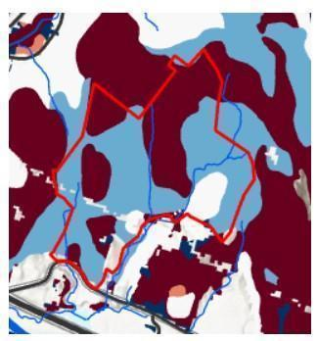
The ACF’s soil suitability for trail construction, from a study classifying soils in the Northeastern U.S. based on their susceptibility to erosion and compaction. On a scale of 1 to 5, the dark areas rank 5 as the least suitable. Blue areas rank 2 and white rank 3.

Over the eons, wind, water and glaciers deposited loose materials across the ACF, which combined with glacial till – boulders, stones, pebbles and fine silt deposited by glaciers at the end of the last ice age, about 14,000 years ago. Soil particles deposited by post-glacial Lake Vermont can be found on roughly half of the ACF’s elevation range, up to 600 feet.

Elevation
The ACF rises from an elevation of about 400 feet above sea level at the parking lot to 1,240 feet along its northern ridgeline. This gives it the greatest elevation range among conserved properties in Richmond, with soil and temperature diversity to match. In contrast, most of Vermont’s conserved land lies above 2,000 feet, where biodiversity is the least. Protecting the ecological functioning of lower areas like the ACF is important to conserving local and state-wide biodiversity.

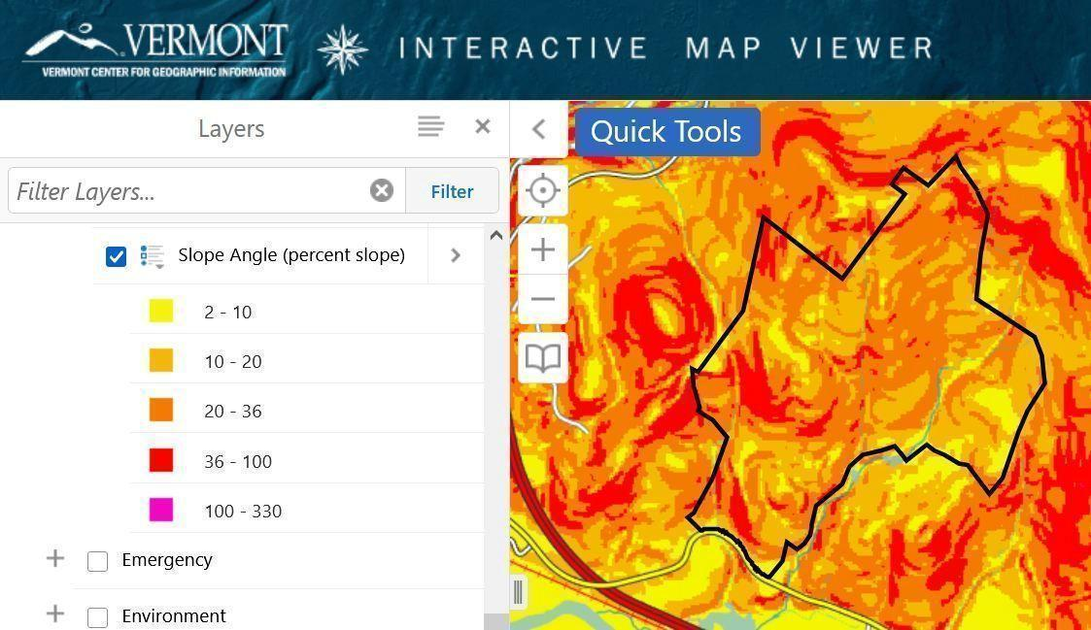

Terrain slopes, color-coded according to steepness ranging from yellow to red, highlight the ACF’s rugged terrain and susceptibility to erosion and washouts, particularly as warmer weather brings more intense rain.

Climate
Though today our climate appears to be in a period of unprecedented rapid change, a forest’s climate is also considered to be another enduring element. The ACF is part of the Northern Green Mountains biophysical region, which is cooler and wetter than other portions of the State. However, life in the ACF is also influenced by its proximity to the warmer Champlain Valley biophysical region as well as its south-facing slopes. The result is a forest dominated by tree species adapted to warm, dry sites – with poorer soils on upper elevations, and slightly richer forest soils on lower elevations (thanks to the glacial deposits).

Community-Level Elements
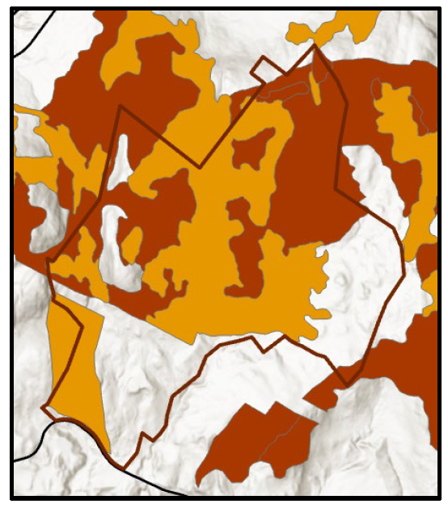


The ACF’s natural community areas, mostly clustered above the powerline corridor and former VAST trail, are rated “Highest Priority” and “Priority” on BioFinder by Vermont Conservation Design.

A natural community is an interacting assemblage of plants and animals, their physical environment, and the natural processes that affect them. While named for their dominant plants, natural communities encompass distinct mixes of mutually dependent plants and animals from fungi and microbes to mammals and trees, along with their settings amidst particular soils, bedrock, and ecological processes.

To date 97 types of natural communities have been found across Vermont. The ACF has at least 10, ranging from small patches of wetland seeps to a multi-hundred-acre stand of Northern Hardwood Forest and its Mesic Red Oak, White Pine and Hemlock associated communities.

Conserving the ACF’s natural communities offers a practical way to understand and maintain the Forest’s biodiversity. Otherwise, we would be faced with the task of trying to conserve tens of thousands of individual species.

Upland Natural Communities
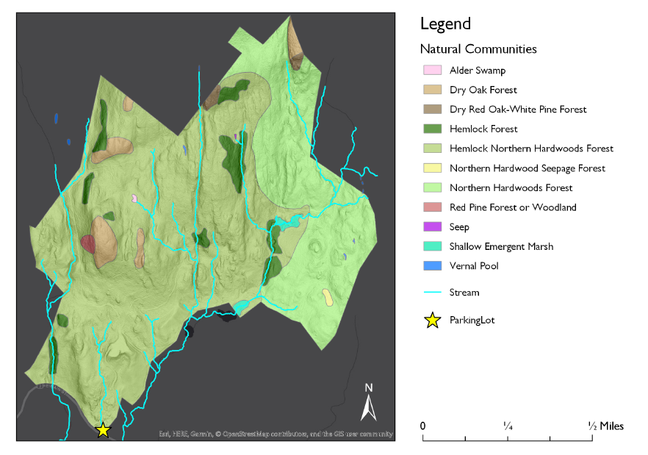
The ACF’s natural communities. Source: UVM Field Naturalist Program

Three upland natural communities comprise most of the forest: Mesic Red Oak-Northern Hardwood Forest, White Pine-Northern Hardwood Forest.
- The White Pine-Northern Hardwood Forest community occupies much of the southern portion of the forest, indicative of areas formerly in pasture or cultivated.
- In the northern part of the forest, roughly north of the VELCO transmission line, the Mesic Red Oak-Northern Hardwood community dominates, extending well beyond the ACF’s borders into the surrounding forest block. These are uncommon community types, occupying the Forest’s droughty ridges and south-facing summits and featuring shallow soils and frequent bedrock outcrops. The small size of these stands makes them especially vulnerable to disturbances. As diseases claim the Forest’s few remaining sources of beechnuts and butternuts, Dry Oak acorns will become even more critical food sources for black bears, wild turkeys, coyotes, corvids and other species.
- Several patches of Hemlock-Northern Hardwood Forest provide deer and dozens of other species with vital wintertime shelter and deep, cooling summertime shade on secluded, south-facing slopes throughout the Forest.

Wetland Natural Communities
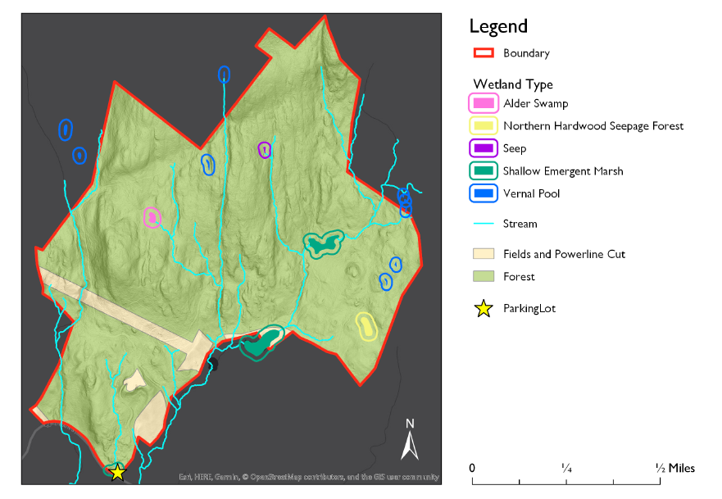
Streams and wetlands of the ACF. Solid color indicates actual location and size of wetland feature. Colored rings have been added to highlight location and have no other descriptive purpose. Source: UVM Field Naturalist Program.

Though the ACF is primarily a landscape of upland natural communities, wetland communities can be found in low areas, narrow benches and areas of groundwater discharge. Though their total acreage is relatively small, rarity in the ACF makes them much more important.
- Two of the ACF’s three Shallow Emergent Marsh communities are on its southern border and continue off-property. Each is a beaver-influenced wetland with a diverse mixture of open water, herbaceous vegetation, and occasional shrubs. The northern marsh sits in a scenic low area surrounded by upland forests. These marshes are significant for a wide range of functions and values including water quality, erosion control, and floodwater attenuation. Being part of a public, conserved parcel, they also offer opportunities for education and research.

Perhaps the most important function that they serve is that of wildlife habitat. The mosaic of open water and herbaceous vegetation in a forested matrix is ideal for a wide variety of songbirds, raptors, mammals, reptiles, and amphibians, especially as surrounding areas are kept relatively undisturbed by human activity.
- The ACF’s seeps are small, wet areas of groundwater discharge that often form the headwaters of streams. They are among the first areas in spring to thaw and grow vegetation, making them important food sources for black bears, American woodcock and other wildlife after winter’s privations. Certain amphibians thrive in woodland seeps, including northern dusky, northern two-lined, and spring salamanders. They are also important for providing a cold, clean source of water for wildlife and downslope streams, even in the driest summer months. Three seeps have been mapped to date in the ACF, but more are likely to exist. Their size and tree cover make them difficult to find using aerial and satellite photography, and direct field observation remains the best way to locate and assess them.
- Four Vernal Pools have been identified in the ACF to date, with two confirmed and described in the Baseline Report (Diamond, 2017) while two others await field confirmation. The two identified pools are likely to be state-significant examples of their natural community type. Each contained many hundreds of wood frog and spotted salamander eggs in what appeared to be a stable breeding habitat for these and many other species.

The surrounding upland landscape, though parts were harvested before the Town acquired ownership, provides valuable year-round habitat for the vernal pools’ breeding amphibians. This has earned the pools special protection in the Conservation Easement, which requires at least a 100’ undisturbed buffer around each pool. This is surrounded by a 500’ secondary protection zone where timber harvesting aimed at enhancing amphibian habitat is allowed. The Easement also allows foot paths in the outer, 500’ ring. The ACF Management Plan recognizes the local importance and sensitivity of these small but mighty contributors to the Forest’s biodiversity.

Streams and Riparian Areas

The Andrews Community Forest is located within the Winooski watershed. Water from forests, fields and streams runs off into the Winooski River, which flows into Lake Champlain. Surface waters on the property include wetland natural communities (described above), three headwater streams, and two confirmed vernal pools. Maintaining forested riparian cover adjacent to these resources is vital for the protection of water quality and conservation of important aquatic habitats.

Several streams arise on and meander through the property on their way to the Winooski River and, eventually, Lake Champlain and points north to the Atlantic Ocean. Streams may flow perennially or intermittently. The ACF has three perennial streams, including one identified by Arrowwood within the Forest’s major wildlife movement corridor.

Streams feature channels with defined beds and banks that confine low or moderate flows. Beginning at the tops of stream banks are riparian areas – typically undisturbed zones of trees, shrubs, ground cover plants, a duff layer, and an uneven ground surface.
Forested streamside riparian habitats such as those in the ACF offer a suite of ecological benefits. They:
- Anchor shorelines and limit streambank erosion
- Filter soil and silt from stormwater run-off, greatly reducing degradation of water quality from heavy rains.
- Provide plant and animal life with organic matter, nutrients, shade and coarse woody debris, sheltering and feeding insects, fish and amphibians.

Terrestrial food chains depend on streams and riparian areas as well. For example, their flowing waters create microclimates that often host the first plant life to emerge in the spring. Black bears will sometimes seek out these plants even while ice can still be found along the stream edges. Mink, fisher, bobcat and owls follow soon behind to seek out the frogs and salamanders endemic to these areas.

The ACF’s Conservation Easement contains strict protections for riparian areas to safeguard water quality even beyond the ACF’s borders. Due to their importance to many types of wildlife, this Management Plan recognizes the vulnerability of riparian areas and their broad far-ranging ecological functions to nearby human disturbances.
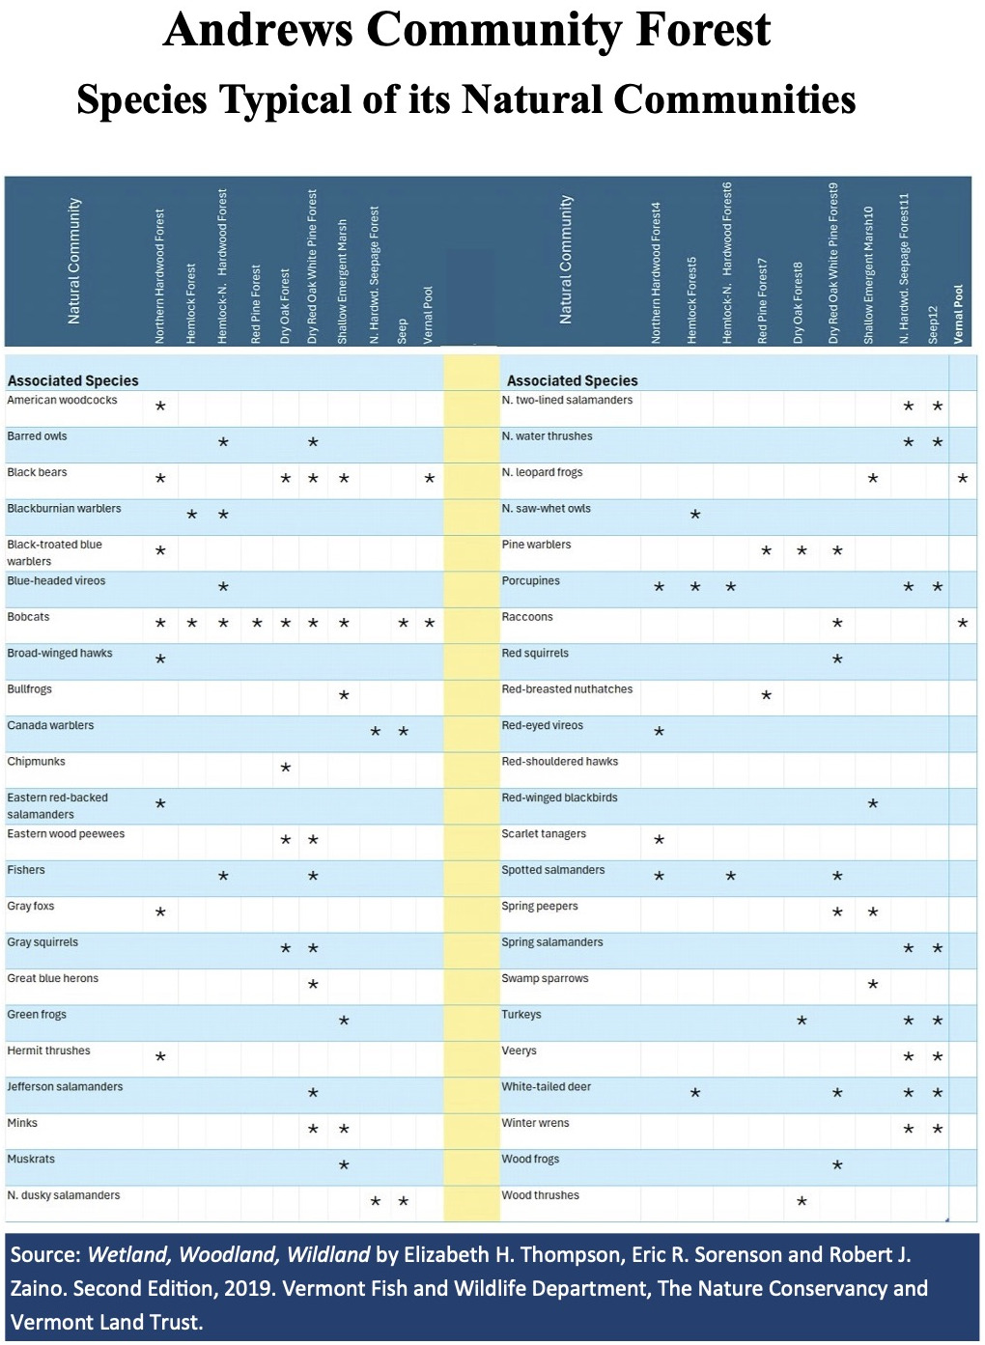

Species-Level Elements
Some features of a forest that are important to its ecological integrity and biodiversity do not fit neat classification into either landscape- or community-level classification. They are vital to the survival of certain species, and critical to include in any conservation plan.

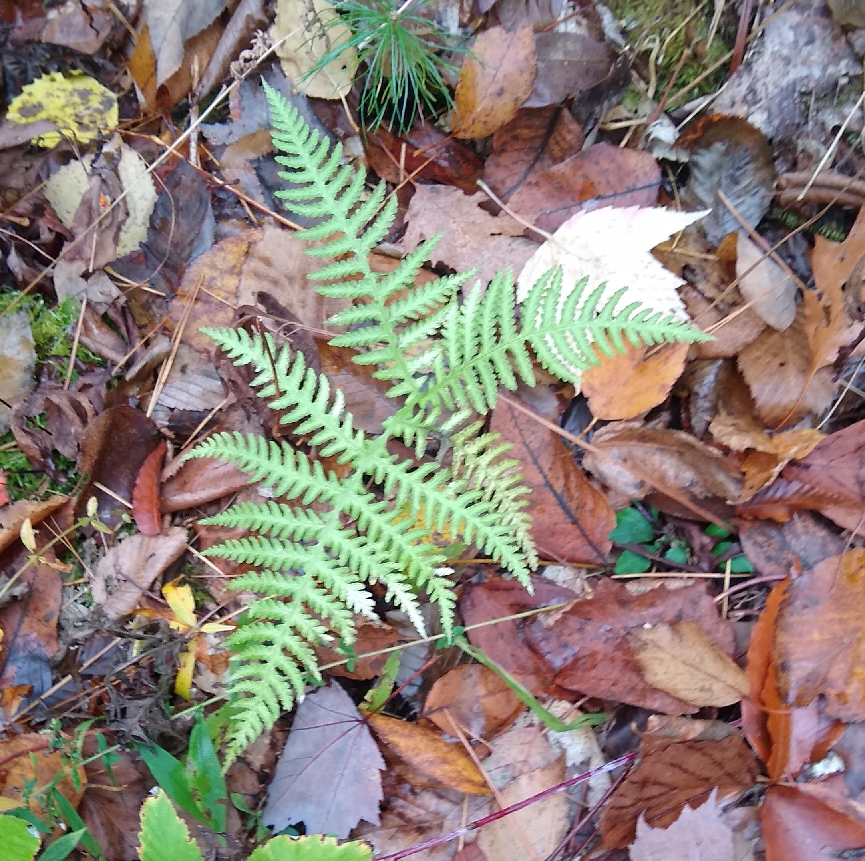
Rare, Threatened, and Endangered Species
To date only one such species, the broad-beech fern (left), has been found in the ACF. A patch of them was discovered during a fine-scale assessment of the proposed route for a new trail.
Bobcats, evidence of which has been found in several parts of the forest, are not considered rare, threatened or endangered, but are listed by the State of Vermont as a Species of Greatest Conservation Need. On a broader scale, they are on the list of Regional Species of Greatest Conservation Concern in the Northeastern U.S.
Protecting these wide-ranging species amounts to protecting forest contiguity and connectivity, and their need for wide-ranging, undisturbed
places and sheltered habitat to raise their young. (See Outcrops and Ledges, below.)

Wildlife Wintering Areas
Much of ACF is listed on state maps as “potential” whitetail deer wintering areas, due to the extent of the forest that faces south and is covered by thick stands of hemlock that ward off wind and heavy snow accumulations. East- and west-facing slopes can serve as wintering areas as well. To save energy when food is scarce, deer will often survive by congregating in these areas when snow reaches depths of 15 inches or more. These winter habitats also attract bobcat, coyote, and scavenging bear and fisher looking to scavenge weakened and dead deer. Other animals such as conifer-nesting birds, porcupines, and fox also utilize these habitats.

Mast Stands
The seeds of shrubs and trees that provide food for wildlife are known as “mast.” “Hard mast” refers to nuts such as acorns, beech nuts and butternuts, while “soft mast” is defined as berries from a variety of species. Hard mast provides high-calorie food for black bears, turkey, fisher and other wildlife, and soft mast such as blueberries and huckleberries are a particular favorite of black bears and birds alike.
As a food source for bears, Conserving Vermont’s Natural Heritage emphatically states in bold italics, “Simply put, these stands of beech and oak used by black bear are absolutely essential for the survival and reproduction of this species in Vermont!” It cites research by Elowe and Rogers that found a direct correlation between the availability of hard mast in the fall and the minimum reproductive age of bears, productivity rates and cub survival.

Black bears are ecologically important to the ACF and any large forest. By spreading seeds through their scat for dozens of square miles in their wanderings they are a key agent in forest regeneration and diversity. (Fishers are another.) However, beech stands in the ACF are suffering from fatal beech bark disease, along with other stands across the state. A newer, beech leaf disease is also spreading into our region. This greatly raises the importance of acorns as mast, which, to provide the same amount of nutrition, must be consumed in greater quantities than beech nuts.

Outcrops and Ledges
The ACF’s outcrops and ledges support a variety of natural communities and associated wildlife, depending on their geological composition and aspect. Their crevices can shelter porcupines, winter wrens, insects, bats and snakes. Bobcats favor ledges and small caves for courting, breeding and keeping their young safe from less-nimble predators. Evidence of bobcats in the ACF is not hard to come by, including, predictably, in the ledgy terrain below a Dry Oak natural community no doubt rich with squirrels, chipmunks and other prey. Beyond the ACF but well within bobcat range are known denning areas – among the westernmost of the ACF’s forest block.

Early Successional Forest and Shrubland
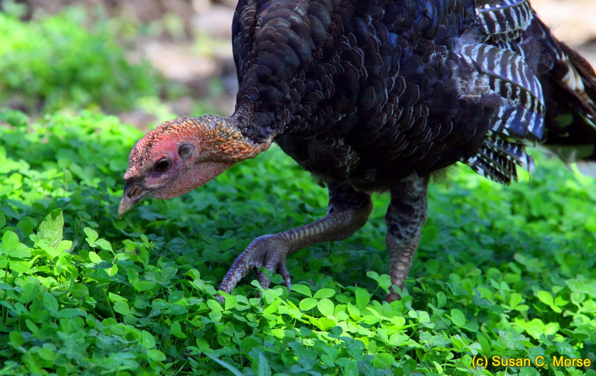
Healthy forests feature trees of a variety of edges, each providing their own ecological services to the landscape as a whole. Heavy cutting, such as was conducted decades ago in the ACF, can rob forests of this diversity. Fortunately, the ACF’s Forestry Plan is designed to restore this age diversity faster than wind, fire and disease would eventually accomplish on their own. Careful harvesting and patch cuts are designed to restore young forests and the food and other services they offer wildlife.

Among the beneficiaries are ruffed grouse, American woodcock, and scarlet tanagers – the latter which have entertained springtime birding groups in the ACF. Another significant area of such growth is found beneath the powerlines, where the utilities’ regular maintenance keeps tree heights down, although the methods and materials used may limit the results for some wildlife and ecological processes.

Wildlife Connectivity Corridors
The ACF’s permanent and intermittent streams and its riparian areas serve as safe, convenient and often food-rich routes for travel up, down and across the forest’s 800-foot elevation span. In unprotected forests the connectivity functions of such corridors are vulnerable to human disturbance or outright destruction, highlighting the importance of safeguarding the viability of those within the ACF.

New Perspectives
Beyond looking at the key functions and features of the ACF itself, the Committee considered a range of factors that had changed or come to light since the original, 2018 Management Plan was written, among them:
- The ACF’s ecological role and importance. Assessments by UVM, Arrowwood and others since the original plan was written confirm the ACF’s value for black bear, bobcat, whitetail deer, fisher and other wildlife, especially in the northern, least developed and visited areas of the forest.
- Early proposals for building several miles of new trails and associated bridges and boardwalks, some to connect the forest to trail systems on adjoining private land and to networks beyond.
- Advances in recreation. Growing interest in outdoor recreation reflects both national trends and Richmond residents' commitment to active, outdoor lifestyles. New technologies enable more efficient and fast-paced travel, enabling adventures deeper into the landscape. Trail apps like Trail Finder and Trailforks both increase access to natural areas and provide valuable tools for helping monitor and manage use to protect ecological resources and recreational experiences.
- New connections. Two of the three neighboring landowners with developed trail systems on their properties directly connect those systems to ACF trails.
- Continuing research showing wildlife’s sensitivity to trail traffic. Recently published scientific studies and literature reviews further explain how trail traffic can fragment, degrade and destroy productive wildlife habitats within “zones of influence” extending up to one thousand feet or more from the trails themselves.
- Limited space for sustainable trail development. Even buffering sensitive areas by the 330 feet recommended by a broad Vermont meta-study would block trail development in much of the ACF. The steepness, wetness and soil suitability of much of the ACF’s terrain is another concern, and could subject some trail development projects to state and local erosion control requirements.
- The Indigenous Land Acknowledgement. The Town of Richmond has pledged to foster a healthy forest community by incorporating into our management practices the traditional ecological knowledge that sustained our area’s forests for thousands of years. Pending Indigenous Land Acknowledgement and Uses appendix, Part 1
- Assessments of needs. As noted above, there are a number of trails available to the public within Richmond and its neighboring towns, most on private lands ACF hiking and biking trails directly connect to additional miles of trails on two neighboring properties – VYCC and Maple Wind Farm.

Protecting Forests While Welcoming Recreation
The ACF Management Plan’s approach to meaningfully protecting the forest and accommodating diverse, sustainable recreational and other community wishes centers on balancing ecological and recreational needs.

The Management Plan provides diverse, sustainable recreational opportunities including trails for varied abilities and interests, connections to neighboring trail networks, and experiences ranging from accessible family outings to backcountry adventures. These recreational goals are achieved through thoughtful design and management that sustain both the forest's ecological health and its capacity to serve the community.

The Management Plan establishes two distinct management zones, each based on its particular topography, sensitivities and accessibility:
- Southern Management Zone. This zone is designed to support a wide range of outdoor activities while following sustainable trail-building practices. This area allows for a higher density of trails, including those open to bicycles and other non-motorized uses, and is intended to accommodate a variety of user experiences including hiking, biking and nature exploration for people of a wide range of ages and abilities. Trails are constructed and monitored to minimize erosion and protect natural features, with careful attention to grade, drainage, and long-term maintenance. Route 2, the ACF parking lot and existing trail and utility road connections provide convenient access to this area (and also simplify trail construction and maintenance for the Town). This zone fulfills the easement's directive to provide meaningful recreational opportunities by offering trails for diverse users and abilities, welcoming forest experiences while concentrating higher-impact activities away from the most sensitive ecological areas.
- Northern Management Zone. Managed to prioritize conservation, this zone also maintains its tradition of providing hiking, hunting and other forms of low-impact, backcountry recreation. Following trail design best practices, this zone includes a limited number of simple footpaths, carefully routed to avoid sensitive ecological areas and minimize disruption to wildlife. , bicycles and mechanized uses are not permitted, helping to maintain a quiet, secluded environment that supports habitat preservation and nature observation.

Throughout the ACF, the Management Plan applies a variety of measures to mitigate impacts on both the forest’s wildlife and people wanting to experience its diverse recreational opportunities, particularly the mountain biking community. These measures include:
- Clear parameters. The Management Plan’s parameters for new trail approvals and construction are designed to clarify and expedite those processes.
- Reduced buffering. The widest buffer zones around the ACF’s natural areas are significantly smaller than the minimums recommended in Vermont and New Hampshire wildlife agency publications To also allow for greater trail coverage, buffering for wetlands, streams and riparian areas is a third to a sixth less than for the ACF’s other sensitive areas.
- Seasonal scheduling. By adjusting trail openings and closures according to seasonal wildlife needs for food, shelter and breeding, more miles of trail can be kept available for human use at certain times of the year.
- Case-by-case flexibility: Allowances are made for new trails that might need to encroach on buffered areas by only a small amount.

Together, these measures reflect a balanced approach to forest management, honoring both ecological stewardship and public access. This helps the Town meet the full suite of its legal obligations under the Conservation Easement and align with Town Plan policies. It also provides the community with an expanded range of recreational opportunities balanced with lessened impacts on its most sensitive and vulnerable resources.

Special considerations
- Dogs. The rules for bringing dogs into the ACF are published on the ACF Committee’s web page. They draw on guidelines used at the Green Mountain Audubon Center in Huntington and other areas with special qualities and protective needs similar to the ACF’s. The rules reflect wildlife’s response to the sight and long-lingering scents of even the friendliest and most securely leashed dogs, which they will fear as predators. This can lead to abandoned dens, nests and habitats along with undue stress and exhaustion on the animals, and diminished chances of people being able to enjoy the sights and sounds of the ACF’s wildlife due to their abandonment of the landscape.
- Hunting. Benefits include control of the ACF’s deer population, important to restoring healthier diversities of age and species to the forest’s trees and understory. Hunters and non-hunters can share the landscape at any time of year. The ACFC urges each to take safety precautions such as wearing highly visible clothing and keeping dogs leashed. Citizens of recognized Abenaki tribes may obtain free hunting licenses from the state of Vermont. See the posted guidelines for the latest requirements and advice.
- Trapping. Due to safety hazards to visitors, pets and wildlife, trapping is not permitted in the ACF.
Snowmobiling. Previously the ACF contained a snowmobile trail that was part of the VAST trail network. Snowmobiling may be permitted to resume on the former VAST trail subject to a use contract ensuring compatibility with the ACF Conservation Easement and Management Plan. Motorized recreation is otherwise prohibited in the ACF.

References
Arrowwood Environmental. 2013. Science-to-Action: Four-Town Natural Resources Inventory. Towns of Bolton, Huntington, Jericho and Richmond. https://arrowwoodvt.com/sta/
Arrowwood Environmental. 2021. Andrews Community Forest, Ecological Trail Planning Project Summary Report. https://arrowwoodvt.com/acf/
Arrowwood Environmental. 2022. Andrews Community Forest. Ecological Trail Planning Process: Detailed Field Assessment in Area of Select Proposed Trail. https://www.richmondvt.gov/fileadmin/files/Andrews_Community_Forest/Meetings/ACF_Ecological_Trail_Design_Detailed_Field_Assessment_20221128.pdf
Arrowwood Environmental. 2018. Natural Resource Guidance Toolkit. Vermont Town Forest Recreation Planning.
Audubon Vermont and the Vermont Department of Forests, Parks, and Recreation. 2011. Silviculture with Birds in Mind: Options for Integrating Timber and Songbird Habitat Management in Northern Hardwood Stands in Vermont.
Austin, J; Alexander, C.; Marshall, E.; Hammond, F.; Shippee, J.; Thompson, E.; Vermont League of Cities and Towns. 2004. Conserving Vermont’s Natural Heritage: A Guide to Community-Based Planning for the Conservation of Vermont’s Fish, Wildlife, and Biological Diversity. Vermont Fish and Wildlife Department and Agency of Natural Resources. Waterbury, VT. http://vtfishandwildlife.com/sites/fishandwildlife/files/documents/Get%20Involved/Partner%20in%20Conservation/Conserving_Vermont's_Natural_Heritage.pdf
Barre Community Forest Management Plan Committee. (2013, 2 27). Barre Community Forest Community Forest Plan. Community Forest Plan for the Barre Community Forest. Vermont: Barre Town Selectboard.
Baas, J.; Dupler, K.; Smith, A.; Carnes, R. An assessment of non-consumptive recreation effects on wildlife: current and future research, management implications, and next steps. California Fish and Wildlife, Recreation Special Issue; 62-73; 2020. https://nrm.dfg.ca.gov/FileHandler.ashx?DocumentID=178954&inline
Bennington County Conservation District. 2016. Final Management Plan, The Greenberg Headwaters Park. Bennington, VT: Town of Bennington.
Degraaf, R.M. et al. 1992. New England Wildlife: Management of Forested Habitats. General Technical Report NE-144. Amherst, MA. U.S.D.A., Forest Service.
Dertien, J.; Larson, C.; Reed S. Recreation effects on wildlife: A review of potential quantitative thresholds. 2021. Nature Conservation 44: 51-68. https://natureconservation.pensoft.net/article/63270/
Diamond, A. 2017. Rapid Ecological Assessment of the Richmond Town Forest. Vermont Land Trust. Richmond, VT.
Forest Ecology Monitoring Cooperative. 2024. Forest Recreation Impacts on Dimensions of Northeast Regional Forest Health. https://www.uvm.edu/femc/CI4/file/info/12148
Hagenbach, Steve. 2017. Forest Bird Habitat Assessment: Richmond Town Forest/Andrews Forestland. Audubon Vermont. https://www.richmondvt.gov/fileadmin/files/Andrews_Community_Forest/General/2024/05/09_ACF_Forest_Bird_Habitat_Assessment_-_Audubon.pdf
Hawes, Ellen and Markelle Smith. 2005. Riparian Buffer Zones: Functions and Recommended Widths. Yale School of Forestry and Environmental Studies.
Morse, Susan. 2022. Letter to the Andrews Community Forest Committee. https://infoacf.wordpress.com/wp-content/uploads/2022/03/morse-letter-to-afc.pdf
Naughton, Meredith. 2021. Wildlife & Recreation: Understanding and Managing the Effects of Trail Use on Wildlife. Vermont Fish and Wildlife and Vermont Department of Forests, Parks and Recreation. Montpelier, Vermont. https://material-civet.files.svdcdn.com/production/images/documents/wildlife_and_recreation_-M_naughton_2021.pdf
New Hampshire Department of Fish and Game Department. Trails for People and Wildlife. https://www.wildlife.nh.gov/sites/g/files/ehbemt746/files/inline-documents/sonh/trails-for-people-wildlife.pdf
Northern Forest Alliance. Vermont Town Forest Stewardship Guide. https://fpr.vermont.gov/sites/fpr/files/Forest_and_Forestry/Community_Forests_and_Trees/Library/TownForestStewardshipGuide.pdf
Oehler, J. 2017. Impacts of recreational trails on wildlife. New Hampshire Fish and Game Department. Retrieved from https://share.google/d0mwODQWkb9NAEB85
Quinn, M. and Chernoff, G. Mountain Biking: A Review of the Ecological Effects. 2010. Miistakis Institute for Parks Canada, National Office. Alberta, Canada.
RJ Turner Company. 2008. Eaton Forest Management Plan. Bristol, Vermont: Town of Warren Conservation Commission. https://www.valleyreporter.com/index.php/news/local-news/1394-
Terwilliger Consulting, Inc. and the Northeast Fish and Wildlife Diversity Technical Committee. 2013. Taking Action Together: Northeast Regional Synthesis for State Wildlife Action Plans. https://www.northeastwildlifediversity.org/rsgcn
Thompson, E.; Sorenson, R.; Zaino, R. 2019. Wetland, Woodland, Wildlife: A Guide to the Natural Communities of Vermont, 2nd ed. Vermont Department of Fish & Wildlife, The Nature Conservancy and Vermont Land Trust. Montpelier, VT.
Town of Richmond Vermont. 2024. Andrews Community Forest Committee Bylaws. https://www.richmondvt.gov/fileadmin/files/Andrews_Community_Forest/General/2024/11/Appendix_D._Andrews_CFMC_-_Bylaws_-10-30-2018_VERS_-_amended_10-28-24_-_clean.pdf
Town of Richmond, Vermont. 2019, 2024. Andrews Community Forest Management Plan. https://www.richmondvt.gov/fileadmin/files/Andrews_Community_Forest/General/2024/06/management_plan_11-19-2018_-_Amended_5-6-24.pdf
Town of Richmond, Vermont. 2026 Town Plan. https://www.richmondvt.gov/fileadmin/files/Planning_Commission/4.0_-_TOWN_PLAN_2026_FOURTH-FINAL_DRAFT_EDITS_CLEAN_2.18.26.pdf
University of Vermont Field Naturalist Program, 2019. Landscape Analysis and Wildlife in the Andrews Community Forest, Richmond, Vermont. https://infoacf.files.wordpress.com/2022/11/andrews-community-forest-field-naturalist-report-jan.-2019.pdf
Vermont Agency of Natural Resources. Vermont Conservation Design Rankings of Andrews Community Forest and Surroundings. https://www.richmondvt.gov/fileadmin/files/Andrews_Community_Forest/General/2024/05/09_ACF_Forest_Bird_Habitat_Assessment_-_Audubon.pdf
Vermont Department of Fish and Wildlife. 2015. A Landowners Guide: Wildlife Habitat Management for Lands in Vermont. https://www.vtfishandwildlife.com/learn-more/landowner-resources/wildlife-habitat-management-a-landowners-guide
Vermont Department of Fish and Wildlife and the Agency of Natural Resources. 2004. Conserving Vermont’s Natural Heritage. A Guide to Community-Based Planning for the Conservation of Vermont’s Fish, Wildlife, and Biological Diversity. https://anr.vermont.gov/sites/anr/files/maps/biofinder/CVNH%202013_FINAL.pdf
Vermont Land Trust. 2018. Baseline Documentation Report: Andrews II Richmond Town Forest. https://www.richmondvt.gov/fileadmin/files/Andrews_Community_Forest/General/2024/05/08VLT_Baseline_Doc_and_Eco_Report__from_MP1_.pdf
Vermont Land Trust. 2018. Grant of Development Rights, Conservation Restrictions, and Public Access Easement, Andrews II – Richmond Town Forest Property. https://www.richmondvt.gov/fileadmin/files/Archive/2018/04/Conservation-Easement-2018.pdf
Vermont Urban and Community Forest Program. Vermont Town Forest Trail Design Guide. https://fpr.vermont.gov/anr/climatechange/sites/fpr/files/doc_library/FPR-VT-Town-Forest-trail-design-guide.pdf
Further Reading
Arrowwood Environmental. 2013. Science-to-Action: Four-Town Natural Resources Inventory. Towns of Bolton, Huntington, Jericho and Richmond. https://arrowwoodvt.com/sta/
Arrowwood Environmental. 2021. Andrews Community Forest, Ecological Trail Planning Project Summary Report. https://arrowwoodvt.com/acf/
Arrowwood Environmental. 2022. Andrews Community Forest. Ecological Trail Planning Process: Detailed Field Assessment in Area of Select Proposed Trail. https://www.richmondvt.gov/fileadmin/files/Andrews_Community_Forest/Meetings/ACF_Ecological_Trail_Design_Detailed_Field_Assessment_20221128.pdf
Arrowwood Environmental. 2018. Natural Resource Guidance Toolkit. Vermont Town Forest Recreation Planning.
Audubon Vermont and the Vermont Department of Forests, Parks, and Recreation. 2011. Silviculture with Birds in Mind: Options for Integrating Timber and Songbird Habitat Management in Northern Hardwood Stands in Vermont.
Austin, J; Alexander, C.; Marshall, E.; Hammond, F.; Shippee, J.; Thompson, E.; Vermont League of Cities and Towns. 2004. Conserving Vermont’s Natural Heritage: A Guide to Community-Based Planning for the Conservation of Vermont’s Fish, Wildlife, and Biological Diversity. Vermont Fish and Wildlife Department and Agency of Natural Resources. Waterbury, VT. http://vtfishandwildlife.com/sites/fishandwildlife/files/documents/Get%20Involved/Partner%20in%20Conservation/Conserving_Vermont's_Natural_Heritage.pdf
Barre Community Forest Management Plan Committee. (2013, 2 27). Barre Community Forest Community Forest Plan. Community Forest Plan for the Barre Community Forest. Vermont: Barre Town Selectboard.
Baas, J.; Dupler, K.; Smith, A.; Carnes, R. An assessment of non-consumptive recreation effects on wildlife: current and future research, management implications, and next steps. California Fish and Wildlife, Recreation Special Issue; 62-73; 2020. https://nrm.dfg.ca.gov/FileHandler.ashx?DocumentID=178954&inline
Bennington County Conservation District. 2016. Final Management Plan, The Greenberg Headwaters Park. Bennington, VT: Town of Bennington.
Cotnoir, Alexander W. (n.d.) An Abenaki History of Maple https://abenakitribe.org/maple-syrup. Chenevert, Brian. 2021. Maple sugaring among the Abenaki and Wabanaki Peoples. https://abenakitribe.org/maple-syrup
Cummings, Angus B. 2019. Farm to Forest: The Andrews Community Forest. University of Vermont senior thesis. Archived at: https://hdl.handle.net/20.500.14849/1520
Degraaf, R.M. et al. 1992. New England Wildlife: Management of Forested Habitats. General Technical Report NE-144. Amherst, MA. U.S.D.A., Forest Service.
Dertien, J.; Larson, C.; Reed S. Recreation effects on wildlife: A review of potential quantitative thresholds. 2021. Nature Conservation 44: 51-68. https://natureconservation.pensoft.net/article/63270/
Diamond, A. 2017. Rapid Ecological Assessment of the Richmond Town Forest. Vermont Land Trust. Richmond, VT.
Doherty, Prudence, Robert Florentin and Peter A. Thomas. 1996/Revised 1997. Phase I and II Archeological Studies Richmond BRZ 1445(18) Richmond, Vermont. Submitted to Vermont Agency of Transportation.
Forest Ecology Monitoring Cooperative. 2024. Forest Recreation Impacts on Dimensions of Northeast Regional Forest Health. https://www.uvm.edu/femc/CI4/file/info/12148
Hagenbach, Steve. 2017. Forest Bird Habitat Assessment: Richmond Town Forest/Andrews Forestland. Audubon Vermont. https://www.richmondvt.gov/fileadmin/files/Andrews_Community_Forest/General/2024/05/09_ACF_Forest_Bird_Habitat_Assessment_-_Audubon.pdf
Haviland, William A. and Marjory W. Power. 1994. The Original Vermonters: Native Inhabitants Past and Present. University of Vermont. Hanover and London: University Press of New England.
Hawes, Ellen and Markelle Smith. 2005. Riparian Buffer Zones: Functions and Recommended Widths. Yale School of Forestry and Environmental Studies.
Longstreth, Julie. 2007. Everett and Mary Jo Andrews’ Farm. in Riggs, H.W. et al. Richmond, Vermont: A History of More Than 200 Years. Richmond, VT: Richmond Historical Society. https://rfl.kohavt.org/Record/67654
Morse, Susan. 2022. Letter to the Andrews Community Forest Committee. https://infoacf.wordpress.com/wp-content/uploads/2022/03/morse-letter-to-afc.pdf
Naughton, Meredith. 2021. Wildlife & Recreation: Understanding and Managing the Effects of Trail Use on Wildlife. Vermont Fish and Wildlife and Vermont Department of Forests, Parks and Recreation. Montpelier, Vermont. https://material-civet.files.svdcdn.com/production/images/documents/wildlife_and_recreation_-M_naughton_2021.pdf
New Hampshire Department of Fish and Game Department. Trails for People and Wildlife. https://www.wildlife.nh.gov/sites/g/files/ehbemt746/files/inline-documents/sonh/trails-for-people-wildlife.pdf
Northern Forest Alliance. Vermont Town Forest Stewardship Guide. https://fpr.vermont.gov/sites/fpr/files/Forest_and_Forestry/Community_Forests_and_Trees/Library/TownForestStewardshipGuide.pdf
Oehler, J. 2017. Impacts of recreational trails on wildlife. New Hampshire Fish and Game Department. Retrieved from https://share.google/d0mwODQWkb9NAEB85
Quinn, M. and Chernoff, G. Mountain Biking: A Review of the Ecological Effects. 2010. Miistakis Institute for Parks Canada, National Office. Alberta, Canada.
RJ Turner Company. 2008. Eaton Forest Management Plan. Bristol, Vermont: Town of Warren Conservation Commission. https://www.valleyreporter.com/index.php/news/local-news/1394-
Terwilliger Consulting, Inc. and the Northeast Fish and Wildlife Diversity Technical Committee. 2013. Taking Action Together: Northeast Regional Synthesis for State Wildlife Action Plans. https://www.northeastwildlifediversity.org/rsgcn
Thomas, Peter A., 2007. Richmond’s ancient past, in Riggs, Harriet (ed). 2007. Richmond, Vermont: A History of More than 200 Years. Richmond Historical Society. Submitted to Vermont Agency of Transportation. https://rfl.kohavt.org/Record/186593
Thomas, Peter A., Robert Stone, Nanny Carder and Robert Florentin. 1995. Archaeological Site Identification Evaluation and Mitigation pf VT-CH-619 for Richmond TH 2407, Richmond, Chittenden County, Vermont.
Thompson, E.; Sorenson, R.; Zaino, R. 2019. Wetland, Woodland, Wildlife: A Guide to the Natural Communities of Vermont, 2nd ed. Vermont Department of Fish & Wildlife, The Nature Conservancy and Vermont Land Trust. Montpelier, VT.
Town of Richmond Vermont. 2024. Andrews Community Forest Committee Bylaws. https://www.richmondvt.gov/fileadmin/files/Andrews_Community_Forest/General/2024/11/Appendix_D._Andrews_CFMC_-_Bylaws_-10-30-2018_VERS_-_amended_10-28-24_-_clean.pdf
Town of Richmond, Vermont. 2019, 2024. Andrews Community Forest Management Plan. https://www.richmondvt.gov/fileadmin/files/Andrews_Community_Forest/General/2024/06/management_plan_11-19-2018_-_Amended_5-6-24.pdf
Town of Richmond, Vermont. 2026 Town Plan. https://www.richmondvt.gov/fileadmin/files/Planning_Commission/4.0_-_TOWN_PLAN_2026_FOURTH-FINAL_DRAFT_EDITS_CLEAN_2.18.26.pdf
UNESCO. 2010. Atlas of the world's languages in danger. https://unesdoc.unesco.org/ark:/48223/pf0000187026
University of Vermont Field Naturalist Program, 2019. Landscape Analysis and Wildlife in the Andrews Community Forest, Richmond, Vermont. https://infoacf.files.wordpress.com/2022/11/andrews-community-forest-field-naturalist-report-jan.-2019.pdf
Vermont Agency of Natural Resources. Vermont Conservation Design Rankings of Andrews Community Forest and Surroundings. https://www.richmondvt.gov/fileadmin/files/Andrews_Community_Forest/General/2024/05/09_ACF_Forest_Bird_Habitat_Assessment_-_Audubon.pdf
Vermont Department of Fish and Wildlife. 2015. A Landowners Guide: Wildlife Habitat Management for Lands in Vermont. https://www.vtfishandwildlife.com/learn-more/landowner-resources/wildlife-habitat-management-a-landowners-guide
Vermont Department of Fish and Wildlife and the Agency of Natural Resources. 2004. Conserving Vermont’s Natural Heritage. A Guide to Community-Based Planning for the Conservation of Vermont’s Fish, Wildlife, and Biological Diversity. https://anr.vermont.gov/sites/anr/files/maps/biofinder/CVNH%202013_FINAL.pdf
Vermont Land Trust. 2018. Baseline Documentation Report: Andrews II Richmond Town Forest. https://www.richmondvt.gov/fileadmin/files/Andrews_Community_Forest/General/2024/05/08VLT_Baseline_Doc_and_Eco_Report__from_MP1_.pdf
Vermont Land Trust. 2018. Grant of Development Rights, Conservation Restrictions, and Public Access Easement, Andrews II – Richmond Town Forest Property. https://www.richmondvt.gov/fileadmin/files/Archive/2018/04/Conservation-Easement-2018.pdf
Vermont Urban and Community Forest Program. Vermont Town Forest Trail Design Guide. https://fpr.vermont.gov/anr/climatechange/sites/fpr/files/doc_library/FPR-VT-Town-Forest-trail-design-guide.pdf
Wiseman, Frederick M. 1995a. Gift of the Forest: The Abenaki, Bark and Root. Abenaki Educational Series, Handbook No. 1. Vermont: Ethan Allen Homestead Trust.

https://www.richmondvt.gov/boards-meetings/andrews-community-forest
https://fpr.vermont.gov/sites/fpr/files/Forest_and_Forestry/Community_Forests_and_Trees/Library/TownForestStewardshipGuide.pdf
https://fpr.vermont.gov/anr/climatechange/sites/fpr/files/doc_library/FPR-VT-Town-Forest-trail-design-guide.pdf
https://vtfishandwildlife.com/conserve/vermont-conservation-design
https://anrmaps.vermont.gov/websites/BioFinder4
https://maps.vermont.gov/vcgi/html5viewer/?viewer=vtmapviewer
https://arrowwoodvt.com/sta/
https://infoacf.wordpress.com/wp-content/uploads/2022/05/acf-report-ecological-trail-design.pdf
https://infoacf.files.wordpress.com/2022/11/andrews-community-forest-field-naturalist-report-jan.-2019.pdf
https://www.richmondvt.gov/fileadmin/files/Archive/2018/04/Conservation-Easement-2018.pdf
https://www.richmondvt.gov/fileadmin/files/Planning_Commission/RICHMOND_TOWN_PLAN_2026_APPROVED_3.3.26.pdf
Typical ecological processes for a Vermont forest include succession, carbon sequestration, natural disturbances, and the interaction of biotic (organisms) and abiotic (climate and soil) factors, all contributing to a dynamic and resilient ecosystem.
https://www.richmondvt.gov/fileadmin/files/Andrews_Community_Forest/General/2024/11/Appendix_D._Andrews_CFMC_-_Bylaws_-10-30-2018_VERS_-_amended_10-28-24_-_clean.pdf
https://www.richmondvt.gov/fileadmin/files/Andrews_Community_Forest/General/2024/05/13MP1_Plan_Only.pdf
https://www.richmondvt.gov/fileadmin/files/Andrews_Community_Forest/General/2024/05/14ACF_Management_Plan_Appendicescompress.pdf
https://www.richmondvt.gov/fileadmin/files/Archive/2018/04/Conservation-Easement-2018.pdf
Working Definition of Traditional Ecological Knowledge (US Fish & Wildlife Service: https://www.fws.gov/nativeamerican/pdf/tek-fact-sheet.pdf) Traditional Ecological Knowledge, also called by other names including Indigenous Knowledge or Native Science, (hereafter, TEK) refers to the evolving knowledge acquired by Indigenous and local peoples over hundreds or thousands of years through direct contact with the environment. This knowledge is specific to a location and includes the relationships between plants, animals, natural phenomena, landscapes and timing of events that are used for lifeways, including but not limited to hunting, fishing, trapping, agriculture, and forestry. TEK is an accumulating body of knowledge, practice, and belief, evolving by adaptive processes and handed down through generations by cultural transmission, about the relationship of living beings (human and non-human) with one another and with the environment. It encompasses the world view of Indigenous people which includes ecology, spirituality, human and animal relationships, and more.
Visioning Process Results (2017) in 2018 ACF Management Plan, page 279
Naughton, New Hampshire Fish & Game Department.
Austin, J; Alexander, C.; Marshall, E.;, Hammond, F.; Shippee, J.; Thompson, E.; Vermont League of Cities and Towns. 2004. Conserving Vermont’s Natural Heritage: A Guide to Community-Based Planning for the Conservation of Vermont’s Fish, Wildlife, and Biological Diversity. Vermont Fish and Wildlife Department and Agency of Natural Resources. Waterbury, VT.
Forest Ecology Monitoring Cooperative. 2024. Forest Recreation Impacts on Dimensions of Northeast Regional Forest Health, pp. 11-12. https://www.uvm.edu/femc/CI4/attachments/project/999/RecreationImpacts.pdf.
Vermont Interactive Map Viewer. Parcels, Elevation/Slope Angle. https://maps.vermont.gov/vcgi/html5viewer/?viewer=vtmapviewer
https://anrmaps.vermont.gov/websites/BioFinder4/
University of Vermont Field Naturalist Program, 2019. Landscape Analysis and Wildlife in the Andrews Community Forest, Richmond, Vermont. October, 2018. Page 14. https://infoacf.files.wordpress.com/2022/11/andrews-community-forest-field-naturalist-report-jan.-2019.pdf
University of Vermont Field Naturalist Program, 2019. Landscape Analysis and Wildlife in the Andrews Community Forest, Richmond, Vermont. October, 2018. Page 16. https://infoacf.files.wordpress.com/2022/11/andrews-community-forest-field-naturalist-report-jan.-2019.pdf
Terwilliger, 2013
Austin et. Al. P. 89
Morse. 2023.
- Naughton, New Hampshire Fish & Gamer

