
Town of Richmond
203 Bridge Street, P.O. Box 285
Richmond, VT 05477
www.richmondvt.gov

Development Review Board
August 12, 2026, Meeting Minutes

Members Present: Matt Dyer (Chair), Bob DiPalma (Vice-Chair), & Padraic Monks.
Members Absent: Matt Parisi.
Staff: Danté DeNault (Zoning Administrator & E911 Coordinator).
Public Attendance: Doreen Marquis (Item 3 Applicant), Michael Parent (Item 2 Property Owner or Authorized Representative), Lisa Bresler (Item 2 Co-Applicant), Kerry Walker (Item 2 Co-Applicant), Peter Cahill (Item 1 Applicant), Karl Marchessault (Item 3 Engineer), and Chelsye Brooks (Jericho Road Resident and Planning Commission Member).

Summary

The Richmond Development Review Board (DRB) met, as warned, to discuss the four (4) following agenda items. A full recording of this meeting can be viewed on MMCTV’s YouTube channel. And all related meeting materials are archived on the DRB’s webpage. The Board also considered dates and times for future legal training on permit amendments and appeals.

Agenda Item # 1: SP2026-003-A. Applicant = Peter Cahill. Parcel ID: EM0010.
- Continued hearing from July 8, 2026.
- DRB Vice-Chair DiPalma did not anticipate any conflicts in this matter. He filled out and submitted a Disclosure of Conflict-of-Interest form to support his decision to participate. No other Board members or members from the public had concerns with the vice-chair’s decision to participate. The submitted Disclosure is appended to this document. See Appendix, Disclosure of Conflict of Interest as Required by the VT Code of Ethics.
- Applicant Pete Cahill (d/b/a Cahill Mountain Properties) talked about the proposed façade change amendments to the Greensea building at 10 East Main Street.
- The front brick wall was determined to be unsalvageable; hence, the amended façade.
- The proposed material to cover the brick wall will be Corten steel.
  - The restored brick would be noticeable
  - Applicant noted that Corten steel exists around Town at the Creamery building.
- Also proposed are new black metal railings and black trim.
  - Applicant noted that the bakery on Bridge Street, Sweet Simones, also has black trim.
- The final change will be to the existing Hardie board siding, which will be painted navy blue.
  - The navy blue matches the color of the building’s tenant, Greensea Systems Inc.
- Conclusion. The Board voted (3-0) to APPROVE the application as proposed.

Agenda Item # 2: CU2026-004. Applicant = Lisa Bresler & Kerry Walker. Parcel ID: BR0052.
- Applicants Lisa Bresler, Kerry Walker, and Mike Parent presented on this application.
- Applicants proposed a commercial multi-use building at 6 Depot Street (Parcel ID BR0052).
- Historically, one business—the Richmond Home Supply—existed at the Depot Street storefront.
- Now, Applicants propose to have two businesses exist in the space. The first business is Wild at heART. It is a retail art store and community engagement space. The second business is Balance Yoga. It features services for yoga, wellness, and massage therapy.
- Discussion was had on use classification, including uses for commercial multi-use buildings, personal services, retail business, recreational facilities, and fitness facilities.
- Conversation was had on parking. Applicants noted that drivers often drive the wrong way down Depot Street. They also explained that existing short-term parking spaces on Depot Street (both 15-minute and 2-hour) are rarely enforced, if at all.
  - Applicants noted that Richmond does not have a parking issue, the Town has a walking issue. It was reported that employees park close to work, not leaving open spaces for customers or patrons.
- Conclusion. The Board voted (3-0) to APPROVE this application as presented, with the proposed use falling under the definition of commercial multi-use building under the Zoning Regulations and therefore the proposed use is allowable in this Zoning District as a conditional use.

Agenda Item # 3: SB2026-002. Applicants = Bob & Doreen Marquis. Parcel ID: HU0595.
- Applicant Doreen Marquis and engineer Karl Marchessault presented on this final subdivision application.
- Not much changed from preliminary approval except for the justification of drainage features with hydrological modeling and certification that there will be no undue drainage caused on downhill Town infrastructure.
- A State WW permit was recently obtained for the subdivided lot proposed.
- Applicant’s engineer explained the hydrologic modeling for up to a 100-year storm, even if Richmond’s standards are only for a 25-year storm.
- With recent flooding events, neither the landowners experienced driveway washout nor did the Town’s road culvert fail.
  - The Town’s Highway Foreman, Pete Gosselin, noted that the Town’s culvert under Huntington Road has not recently failed and is not expected or anticipated to fail anytime soon. This was in contrast to other crossings up hill where the culverts failed and washed out over the past few years, particularly during extreme rain events.
- Conclusion. The Board voted (3-0) to APPROVE the application as proposed.

Agenda Item # 4: SK2026-002. Applicants = Matt Dyer & Heather Chadwick. Parcel ID: EM0617.
- Matt Dyer recused himself as chair on this voluntary sketch plan application because he is the applicant. Bob DiPalma took over as acting chair for this agenda item only.
- Discussion was had on Applicants proposed 2-lot subdivision.
- Preliminary plans were reviewed, the lot to be subdivided abuts the road.
- Applicant noted that the proposed subdivision will create an interior lot with no frontage, triggering the need for an easement or right-of-way.
  - Applicant noted that this legal requirement to reserve the easement will be captured in a draft deed.
  - DRB Vice-Chair DiPalma noted that the driveway maintenance agreement may want to be left out of the deed and captured instead in a separate, standalone document.
- A State WW permit will be pulled.
- Applicant asked the DRB if stormwater and drainage would be a potential concern.
  - Discussion was had on when to calculate or determine if the increased impervious associated with a future house site would cause or create any undue drainage or increase expenditure of public funds.
  - Additional discussion was conducted on the type of proof needed to show that drainage and stormwater are accounted for.
    - Ideally, hydrologic modeling will prove satisfaction with the subdivision drainage standards.
    - A narrative or cover letter from the engineer could also be used to show satisfaction with applicable standards.
  - Applicant will depict the new, replaced culvert under Route Two on both the proposed Plat and Plans.
    - Applicant may get additional information or provide further testimony to speak to the adequacy and capacity of the existing culvert under Route Two.
- DRB Member Monks noted that the Applicant should denote on the site plan, not the plat, that this subdivision is a master development plan.
- Applicant discussed the procedure for requesting a combined subdivision hearing and asked what it would take for the Board to entertain a waiver to such requirement.
  - It was determined that a waiver could be granted to the subdivision two-step, consisting of preliminary then final approval.
  - It was discussed that holding a preliminary subdivision hearing then a final subdivision hearing may cause public notice issues.
- Jericho Road Resident and Planning Commission Member Cheslye Brooks asked about the access width for emergency service vehicles to pass one another.
  - Applicant explained the existing conditions of the driveway and access, including built features for fire access.
- Conclusion. No decision was made because this sketch plan review was a voluntary, non-binding discussion on the Applicant.
APPENDIX
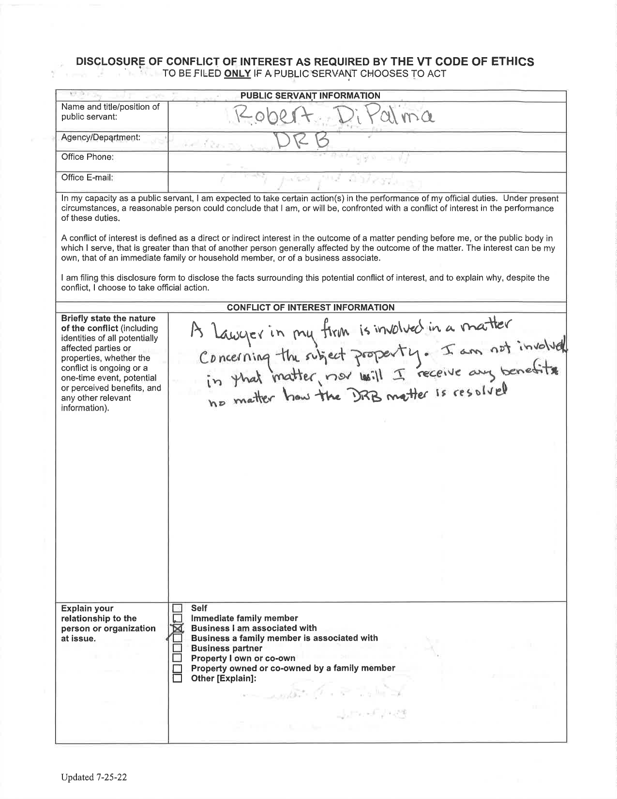

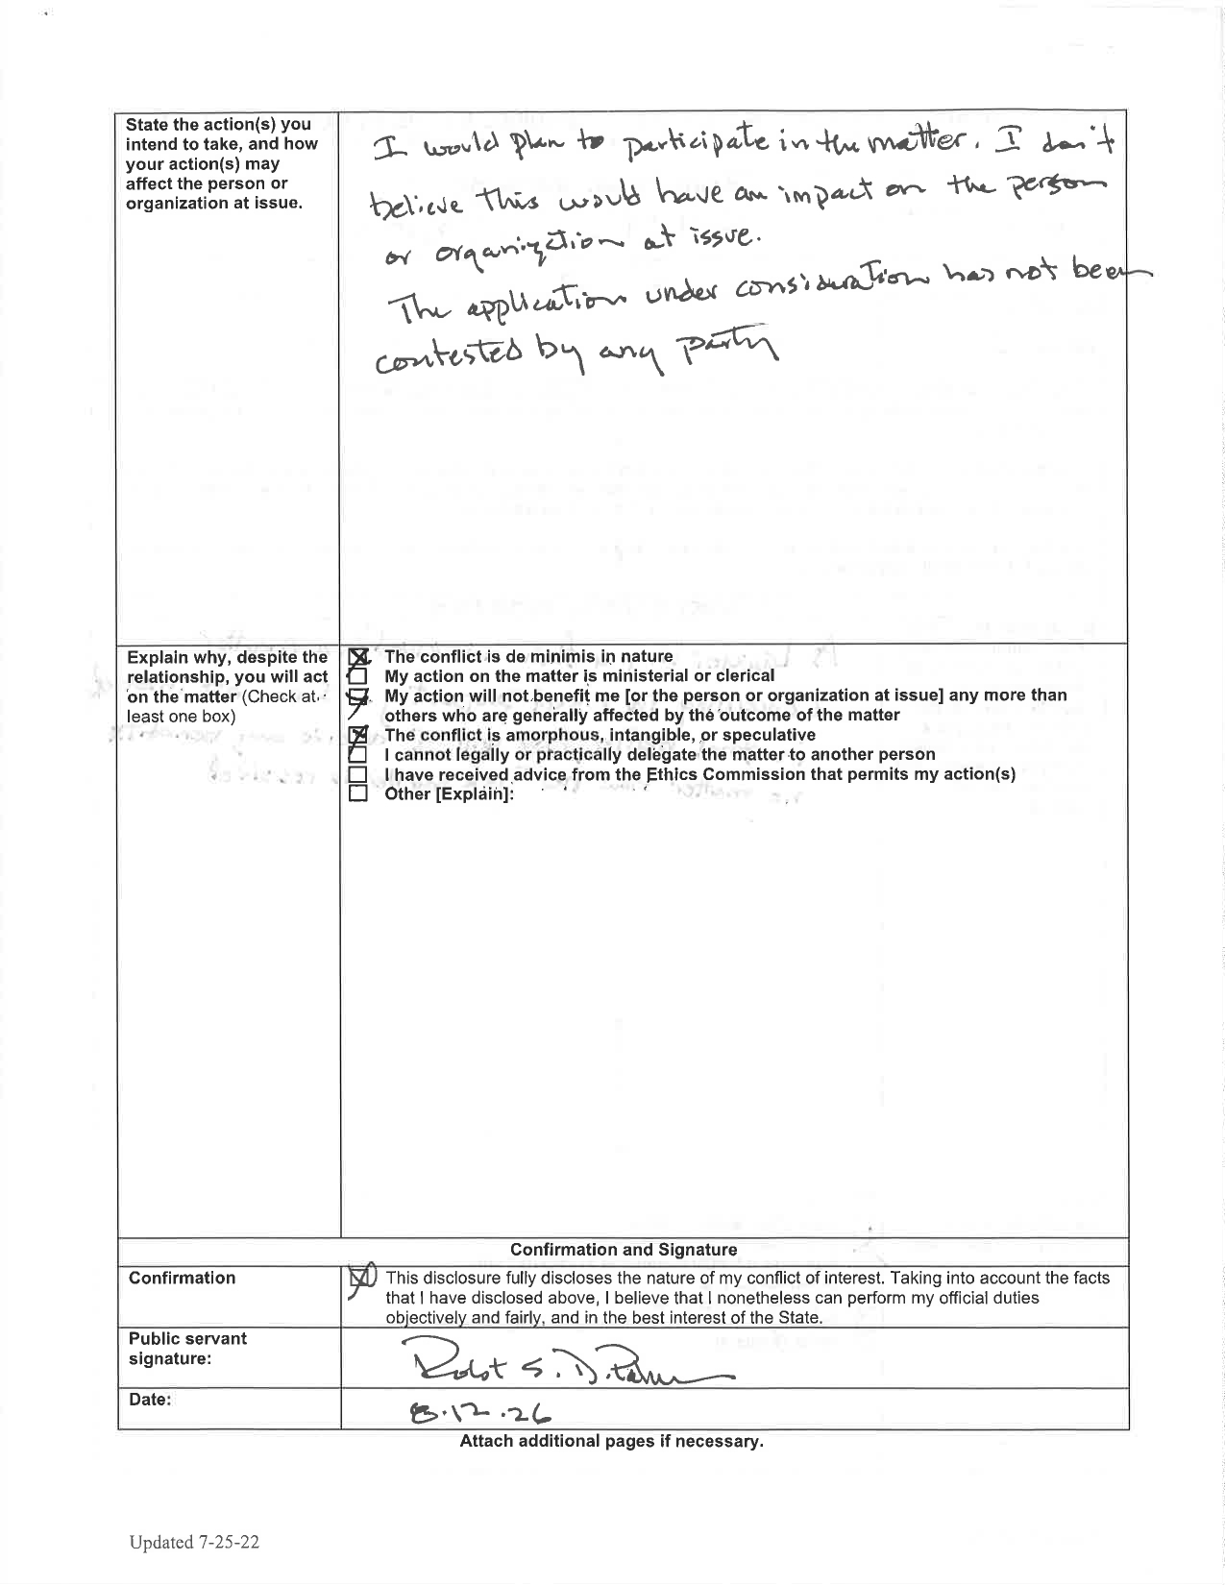

YouTube, MMCTV, Richmond DRB Aug. 12, 2026, https://www.youtube.com/watch?v=8w3loerS6jM.
See DRB 8/12/26, https://www.richmondvt.gov/calendar/meeting/development-review-board-8-12-26.

