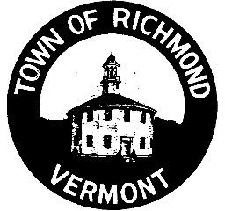
Town of Richmond Planning & Zoning Office
203 Bridge Street, P.O. Box 285
Richmond, VT 05477 www.richmondvt.gov

Town of Richmond Development Review Board (DRB) Agenda

December 10, 2025 at 7:00 PM

THIS IS A HYBRID MEETING WITH ON-SITE AND REMOTE ACCOMODATIONS.

Note: Pursuant to 1 V.S.A. § 312(a)(2), this meeting will be held in the three following locations: (1) in person; (2) electronically via Zoom; and (3) by phone call. You do not need a computer to attend this meeting. Calls can be placed by using the "Join by Phone Call" number below—this is a toll-free number. Your participation in this hearing process is a prerequisite to the right to take any subsequent appeal. For more information or accommodations to improve the accessibility of this meeting, please contact Danté DeNault at (802) 556-4959 or ddenault@richmondvt.gov.

Join In Person: 3rd Floor Meeting Room A, 203 Bridge Street, Richmond, VT 05477.

Join Electronically via Zoom: https://us02web.zoom.us/j/89057870483.

Join by Phone Call: +1 (305) 224-1968 (US) // Meeting ID: 890 5787 0483.

PUBLIC HEARING AGENDA ITEMS:

Materials: https://www.richmondvt.gov/calendar/meeting/development-review-board-12-10-25.

- CU2025-06 Mt. Mansfield Community TV (MMCTV) Parcel ID: BR0203
Project Description: MMCTV seeks DRB approval to install a modest mast and antenna on the City Center building to enable a low power FM non-commercial community radio station.

- APE2025-01 Chelsye & Trevor Brooks Appealing: ZO 2025-61 Continued hearing. Appellants Chelsye & Trevor Brooks challenge the issuance of Zoning Permit 2025-61 for allegedly missing information & violating the Town’s zoning regulations.

