3/06/26
Appendix __
The ACF for People and Wildlife
Conserving Ecological Integrity; Expanding Recreational Uses and Enjoyment

Meeting Community Interests and Responsibilities
The Andrews Community Forest has long offered many benefits to Richmond residents and visitors. For millennia it has provided food, shelter and other vital needs for local populations of people and wildlife alike.

Today the ACF’s rich resources continue serving our population’s health, safety, recreational, educational, aesthetic and other interests in many ways, and in keeping with key responsibilities of our town:
- The ACF Conservation Easement specifically requires the Town of Richmond to “provide for non-motorized, non-commercial recreational, educational and other appropriate community uses” within the ACF.
- The Easement also requires the Town to “conserve productive forestland, wildlife habitat, biological diversity, natural communities, riparian buffers, wetlands, soil productivity, water quality and native flora and fauna…and the ecological processes that sustain these natural resource values….”
- The Richmond Town Plan echoes these points, calling on all of us to protect “priority natural areas” along with supporting recreational activities and ensuring “best stewardship” of Town-owned land such as the ACF.

These dual responsibilities reflect Richmond's long-standing commitment to both land conservation and outdoor recreation. For generations, Richmond residents have valued access to natural areas for hiking, hunting, wildlife observation, and other outdoor pursuits. These activities support physical and mental health, build community connections, and foster environmental stewardship. The Andrews family's tradition of welcoming the public onto their land, ultimately formalized through the conservation easement, recognizes these activities as community benefits to be actively provided and sustained.

Achieving Balance
The ACF was conserved with two equally important purposes: to protect ecological integrity and to provide recreational opportunities to the community. The conservation easement explicitly requires both, reflecting the community's recognition that a healthy forest and meaningful public access can be complementary, not competing, values. To achieve this, the Town has sought, largely through the ACFC, a clear understanding of these responsibilities and how each can be achieved in concert with the other.

For example, early in the process the Town surveyed town residents to learn their preferences for allowed activities in the ACF. The ten most favored, in order of preference, were hiking, running, hunting, snowshoeing, skiing, bird- and wildlife-watching, picnicking, biking and dog-walking. Later input focused on expanding mountain biking use in the ACF, including building connections to abutting trail systems.

Recreational trails are a well-established, much-loved part of the Vermont landscape. The oldest long-distance trail in the U.S. is Vermont’s Long Trail, running 272 miles from Massachusetts to Quebec. For decades in Richmond, the Andrews family welcomed hunters, hikers and snowmobilers through their land to what is now the ACF, ultimately signing a conservation easement guaranteeing public recreational access to the forest in perpetuity along with strong ecological protections. This commitment reflected a broader Richmond value: that access to and protections for natural areas supports community wellbeing.

The many benefits that recreational trails bring to people’s physical and mental health and relaxation are widely documented. In Richmond, these benefits are evident in the families who hike together on weekends, the bikers who use trails for thrills and stress relief, and the nature enthusiasts who find solace and inspiration in the forest. Trails can also bring economic gains to the local economy when residents buy equipment at local outdoor gear stores and visitors stop for gas, meals and refreshments in town businesses.

In step with national and global trends, trail visitations are booming in Richmond, as evidenced by the bike rack-equipped cars that can be seen parked near popular trails all around town. Apps like Trail Finder and Trailforks map more than 100 miles of trails in or within a few minutes of Richmond – single use, multi-use, even for people with physical disabilities. Work is underway on building the Velomont trail network, optimized for mountain biking, to run the length of Vermont, and locally to include mileage managed by Richmond Mountain Trails.

This growing enthusiasm for outdoor recreation creates both opportunities and responsibilities. The ACF can serve as a premier destination for diverse trail experiences while also demonstrating how thoughtful management can sustain both recreational access and ecological health for future generations.

Residents also expressed concern about the impacts new types and intensities of trail traffic would have on forest ecology and recreational enjoyment alike. This concern is borne out research studies and meta-studies, including in Vermont.

Through this process, today we know much more about the ACF and residents’ desires than we did in 2018, when the forest was conserved. This plan draws upon the large bank of research – much of which was not available when the ACF’s first management plan was published – describing how to avoid the conflicts and negative impacts that even seemingly benign human activities can bring to the forest and its users and inhabitants.

For example, the plan designates two distinct and complementary management areas within the ACF. Described in more detail below. Each has its own focus and yet together they help to ensure the long-term conservation of the features that give the ACF such tremendous value to our community and beyond.

A Comprehensive View
As a practical and effective way to safeguard a parcel’s ecological integrity and functions, Vermont’s Agency of Natural Resources recommends that forest managers avoid taking a species-by-species approach to conservation. Instead, it urges protection of those elements of the broad landscape that sustain multiple species in myriad ways.

To quote its guide to this topic, “focusing conservation planning efforts on these elements will effectively address many of the public interests associated with the natural environment.” To ensure conservation of the complex web of plants, animals, places and other elements that comprise a healthy forest – all the while serving a suite of public interests such as education, forestry and recreation – this plan looks at the components of ACF’s ecological health at three levels: landscape, community and species.

Landscape-Level Elements
Contiguous Forest
One of the most outstanding features of the Andrews Community Forest is what it lacks – roads, buildings, driveways, agricultural land and other forms of development and disturbance. Because of the integrity of the ACF and its contiguity with other largely undisturbed forest tracts, the State of Vermont’s Vermont Conservation Design designates nearly all of the ACF’s as a “High Priority” area for interior forest conservation.

This reflects the importance of the ACF and other large expanses of intact forest in supporting the biological requirements of many native plants and animals, including those sensitive to human disturbance. They create the large, intact landscapes critical to the continuing survival of Vermont’s widest ranging animals, species such as black bear, bobcat, moose and others known to frequent the ACF. They serve the needs of interior-nesting birds, who in a more open or disturbed landscape could suffer excessive predation. The ACF provides them and other wildlife with vital feeding habitat and space to roam, find mates and promote genetic diversity.
Contiguous interior forests like the ACF also buffer species against the negative consequences of forest fragmentation, climate change and human disturbances elsewhere. They give wildlife new places to thrive in should previous territory become untenable.
Habitat Connectivity

The ACF Conservation Easement notes the ACF’s location in an area “important for regional landscape connectivity.” The State of Vermont recently bolstered this assessment by assigning “Priority” conservation status to much of the ACF for its connectivity features, primarily its northern area. Along with neighboring forests, ecologists recognized the ACF for its contributions to plant and wildlife connectivity across Vermont and into adjacent states and Quebec.

As such, the ACF assists bear, bobcat, moose, turkey and others in moving from place to place to meet season-by-season and other survival needs. Connectivity and contiguity combine to foster species intermixing and breeding, making for healthier populations across the landscape. And as climate change continues, the ACF is another link in enabling animals to adjust their ranges in response to warmer weather creeping northward.

Enduring Elements
The ACF’s enduring features are those that resist change, even over millennia, and play fundamental, long-standing roles in shaping and sustaining the landscape.
For example, south-facing slopes created millions of years ago host different sets of flora and fauna than those with less exposure to sunlight. Minerals and seeps in the ACF’s rocky ledges nurture plant communities unique from those found in looser, lower elevation soils. Crevices in rocky terrain shelter far-ranging mammals from bobcat to bats.

Bedrock and surficial geology
The ACF spans lowland and high elevation terrain, with its bedrock geology generally split on a north-to-south line. Both help account for the forest’s biodiversity. In the southern areas, the meltwaters of glacial Lake Vermont deposited sand, gravel and clay formations. Above, the soil is built upon formations primarily of Underhill and Pinnacle bedrock 500 or more million years old.
Underhill bedrock dominates the forest from its northernmost point to its western edge. Along with the neighboring Pinnacle bedrock, it has dense, metamorphic, sedimentary rocks with visible cracks and fractures. Underhill’s more distinctive silvery-green rocks combine phyllite and schist, with the minerals chlorite, muscovite, and quartz.

To the east, the Pinnacle Formation features finer-grained, gray-to-buff schistose greywacke rock. Its layers show the formation’s metamorphic origins from bits of rock, mud, and debris. The minerals present are quartz, sericite, biotite, and chlorite.

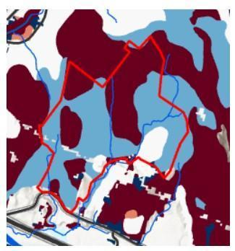
Soil suitability for trail construction in the ACF, with blue areas showing the best areas. Intensive use can cause soil compaction, erosion and degraded vegetation. Source:Forest Recreation Impacts on Dimensions of Northeast Regional Forest Health, Forest Ecology Monitoring Cooperative.

Over the eons, wind, water and glaciers deposited loose materials across the ACF, which combined with glacial till – boulders, stones, pebbles and fine silt deposited by glaciers at the end of the last ice age, about 14,000 years ago. Soil particles deposited by post-glacial Lake Vermont can be found on roughly half of the ACF’s elevation range, up to 600 feet.

Elevation
The ACF rises from an elevation of about 400 feet above sea level at the parking lot to 1,240 feet along its northern ridgeline. This gives it the greatest elevation range among conserved properties in Richmond, with soil and temperature diversity to match. In contrast, most of Vermont’s conserved land lies above 2,000 feet, where biodiversity is the least. Protecting the ecological functioning of lower areas like the ACF is important to conserving local and state-wide biodiversity.
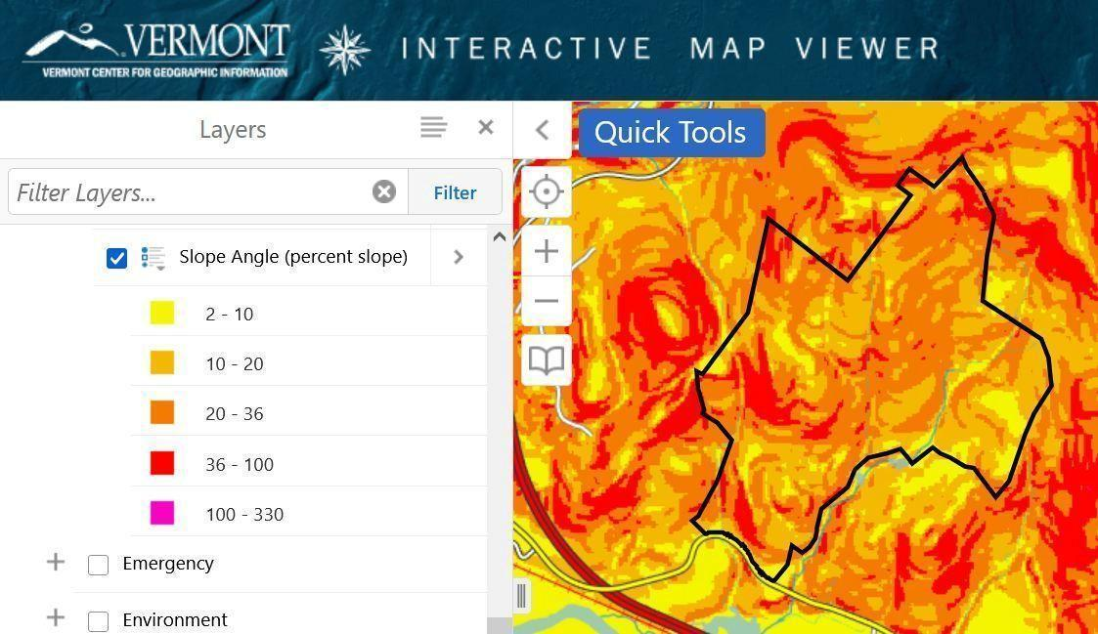
Tight contours ranging from yellow to red highlight the ACF’s rugged terrain and susceptibility to erosion and washouts, particularly as warmer weather brings more intense rainfalls.

Climate
Though today our climate appears to be in a period of unprecedented rapid change, a forest’s climate is also considered to be another enduring element. The ACF is part of the Northern Green Mountains biophysical region, which is cooler and wetter than other portions of the State. However, life in the ACF is also influenced by its proximity to the warmer Champlain Valley biophysical region as well as its south-facing slopes. The result is a forest dominated by tree species adapted to warm, dry sites – with poorer soils on upper elevations, and slightly richer forest soils on lower elevations (thanks to the glacial deposits).

Community-Level Elements
(Map: VCD “Natural Communities” prioritizations)
The ACF’s natural communities, mostly clustered above the powerline corridor and former VAST trail, are rated “Highest Priority” and “Priority” by Vermont Conservation Design.

A natural community is an interacting assemblage of plants and animals, their physical environment, and the natural processes that affect them. While named for their dominant plants, natural communities encompass distinct mixes of mutually dependent plants and animals from fungi and microbes to mammals and trees, along with their settings amidst particular soils, bedrock, and ecological processes.
To date 97 types of natural communities have been found across Vermont. The ACF has at least 10, ranging from small patches of wetland seeps to a multi-hundred-acre stand of Northern Hardwood Forest and its Mesic Red Oak, White Pine and Hemlock associated communities.
Conserving the ACF’s natural communities offers a practical way to understand and maintain the Forest’s biodiversity. Otherwise, we would be faced with the task of trying to conserve tens of thousands of individual species.

Upland Natural Communities
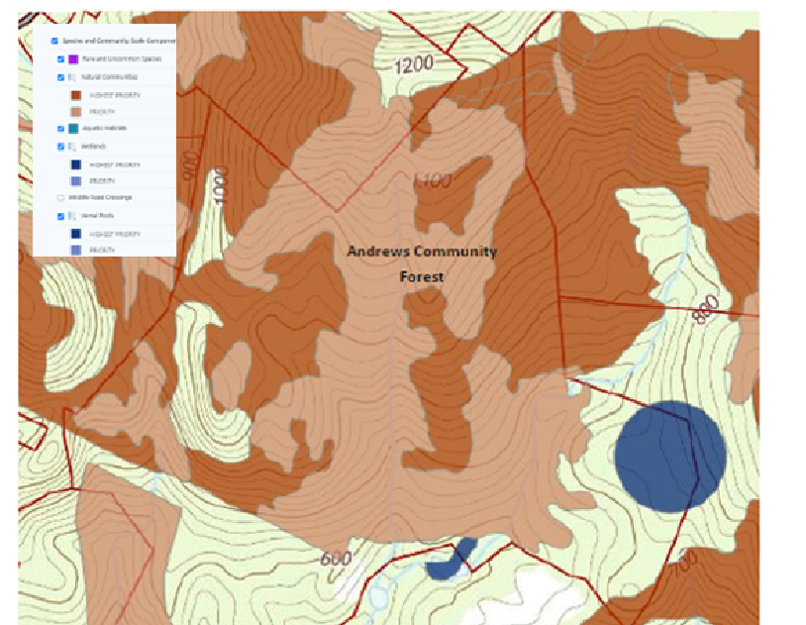
Three upland natural communities comprise most of the forest: Mesic Red Oak-Northern Hardwood Forest, White Pine-Northern Hardwood Forest.
- The White Pine-Northern Hardwood Forest community occupies much of the southern portion of the forest, indicative of areas formerly in pasture or cultivated.
- In the northern part of the forest, roughly north of the VELCO transmission line, the Mesic Red Oak-Northern Hardwood community dominates, extending well beyond the ACF’s borders into the surrounding forest block. These are uncommon community types, occupying the Forest’s droughty ridges and south-facing summits and featuring shallow soils and frequent bedrock outcrops. The small size of these stands makes them especially vulnerable to disturbances. As diseases claim the Forest’s few remaining sources of beechnuts and butternuts, Dry Oak acorns will become even more critical food sources for black bears, wild turkeys, coyotes, corvids and other species.
- Several patches of Hemlock-Northern Hardwood Forest provide deer and dozens of other species with vital wintertime shelter and deep, cooling summertime shade on secluded, south-facing slopes throughout the Forest.

Wetland Natural Communities
Though the ACF is primarily a landscape of upland natural communities, wetland communities can be found in low areas, narrow benches and areas of groundwater discharge. Though their total acreage is relatively small, rarity in the ACF makes them much more important.
- Two of the ACF’s three Shallow Emergent Marsh communities are on its southern border and continue off-property. Each is a beaver-influenced wetland with a diverse mixture of open water, herbaceous vegetation, and occasional shrubs. The northern marsh sits in a scenic low area surrounded by upland forests. These marshes are significant for a wide range of functions and values including water quality, erosion control, and floodwater attenuation. Being part of a public, conserved parcel, they also offer opportunities for education and research.

Perhaps the most important function that they serve is that of wildlife habitat. The mosaic of open water and herbaceous vegetation in a forested matrix is ideal for a wide variety of songbirds, raptors, mammals, reptiles, and amphibians, especially as surrounding areas are kept relatively undisturbed by human activity.
- The ACF’s seeps are small, wet areas of groundwater discharge that often form the headwaters of streams. Their year-round flow of groundwater makes them among the first areas in spring to harbor green vegetation, making them important for black bears and other wildlife seeking sustenance after winter’s privations. Certain amphibians also rely on them, including spring and two-lined salamanders. They are also important for providing a cold, clean source of water for downstream surface waters and the life they harbor.
Three seeps have been mapped to date in the ACF, but more are likely to exist. Their size and tree cover make them difficult to find using aerial and satellite photography, and direct field observation remains the best way to locate and assess them.
- Four Vernal Pools have been identified in the ACF to date, with two confirmed and described in the Baseline Report (Diamond, 2017) while two others await field confirmation. The two identified pools are likely to be state-significant examples of their natural community type. Each contained many hundreds of wood frog and spotted salamander eggs in what appeared to be a stable breeding habitat for these and many other species.

The surrounding upland landscape, though parts were harvested before the Town acquired ownership, provides valuable year-round habitat for the pools’ breeding amphibians. This has earned the pools special protection in the Conservation Easement, which requires at least a 100’ undisturbed buffer around each pool. This is surrounded by a 500’ secondary protection zone where harvesting aimed at enhancing amphibian habitat is allowed. The Easement also allows foot paths in the outer, 500’ ring. The ACF Management Plan recognizes the local importance and sensitivity of these small but mighty contributors to the Forest’s biodiversity.

Streams and Riparian Areas
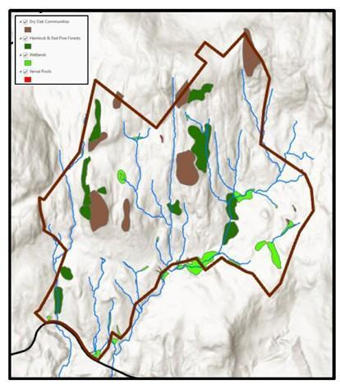
The ACF’s streams and wetlands, along with Hemlock (green) and Dry Oak (brown) natural communities
The Andrews Community Forest is located within the Winooski watershed. Water from forests, fields and streams runs off into the Winooski River, which flows into Lake Champlain. Surface waters on the property include wetland natural communities (described above), three headwater streams, and two confirmed vernal pools. Maintaining forested riparian cover adjacent to these resources is vital for the protection of water quality and conservation of important aquatic habitats.
Several streams arise on and meander through the property on their way to the Winooski River and, eventually, Lake Champlain and points north to the Atlantic Ocean. Streams may flow perennially or intermittently. The ACF has three perennial streams, including the central one dropping 500 feet from a saddle on the northern boundary to the southern edge, and identified by Arrowwood as one of the Forest’s major wildlife movement corridors.
Streams feature channels with defined beds and banks that confine low or moderate flows. Beginning at the tops of stream banks are riparian areas – typically undisturbed zones of trees, shrubs, ground cover plants, a duff layer, and an uneven ground surface.
Forested streamside riparian habitats such as those in the ACF offer a suite of ecological benefits. They:
- Anchor shorelines and limit streambank erosion
- Filter soil and silt from stormwater run-off, greatly reducing degradation of water quality from heavy rains.
- Provide plant and animal life with organic matter, nutrients, shade and coarse woody debris, sheltering and feeding insects, fish and amphibians.
Terrestrial food chains depend on streams and riparian areas as well. For example, their flowing waters create microclimates that often host the first plant life to emerge in the spring. Black bears will sometimes seek out these plants even while ice can still be found along the stream edges. Mink, fisher, bobcat and owls follow soon behind to seek out the frogs and salamanders endemic to these areas.
The ACF’s Conservation Easement contains strict protections for riparian areas to safeguard water quality even beyond the ACF’s borders. Due to their importance to many types of wildlife, this Management Plan recognizes the vulnerability of riparian areas and their broad far-ranging ecological functions to nearby human disturbances.
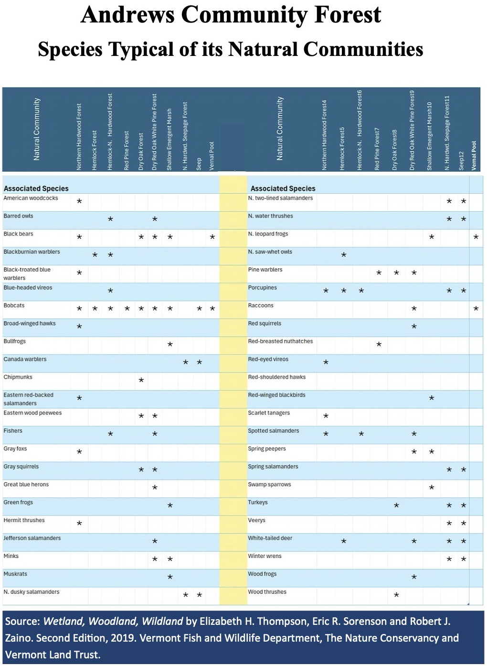

Species-Level Elements
Some features of a forest that are important to its ecological integrity and biodiversity do not fit neat classification into either landscape- or community-level classification. They are vital to the survival of certain species, and critical to include in any conservation plan.
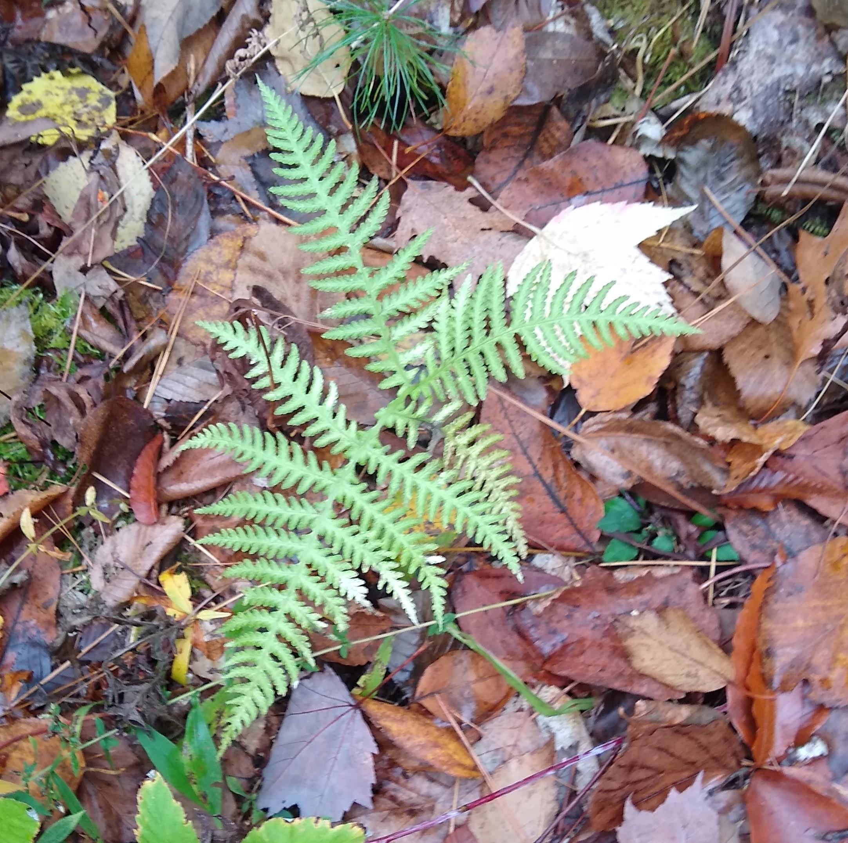
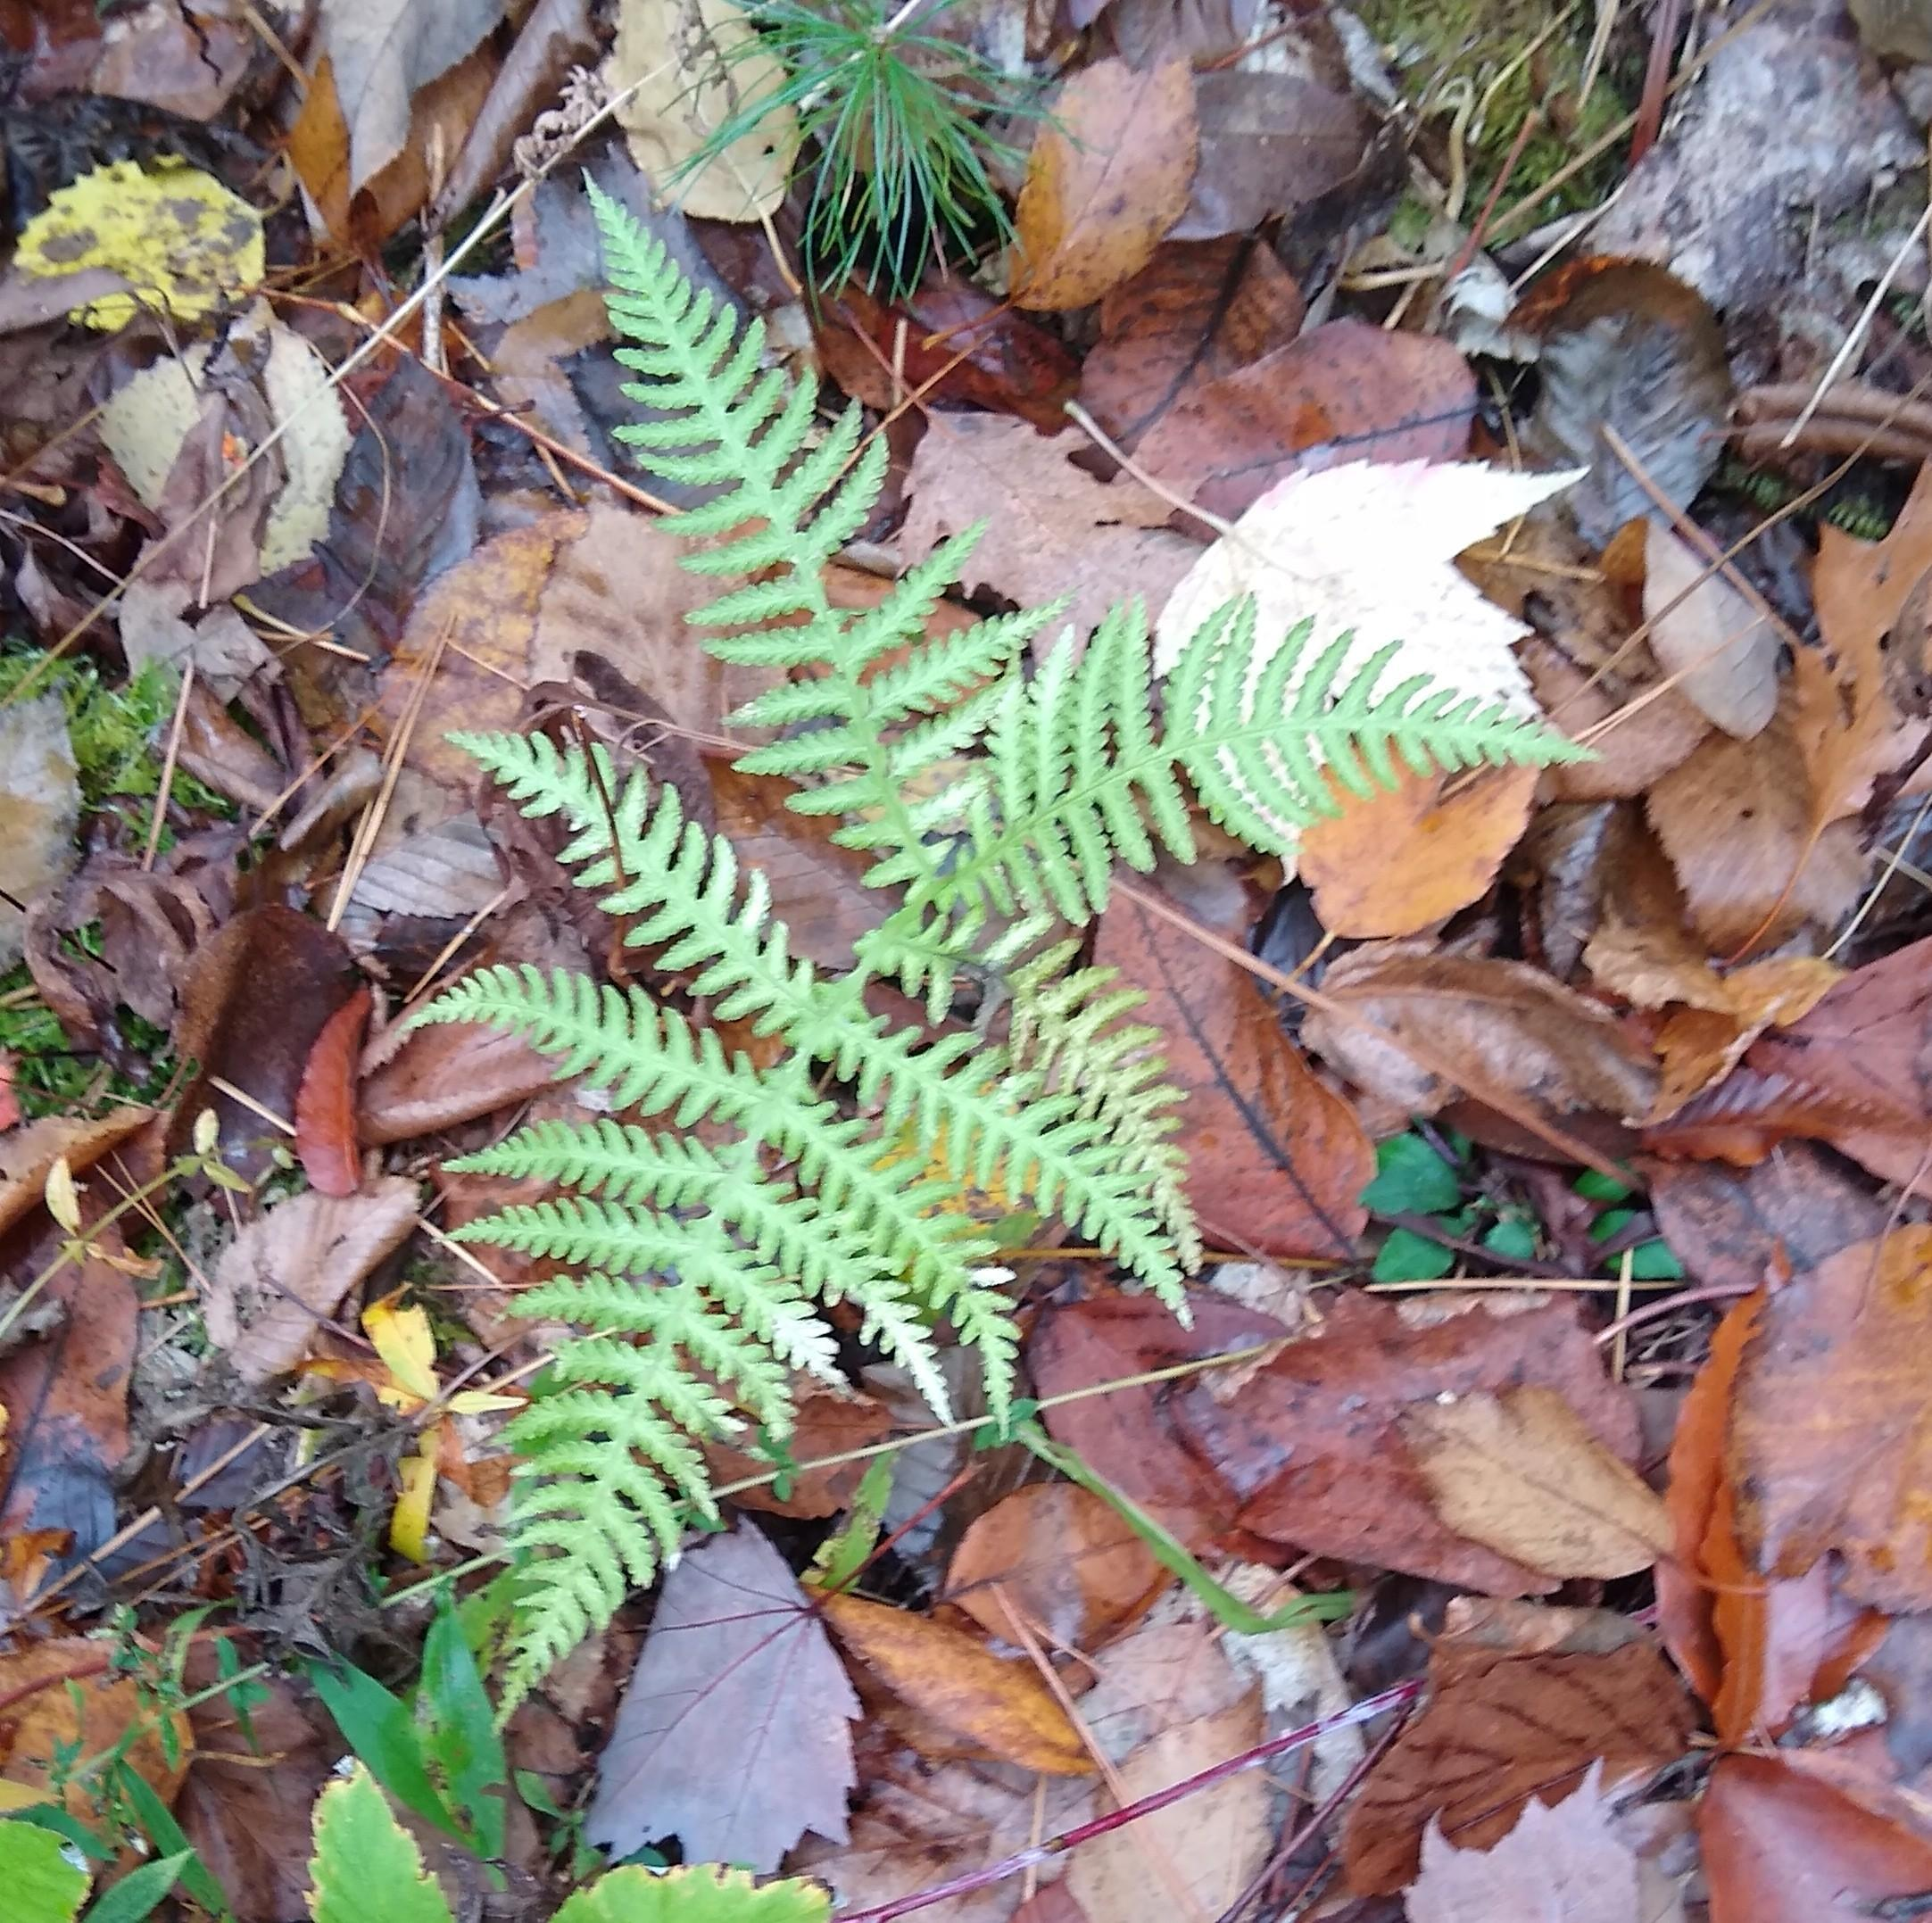
Rare, Threatened, and Endangered Species
To date only one such species, the broad-beech fern (left), has been found in the ACF. A patch of them was discovered during a fine-scale assessment of the proposed route for a new trail.
Bobcats, evidence of which has been found in several parts of the forest, are not considered rare, threatened or endangered, but are listed by the State of Vermont as a Species of Greatest Conservation Need. On a broader scale, they are on the list of Regional Species of Greatest Conservation Concern in the Northeastern U.S.
Protecting these wide-ranging species amounts to protecting forest contiguity and connectivity, and their need for wide-ranging, undisturbed
places and sheltered habitat to raise their young. (See Outcrops and Ledges, below.)

Wildlife Wintering Areas
Much of ACF is listed on state maps as “potential” whitetail deer wintering areas, due to the extent of the forest that faces south and is covered by thick stands of hemlock that ward off wind and heavy snow accumulations. East- and west-facing slopes can serve as wintering areas as well. To save energy when food is scarce, deer will often survive by congregating in these areas when snow reaches depths of 15 inches or more. These winter habitats also attract bobcat, coyote, and scavenging bear and fisher looking to scavenge weakened and dead deer. Other animals such as conifer-nesting birds, porcupines, and fox also utilize these habitats.

Mast Stands
The seeds of shrubs and trees that provide food for wildlife are known as “mast.” “Hard mast” refers to nuts such as acorns, beech nuts and butternuts, while “soft mast” is defined as berries from a variety of species. Hard mast provides high-calorie food for black bears, turkey, fisher and other wildlife, and soft mast such as blueberries and huckleberries are a particular favorite of black bears and birds alike.
As a food source for bears, Conserving Vermont’s Natural Heritage emphatically states in bold italics, “Simply put, these stands of beech and oak used by black bear are absolutely essential for the survival and reproduction of this species in Vermont!” It cites research by Elowe and Rogers that found a direct correlation between the availability of hard mast in the fall and the minimum reproductive age of bears, productivity rates and cub survival.

Black bears are ecologically important to the ACF and any large forest. By spreading seeds through their scat for dozens of square miles in their wanderings they are a key agent in forest regeneration and diversity. (Fishers are another.) However, beech stands in the ACF are suffering from fatal beech bark disease, along with other stands across the state. A newer, beech leaf disease is also spreading into our region. This greatly raises the importance of acorns as mast, which, to provide the same amount of nutrition, must be consumed in greater quantities than beech nuts.

Outcrops and Ledges
The ACF’s outcrops and ledges support a variety of natural communities and associated wildlife, depending on their geological composition and aspect. Their crevices can shelter porcupines, winter wrens, insects, bats and snakes. Bobcats favor ledges and small caves for courting, breeding and keeping their young safe from less-nimble predators. Evidence of bobcats in the ACF is not hard to come by, including, predictably, in the ledgy terrain below a Dry Oak natural community no doubt rich with squirrels, chipmunks and other prey. Beyond the ACF but well within bobcat range are known denning areas – among the westernmost of the ACF’s forest block.
Early Successional Forest and Shrubland

Healthy forests feature trees of a variety of edges, each providing their own ecological services to the landscape as a whole. Heavy cutting, such as was conducted decades ago in the ACF, can rob forests of this diversity. Fortunately, the ACF’s Forestry Plan is designed to restore this age diversity faster than wind, fire and disease would eventually accomplish on their own. Careful harvesting and patch cuts are designed to restore young forests and the food and other services they offer wildlife.

Among the beneficiaries are ruffed grouse, American woodcock, and scarlet tanagers – the latter which have entertained springtime birding groups in the ACF. Another significant area of such growth is found beneath the powerlines, where the utilities’ regular maintenance keeps tree heights down, although the methods and materials used may limit the results for some wildlife and ecological processes.
Wildlife Connectivity Corridors
The ACF’s permanent and intermittent streams and its riparian areas serve as safe, convenient and often food-rich routes for travel up, down and across the forest’s 800-foot elevation span. In unprotected forests the connectivity functions of such corridors are vulnerable to human disturbance or outright destruction, highlighting the importance of safeguarding the viability of those within the ACF.

New Perspectives
Beyond looking at the key functions and features of the ACF itself, the Committee considered a range of factors that had changed or come to light since the original, 2018 Management Plan was written, among them:
- The ACF’s ecological role and importance. Assessments by UVM, Arrowwood and others since the original plan was written confirm the ACF’s value for black bear, bobcat, whitetail deer, fisher and other wildlife, especially in the northern, least developed and visited areas of the forest.
- Early proposals for building several miles of new trails and associated bridges and boardwalks, some to connect the forest to trail systems on adjoining private land and to networks beyond.
- Advances in recreation. New equipment and technologies enable more people than ever to penetrate farther, faster and deeper into forests more often and with less effort. Apps and social media direct people to places only few knew about a decade ago, including rich, remote natural areas and habitats. These apps, such as Trail Finder and Trailforks can also serve as a valuable tool for monitoring and managing trail traffic and conditions to protect the ACF’s ecological resources and recreational infrastructure.
- Advances in recreation. Growing interest in outdoor recreation reflects both national trends and Richmond residents' commitment to active, outdoor lifestyles. New technologies enable more efficient and fast-paced travel, enabling adventures deeper into the landscape. Trail apps like Trail Finder and Trailforks both increase access to natural areas and provide valuable tools for helping monitor and manage use to protect ecological resources and recreational experiences.
- New connections. Two of the three neighboring landowners with developed trail systems on their properties directly connect those systems to ACF trails.
- Continuing research showing wildlife’s sensitivity to trail traffic. Recently published scientific studies and literature reviews further explain how trail traffic can fragment, degrade and destroy productive wildlife habitats within “zones of influence” extending hundreds of meters from the trails themselves.
- Limited space for sustainable trail development. Even buffering sensitive areas by the 330 feet recommended by a broad Vermont meta-study would block trail development in much of the ACF [IS: show a map?]. The steepness, wetness and soil suitability of much of the ACF’s terrain is another concern [IS: refer to map below], and could subject some trail development projects to state and local erosion control requirements.
- The Indigenous Land Acknowledgement. The Town of Richmond has pledged [IS: where?] [BE 7-22: Good point. Presumably the SB will have ok’d the Indigenous Agreement by the time it approves MP2, or as part of that. It might be a good idea to get that language to the SB well before we bring it to the board as part of MP2.] to foster a healthy forest community by incorporating into our management practices the traditional ecological knowledge that sustained our area’s forests for thousands of years.
- Assessments of needs. As noted above, there are a number of trails available to the public within Richmond and its neighboring towns, most on private lands [SP: with no guarantee for continued public access]. ACF hiking and biking trails directly connect to additional miles of trails on two neighboring properties – VYCC and Maple Wind Farm.

Protecting Forests While Welcoming Recreation
The ACF Management Plan’s approach to meaningfully protecting the forest and accommodating diverse, sustainable recreational and other community wishes centers on balancing ecological and recreational needs.

The Plan provides diverse, sustainable recreational opportunities including trails for varied abilities and interests, connections to neighboring trail networks, and experiences ranging from accessible family outings to backcountry adventures. These recreational goals are achieved through thoughtful design and management that sustain both the forest's ecological health and its capacity to serve the community.

The plan establishes two distinct management zones, each based on its particular topography, sensitivities and accessibility:
- Southern Recreation Area. This zone is designed to support a wide range of outdoor activities while following sustainable trail-building practices. This area allows for a higher density of trails, including those open to bicycles and other non-motorized uses, and is intended to accommodate a variety of user experiences including hiking, biking and nature exploration for people of a wide range of ages and abilities. Trails are constructed and monitored to minimize erosion and protect natural features, with careful attention to grade, drainage, and long-term maintenance. Route 2, the ACF parking lot and existing trail and utility road connections provide convenient access to this area (and also simplify trail construction and maintenance for the Town). By concentrating higher-impact recreation in this zone, the forest plan balances public access and enjoyment with the protection of sensitive habitats in the adjacent Northern Forest Preserve. This zone fulfills the easement's directive to provide meaningful recreational opportunities by offering trails for diverse users and abilities, welcoming forest experiences while concentrating higher-impact activities away from the most sensitive ecological areas.
- Northern Forest Preserve. Managed to prioritize conservation, the Northern Forest Preserve also maintains its tradition of providing hiking, hunting and other forms of low-impact, backcountry recreation. Following trail design best practices, this zone includes a limited number of simple footpaths, carefully routed to avoid sensitive ecological areas and minimize disruption to wildlife. Dogs, bicycles and mechanized uses are not permitted, helping to maintain a quiet, secluded environment that supports habitat preservation and nature observation.

Throughout the ACF, the Management Plan applies a variety of measures to mitigate impacts on both the forest’s wildlife and people wanting to experience its diverse recreational opportunities, particularly the mountain biking community. These measures include:
- Clear parameters. The Management Plan’s parameters for new trail approvals and construction are designed to clarify and expedite those processes.
- Reduced buffering. The widest buffer zones around the ACF’s natural areas are significantly smaller than the minimums recommended in Vermont and New Hampshire wildlife agency publications To also allow for greater trail coverage, buffering for wetlands, streams and riparian areas is a third to a sixth less than for the ACF’s other sensitive areas.
- Seasonal scheduling. By adjusting trail openings and closures according to seasonal wildlife needs for food, shelter and breeding, more miles of trail can be kept available for human use at certain times of the year.
- Case-by-case flexibility: Allowances are made for new trails that might need to encroach on buffered areas by only a small amount.

Together, these measures reflect a balanced approach to forest management, honoring both ecological stewardship and public access. This helps the Town meet the full suite of its legal obligations under the Conservation Easement and align with Town Plan policies. It also provides the community with an expanded range of recreational opportunities balanced with lessened impacts on its most sensitive and vulnerable resources.

Special considerations [BE 7-22: Note the new bullet at the top of the list below. This would get us away from specifying rules in the plan that we might want to tighten or relax in the future, as experience warrants. It’s still broad enough to document the considerations we should be following.]
- Dogs. The rules for bringing dogs into the ACF are published on the ACF Committee’s web page. They draw on guidelines used at the Green Mountain Audubon Center in Huntington and other areas with special qualities and protective needs similar to the ACF’s. The rules reflect wildlife’s response to the sight and long-lingering scents of even the friendliest and most securely leashed dog, which they will fear as a predator. This can lead to abandoned dens, nests and habitats along with undue stress and exhaustion on the animals, and diminished chances of people being able to enjoy the sights and sounds of the ACF’s wildlife due to their abandonment of the landscape.
- Hunting. Benefits include control of the ACF’s deer population, important to restoring healthier diversities of age and species to the forest’s trees and understory. Hunters and non-hunters can share the landscape at any time of year. The ACFC urges each to take safety precautions such as wearing highly visible clothing and keeping dogs leashed. Citizens of recognized Abenaki tribes may obtain free hunting licenses from the state of Vermont. See the posted guidelines for the latest requirements and advice.
- Trapping. Due to safety hazards to visitors, pets and wildlife, trapping is not permitted in the ACF.
- Snowmobiling. Previously the ACF contained a snowmobile trail that was part of the VAST trail network. Snowmobiling may be permitted to resume on the former VAST trail subject to a use contract ensuring compatibility with the ACF Conservation Easement and Management Plan. Motorized recreation is otherwise prohibited in the ACF.

References
- Understanding and Managing the Effects of Trail Use on Wildlife. 2021. Meredith Naughton. UVM Field Naturalist Program, for VT’s Fish & Wildlife Department and Department of Forests, Parks, and Recreation.
- Trails for People and Wildlife. New Hampshire Department of Fish & Game.
- Recreation effects on wildlife: a review of potential quantitative thresholds. 2021. Dertien JS, Larson CL, Reed SE. Nature Conservation 44: 51-68.
- An assessment of non-consumptive recreation effects on wildlife: current and future research, management implications, and next steps. John Baas, Kari Dupler, Audrey Smith, And Rachael Carnes, California Fish and Wildlife, Recreation Special Issue; 62-73; 2020.

Appendix __
Trail Maintenance Commitment Agreement

BE 7-29: I’m suggesting we take this out of the preceding, proposed new Appendix and making it a section of its own. Or, we might replace it with an action item as described in the earlier, purple comment below.

This probably should be supported or supplemented by an action item in the main Rec section: “Before connecting to trails on neighboring properties, obtain an agreement signed by both parties to maintain the trail for its intended uses unless both parties agree to discontinue it.”

This Trail Maintenance Commitment Agreement ("Agreement") is made and entered into as of the ____ day of ________, 20, by and between:
Town or Richmond, the owner of the Andrews Community Forest located at [Address or Legal
Description] (Granting Landowner); and
Landowner 2: [Name] ("Receiving Landowner"), the owner of the property located at [Address or Legal Description].

WHEREAS, the Granting Landowner maintains a trail on their property and wishes to connect it to a trail on the Receiving Landowner's property;
WHEREAS, the Receiving Landowner agrees to maintain the trail on their property to ensure its continued usability and connectivity with the Granting Landowner’s trail;NOW, THEREFORE, in consideration of the mutual promises contained herein, the parties agree as follows:
Trail Maintenance Commitment
- The Receiving Landowner commits to maintaining the portion of the trail located on their property in a reasonable condition suitable for continued use by pedestrians, cyclists, and other agreed-upon users.
- Maintenance shall include, but is not limited to, clearing debris, repairing erosion, and ensuring safe passage along the trail.
  - Access and Use
    - The trail shall remain open for public or private use as determined by the Receiving Landowner.
    - The Granting Landowner shall not be responsible for any maintenance, liability, or costs associated with the Receiving Landowner’s trail portion.
  - Duration and Modification
    - This Agreement shall remain in effect unless terminated by mutual written consent of both parties.
    - Any modifications must be in writing and signed by both parties.
  - Indemnification and Liability
    - Each party agrees to hold the other harmless from claims arising from their respective trail maintenance obligations.
    - The Receiving Landowner assumes responsibility for injuries or damages occurring on their portion of the trail.
  - Governing Law This Agreement shall be governed and interpreted under the laws of the State of
Vermont.
IN WITNESS WHEREOF, the parties have executed this Agreement as of the date first written above.
Granting Landowner:

[Name]
[Date]
Receiving Landowner:

[Name]
[Date]

Trail Development and Stewardship

[Insert link to Trail Stewardship Plan] [IS This means Section B6?]

Visioning Process Results (2017) in 2018 ACF Management Plan, page 279
Kerlinger et al., 2013; Kuss, 1986; Naughton, 202_; Olive, 2009).
In 2018 our knowledge of the ACF’s ecology was limited to expert but relatively brief ecological surveys conducted by Vermont Land Trust, Audubon Vermont, and a five-town inventory project called “Science to Action.” Since then, the ACF’s ecological resources have been further documented, detailed and studied by the UVM Field Naturalist Program, Arrowwood Environmental and several botanists, wildlife biologists and naturalists. Vermont Conservation Design, the State framework for conserving biodiversity across Vermont, gives ACF multiple “priority” and “high-priority” designations fortis conservation values, including interior areas, natural communities, wildlife habitats and connectivity features ³ See reference list at the end of this section.
Austin, J, Alexander, C., Marshall, E., Hammond, F., Shippee, J., Thompson, E., Vermont League of Cities and Towns. 2004. Conserving Vermont’s Natural Heritage: A Guide to Community-Based Planning for the Conservation of Vermont’s Fish, Wildlife, and Biological Diversity. Vermont Fish and Wildlife Department and Agency of Natural Resources. Waterbury, VT.
Terwilliger, 2013
Austin et. Al. P. 89
Morse. 2023.
[Cite for Naughton meta-study, Oehler/”Trails for People and Wildlife”]

