Ecology
- These objectives and actions address the ACF from three ecological perspectives — landscape, community and species — following the organization of the Vermont Agency of Natural Resources publication Conserving Vermont’s Natural Heritage. See Appendix __ for background information about this section.

Landscape-Level
Objectives
- Maintain the ACF’s ecological integrity, biodiversity and functionality, including its status as “High Priority” and “Priority” interior forest and connectivity components of Vermont Conservation Design.
- Preserve interior forest health and connectivity to support black bears, bobcats, moose, fishers, ovenbirds, hermit thrushes and other deep-forest species.
- Protect neighboring properties’ landscape-scale ecological integrity and pursue opportunities to conserve and connect wildlife habitats.
- Protect soils, natural vegetation, water quality and natural climate change resilience through measures shown to control erosion and prevent washouts from soil disturbances on [IS: specify ‘terrain slopes’] slopes exceeding 20 percent. Avoid disturbing any soil or duff layers on slopes over 35 percent. Monitor existing trails on those slopes for damage and erosion, and take restorative measures that could include closures [IS: as detailed in Section B6].

Action Items
- Maintain recreational access north of the former VAST trail at current types and levels while creating new and diverse options south of the VAST trail (see Section B6. Recreation Management).
- Work with the County Forester to implement the ACF Forestry Management Plan and enhance the ACF’s interior forest and wildlife connectivity values.
- [IS: ‘Work to replace invasive plant species with …’] Replace invasive species with native vegetation.
- Develop a plan to reduce wildlife mortality along Route 2 crossings.
- Use public signage and events to educate visitors about ACF’s ecological role.

Community Level

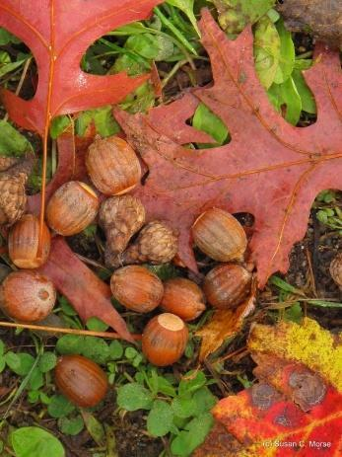
Objectives
- Maintain the relative isolation and integrity of rare upland natural communities (e.g., Dry Oak Forest) to support the conservation needs of bears, bobcats, wild turkeys, hermit thrushes and other deep-forest, far-ranging species. [IS added the underlines]
- Protect wetland and aquatic habitats, including vernal pools, for diverse species such as salamanders and wood frogs.
- Facilitate connectivity between upland and wetland habitats.
- Minimize disturbances to natural communities south [IS: and especially north] of the VAST trail.
- Minimize disturbances to natural communities south [IS: and especially north] of the VAST trail.

Action Items
- [IS: First 2 bullets propose to develop Stewardship plans – isn’t this Section B5 the Stewardship Plan? So add the word ‘additional’ to both bullets.] Develop a Wildlife Stewardship Plan to protect the functionality of the ACF’s community-level elements.
- Promote food, cover and structural diversity for terrestrial and aquatic species in upland and wetland natural communities.
- Maintain hiking, hunting, skiing, snowshoeing, birding, wildlife observation and other types of low-impact recreation north of the former VAST trail on existing forest roads. Identify routes best suited for these types of recreation and maintain them accordingly. Expand recreational opportunities between the parking lot and the former VAST trail to include new and improved trails for mountain bikers, casual walkers, runners, elderly residents and school groups.
- Work with County Forester, UVM resources and professionals to ensure adequate amounts of shade and coarse, woody debris in streams and wetlands.
- Assess and develop plans addressing these major challenges to the ACF’s natural communities:
  - Invasive species
  - Tree and plant diseases
  - Climate change
  - Human impacts
- Use signs and outreach tools to inform and involve the public in conserving the ACF’s natural communities and the ecological processes and benefits they support.
- Monitor the health of the ACF’s natural communities and habitats.
  - Involve ACFC and public volunteers in a program combining field visits, camera and audio traps, and consultations with experts.
  - Utilize black bear and bobcat [and selected songbirds/raptor species] as indicators of the overall biodiversity and health of the ACF.
- Maintain or enhance conditions for wildlife in and among the ACF’s natural communities:
  - Improve deer population management so the ACF’s herd can contribute to its health and species diversity. Encourage hunting subject to VT regulations. Employ exclosures to both track and demonstrate impacts of deer browsing the forest understory.
  - Protect mast-producing areas from disturbances during fruiting and wildlife foraging seasons.
  - Monitor forest health and quantitative/qualitative changes to its habitats (see Appendix C).
  - Post to Times Ink!, Front Porch Forum, the ACFC webpage and social media information about the ACF’s natural and cultural history, and efforts to protect and enhance its natural communities and other habitat features

Species Level
Objectives
- Conserve rare, threatened, and endangered species by integrating updated information into management plans.
- Maintain the functionality of mature softwood cover for wildlife wintering and ensure nearby food sources.
- Promote the health and viability of mast-producing trees and shrubs.
- Enhance early successional habitats to diversify species and age structures.

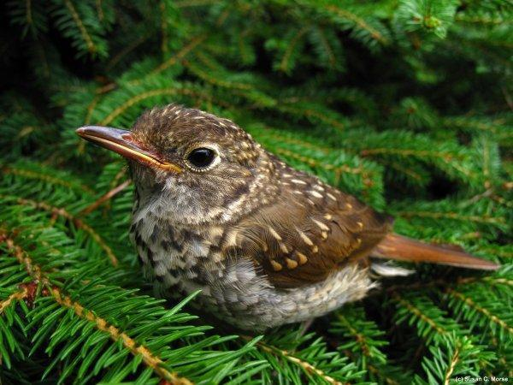
Action Items
- Engage ecologists to survey proposed trail routes and infrastructure areas for rare species within 50 feet of their sides and adapt conservation plans accordingly.
- Maintain at least a 70 percent canopy [Melissa questioned why this 70% specificity] within hemlock stands. Close trails within 100 meters to all but hunters from November through March. [IS: Overly restrictive of recreation? Provide detail in B6]
- Manage deer populations with regulated hunting. Install exclosures to demonstrate browsing impacts and nurture seedlings.
Figure_: Hemlock stands shield deer and other wildlife from winter snows and winds, and also provide nesting spaces for interior forest birds such as the hermit thrush.
- Maintain the oak and other mast requirements of black bears, wild turkeys, white-tailed deer and other species. Avoid disturbing soft- and hard-mast stands areas during fruiting and foraging seasons.
- Provide education and updates about ACF’s efforts to preserve its species and habitats.

