ACF TRAIL STEWARDSHIP PLAN v1

Trail routes and reroutes
- Existing trail reroutes
  - Re-route Urbanik Way from higher in the parking lot past large ash tree. Current route requires persistently wet ground, scramble up rock, and passing very closely to Rt 2.
- Proposed trail reroutes
  - Reroute East Climb and Hemlock Valley to avoid wet areas and rare/sensitive plants, per Arrowood fine-scale review late summer 2022.
- Proposed trail removals
  - Remove Roadside Trail from network, as it is redundant to road and passes through persistently wet areas thereby making trail construction “tricky” per Arrowwood and Sinuosity report and requiring bridges, ramps, puncheon, etc.
  - Remove Ridgetop, as it tracks to closely to the ravine that serves as a key wildlife corridor
  - Remove central path between Cascade Trail and Rocky View; instead, connect the two where they are closest to one another towards south
- Existing logging roads and skid trails
  - Except where they coincide with proposed trail network, these will not be maintained as trails by the ACFC and will be allowed to grow over (although during future forest management activities, they may be maintained by the forester and logger).
- Trail-free zones
  - Other than proposed trails and where present-day VAST trail connects, designate all other areas of the forest as trail-free
- ADDRESS PHASED TRAIL DEVELOPMENT

Allowable activities
- Biking is to be allowed only on established trail networks and not on pedestrian-only trails
- Pedestrians are allowed on all trails
- Dana’s Climb is to be pedestrian only
- Rocky View and Cascade are pedestrian only (Stream View, which is one access point for those two trails, will have both pedestrian and non-pedestrian traffic).
- Electric mountain bikes (eMTB) are not allowed on the trail network, which is consistent with the policies of other trail networks within the state (eg Kingdom Trails here). The ACFC acknowledges that allowing eMTBs may broaden access for individuals with physical limitations, as is consistent with our commitment to equity and inclusion. However, concerns regarding eMTBs (eg faster speeds, safety, user conflict) and the non-motorized specifications within the Conservation Easement compel the ACFC to not permit eMTBs. Any ACF visitors with mobility disabilities who seek to use motorized personal assistive mobility devices (as permitted in the Conservation Easement, screenshot below) should reach out to the ACF Chair for permission to do so.

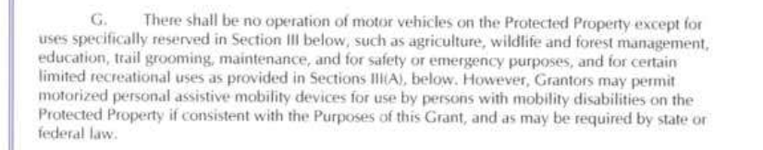

Trail use policy enforcement
- Clear signage at kiosk and at trail signs
- Ropes across trail entrances when trails are closed for the season (but not on, for example, daily basis)
- Use current systems to indicate status (and describe allowable uses) working with existing trail groups (eg RMT, Richmond Trails Committee, Cochran’s). There will be a designated point person on ACFC to ensure statuses are updated.

Closures
- Following state guidance for deer wintering closures, close Middle Connector, East Climb, and Hemlock Valley from December 15 - April 1. The ACFC recognizes that people may still recreate across ACF in a dispersed manner (eg x-c skiing) but trails will not officially be open.
- All trails above powerlines will be closed to non-hunting recreation during youth hunting weekend and deer season. Dates will vary from year to year but will follow VT Fish & Wildlife specifications (2023 below).

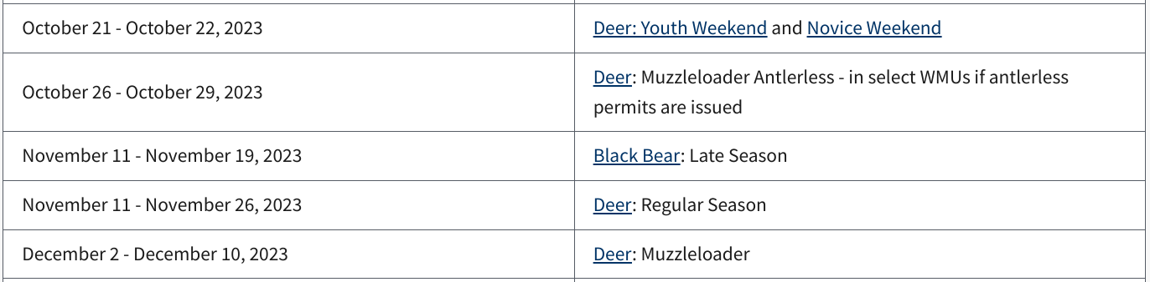
- Because many wildlife species are crepuscular or nocturnal, non-hunting recreational activities are not permitted before sunrise or after sundown north of the powerlines.

Monitoring
- Install trail counters at base of each trail. Pull numbers annually. Devise and commit to non-arbitrary decision-tree to guide what will happen when certain numbers of users are on trails.
- Seasonal visual inspection of trails for erosion and needs for maintenance will be conducted by the ACFC on an ongoing basis.
- Quantitative and qualitative data collected will be reviewed regularly and guide the committee in prioritizing trail maintenance and upgrades.
- Seasonal visual inspection for invasive species will be conducted by ACFC and removal / mitigation will be planned accordingly.
- ADDRESS TRAIL MAINTENANCE

Dogs
- Dogs are to be kept on leash at all times.
  - This is more stringent than the town dog ordinance, this rule is intended to protect wildlife and vegetation to the greatest degree possible, as well as other forest users.
  - The ACFC acknowledges this may limit hunting with dogs, but that is a trade-off we are comfortable taking.
- All pet waste needs to be carried out.

Horses
- Horses are not allowed on any ACFC trails. They are a major vector of invasive species spread.

Parking
- ADDRESS PARKING

