Andrews Community Forest
Management Plan
Appendix - Indigenous Land Acknowledgement and Land Use

Part 1: Statement of Land Acknowledgement

Land Acknowledgment - full length for management plan, website etc

Andrews Community Forest is located within N’Dakinna, the historic home of the Western Abenaki People, who have a unique connection to this land and were its traditional stewards for millennia. For many generations before the European colonists arrived, the Abenaki harvested
animals, nuts, plants, berries, fiber, and timber in these forests, without degrading their ecological health. The Indigenous People who preceded the colonists created an extensive system of trails throughout the Green Mountains that attest to the extended relationships
between the Abenaki and other tribes, who also used these forests, and who took refuge here as the settlers drove them from their homes in the south.
We acknowledge that we have access to this land because it was stolen and that our ability to make decisions about its management rests on this historic theft. The Andrews Community Forest therefore restores the Abenaki rights to use this land in perpetuity, and welcomes the Nulhegan as a partner in our forest management. We aim to honor and respect the Abenaki through responsible forest
management and sustainable land use. Therefore, we commit to management practices that respect and incorporate traditional ecological knowledge, foster a healthy forest community, and restore a healthy balance between our needs and the
needs of the nonhuman people of the forest. We say their name to remind us that the Abenaki are the Original People of the Dawnland, N’Dakinna, out of respect for their culture and special relationship to the land, and to acknowledge their historic and ongoing contributions to our community.

Shorter Acknowledgement to appear on kiosk, access points, trail maps, etc

Andrews Community Forest is located within N’Dakinna, the unceded historic home of the Western Abenaki People, who have a unique connection to this land and were its traditional stewards for millennia. The trails are given Abenaki names of animals, plants and features important to their culture.

Part 2: Indigenous Land Use Agreement

The Andrews Community Forest (ACF) Management Plan hereby establishes the following rights in perpetuity for persons of Indigenous ancestry:
1. Hunting and fishing rights for those holding the appropriate license (available free from the Vermont Fish & Wildlife Department to registered tribe citizens).
2. Rights to collect fungi, plants, and plant parts. (Prefer not to classify or specify, but if the committee feels a need to provide detail other than the “non-endangered” restriction below then I propose changing this to “Rights to collect special forest products as defined below.”)
3. Use of the land for gatherings and ceremonies, including the erection of small, temporary structures relevant to ceremonies.
“Special forest products” are defined by the 36 Code of Federal Regulations (CFR) 223, which contains the regulations for the sale and disposal of National Forest System timber, special forest products, and forest botanical products. Section 223.216 describes special forest products as follows:
“...include, but are not limited to, bark, berries, boughs, bryophytes, bulbs, burls, Christmas trees, cones, epiphytes, fence material, ferns, firewood, forbs, fungi (including mushrooms), grasses, mine props, mosses, nuts, pine straw, posts and poles, roots, sedges, seeds, shingle and shake bolts, transplants, tree sap, rails, and wildflowers.”

(I propose we address the trapping question by reproducing the following paragraph from the 2018 Forest Management Plan.)

Trapping poses a safety hazard to visitors and their pets and at this time is seen as incompatible with recreational and educational off-trail hiking by residents, school groups, researchers and hunters . Exceptions may be granted by the Steering Committee to address animals of concern,natural resource management concerns or cultural use.Appropriate signage will notify visitors of the trap location and purpose.

All collections shall occur within the following parameters: (I have been careful not to say things like “ACF land” because the whole point of this exercise is that the land belongs to the original peoples. Also I would prefer not to include 8 and 9 but they may make the agreement more acceptable to the committee. Cecilia do you think we need this?)
- All gathering shall occur in a sustainable manner that ensures populations are the same size or larger the year following each harvest.
- Only hand tools will be used during hunting and gathering activities.
- Amounts harvested shall be able to be carried out by the person(s) collecting, in bags or baskets. Wheelbarrows, wagons or other wheeled or non-wheeled carts or devices may not be used to transport harvests on and from the ACF without prior permission of the ACF Committee.
- No species listed on federal or state endangered, threatened, or Species of Special Concern lists may be collected on the land. Tribal members shall consult federal and state lists before each harvest to ensure that these species are not harvested. If tribe members are unsure if a plant they wish to collect is on the list, they should further consult with the ACF Management Committee prior to collecting.
- No permanent buildings or structures may be erected on the land. Temporary structures, such as hunting blinds and stands, are permitted in consultation with the ACF Management Committee. All temporary structures must be removed in a timely manner at the end of the season for which it is erected.
- Use of harvested items for limited commercial purposes, such as selling hand-woven baskets and herbal remedies, is permitted inasmuch as collection volumes are limited by the parameters stated above.
- Tribe members harvesting on the land may verbally identify their tribal affiliation and reference this agreement.
- The ACF Management Committee may prevent collection from lands where the safety of tribal citizens or other users may be impacted or in areas deemed ecologically sensitive. Such restrictions will be clearly posted at forest access points and on the ACF website.

Part 3: Proposed Trail Names and Educational Signage

Proposed Trail Names
Ôwdi Wajo (Hill Trail)
Ôwdi Sibosis (Brook Trail)
Ôwdi Nolka (Deer Trail)
Ôwdi Mos (Moose Trail)
Ôwdi Asban (Raccoon Trail)
Ôwdi Segôgw (Skunk Trail)
Ôwdi Sedi (White Cedar Trail)
Ôwdi Maahlakws (Ash Trail)
Padosan (Coming on foot - said as the sun goes up in the sky)
Ôwdi Awasos (Bear trail)
Ôwdi Pezo (Lynx trail)

Trail Sign Examples
Ôwdi Nolka
(on-oo-dee nol-kah)

Deer Trail

Ôwdi Nolka
(on-oo-dee nol-kah)
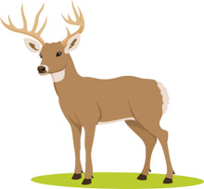

Interpretive Sign Example
Maahlakws (ma-ala-cous) - Ash Tree
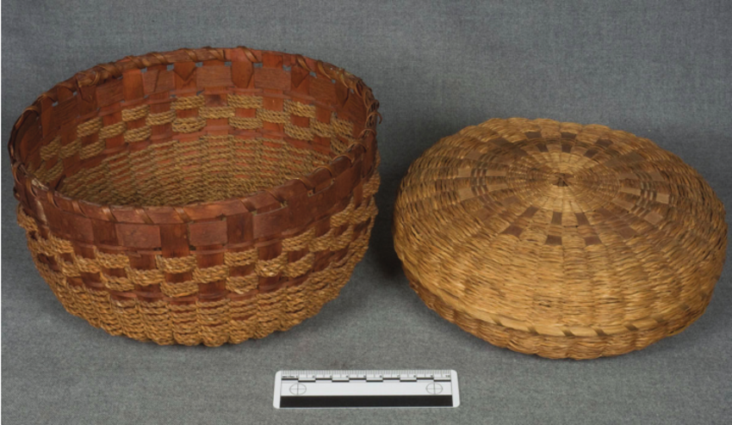

"Gloosekap came first of all into this country, into the land of the Wabanaki, next to the sunrise. There were no Indians here then. And in this way he made men: He took his bow and arrows and shot at trees, the basket trees, the ash. Then Indians came out of the bark of the ash trees.”

-Wabanaki creation story told by Molly Sepsis, published in Algonquin Legends by Charles G. Leland
Baskets are a fundamental part of the culture and traditions of the Wabanaki, who believe that basket making is a skill that has been passed from weaver to weaver, generation to generation, uninterrupted for thousands of years.
The Wabanaki made splint baskets of specific shapes and sizes to gather and prepare food and trap fish, both before and after European contact. Post-contact, many tribal people used basket making as a way to make a living outside of non-native towns and cities.
Wabanaki baskets are made primarily from long, thin strips of wood, or splints, of the brown ash tree. Known as the “basket tree,” the brown ash is considered sacred to many of the native peoples of the northeastern United States and Canada. The wood of the ash tree is also both strong and flexible, making it particularly well suited for weaving durable containers.
The emerald ash borer critically threatens the long-term survival of ash trees today.
Sources:

Mundell, Kathleen. North by Northeast: Wabanaki, Akwesasne Mohawk, and Tuscarora Traditional Arts. Tilbury House Publishers, 2008. Print. (page 29)
(from https://dawnlandvoices.org/collections/exhibits/show/along-the-basket-trail/overview)

“Essay: Wabanaki Basket Weaving.” Hood Museum of Art, Dartmouth College.
(from https://www.naaer.hoodmuseum.dartmouth.edu/essay-wabanaki-basket-weaving)

Sample images may be copyright protected.

Part 4: Indigenous Advisor to the ACF Management Committee

The ACF Management Committee will hire an Abenaki tribal citizen as a paid consultant working on-call. This consultant will advise on all matters of land use and changes to the ACF Management Plan.

Cecilia - would a paid consultant be more appealing to the committee than maintaining an Indigenous committee member (and possibly adding an exception in the bylaws to the Richmond-resident requirement)? Richmond Racial Equity is working to secure funding from the Selectboard to pay an Indigenous consultant , but it’s far from a done deal.

