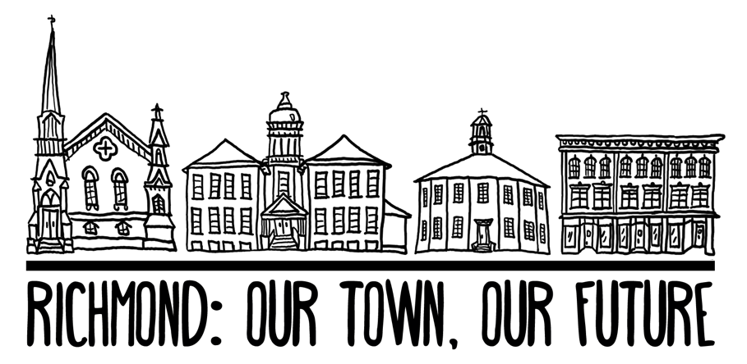

RICHMOND, VERMONT
2018 TOWN PLAN

APPROVED BY THE RICHMOND SELECTBOARD:

contents
INTRODUCTION
OUR TOWN
OUR PLAN
USING THIS PLAN
PLANNING PROCESS
FROM VISION TO ACTION
ACTION PLAN
FUTURE LAND USE Technical Plan
ECONOMIC DEVELOPMENT Technical Plan
ENERGY Technical Plan
HOUSING Technical Plan
NATURAL RESOURCES Technical Plan
COMMUNITY DEVELOPMENT Technical Plan
EMERGENCY RESILIENCE Technical Plan
HISTORIC RESOURCES Technical Plan
EDUCATION Technical Plan
TRANSPORTATION Technical Plan
UTILITIES + FACILITIES Technical Plan
IMPLEMENTATION PLAN
RICHMOND ALMANAC
MAPS
RESOURCES+ REFERENCES+ ACKNOWLEDGMENTS

Introduction

OUR TOWN
Richmond is a small, rural town located in the eastern uplands of Chittenden County with an estimated 4,129 inhabitants. The forested foothills of the Green Mountains and open agricultural land in the Winooski River Valley characterize Richmond’s 34.41 square miles. The earliest forms of commerce were agriculture and trading, yet today most residents find employment elsewhere. Burlington, Vermont’s largest city and urban center, is only 15 miles to the west, and Montpelier, the small state capital, is about 25 miles to the east.
The village center, located at the crossroads of Main Street (US Route 2) and Bridge Street, functions as the community center and is host to a handful of small retail and commercial businesses, the library, the post office, municipal offices, residential side streets, the elementary and middle schools, Volunteers Green, and the iconic Round Church. The village area is served by the municipal water and sewer system and is bisected by the Winooski River.

Located three miles to the east of the village along Route 2 is Jonesville. A small post office and a cluster of businesses define a once thriving small village center. One additional area known locally for its historic settlement significance is Fays Corner. Located approximately two miles west of the village up Hinesburg Road at the intersection with Kenyon Road and East Hill Road, Fays Corner was once a small hamlet defined by its one-room schoolhouse, store, mill, and tannery operation and clustering of farmhouses at a crossroad location.
Today, the majority of housing development is located outside these historic settlement areas along Richmond’s secondary paved and dirt roads or within contemporary subdivisions, such as Hidden Pines, Southview, Greystone and Stonefence. Another significant neighborhood is Riverview Commons Mobile Home Park, one of the largest parks in the state.
Most of the housing was built between 1960 and 1980 reflecting the period of greatest population increase. During the 1960s, Richmond’s population grew fastest, increasing by more than 70% in just a decade. This was most likely due to the completion of the interstate highway system and the establishment of international computer chip manufacturer IBM in nearby Essex Junction. Growth then began to slow and Richmond’s population then declined in the early 2000’s during the economic downturn, for the first time in 50 years. Since 2010, the town has experienced very little population growth.
During the Our Town, Our Future planning process we heard that Richmond residents love the strong community, the available services and amenities, the small town character, the people, and the rural landscape and environment. We heard people wanted new and improved businesses, safe biking and walking routes, and more recreational offerings. We also learned that Richmond residents are both different and the same. Youth and seniors, newcomers and longtime residents have similar values but different needs and priorities.

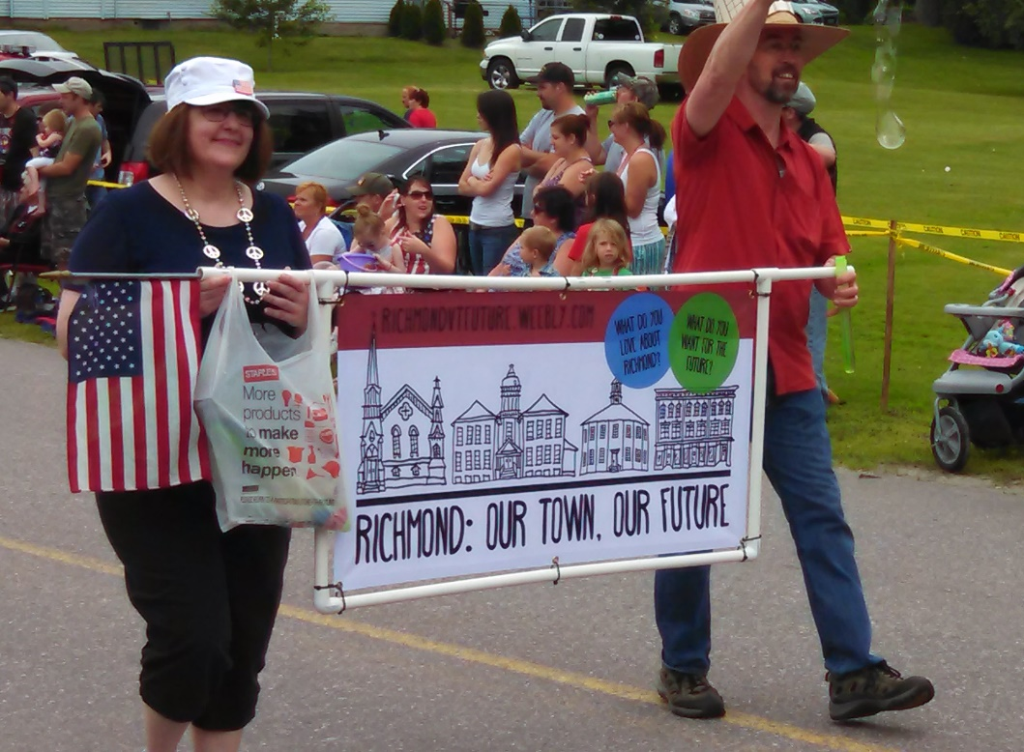

OUR PLAN
The purpose of this plan is to guide community members and leaders in protecting what we love about Richmond and enhancing the aspects we wish to improve. We have great power and responsibility to bring the community’s aspirations and intentions to life, through public investments, incentives, land use regulations and other implementation programs.

A Plan for the Community
First and foremost, this is a plan for and by the Richmond community. Dozens of Richmond community members and groups played a role in developing actions and writing the plan, and they incorporated ideas and suggestions from hundreds more residents. This plan represents the first time in 10 years that Richmond has conducted an extensive community outreach process to reach many diverse community members and developed a common community vision to guide and shape policies and actions. This plan places a strong emphasis on supporting and enhancing the community vision and values identified by community members. It is meant to be a road map for our future, but also offer clear and concrete guidance to the people and groups who live and work in Richmond every day.
We understand that there are inherent conflicts in planning values and priorities that will affect future zoning and development; however, we recognize the responsibility to act on a case-by-case basis and make the best possible decisions as a multifaceted town government.

State and Regional Connections
A community, under Vermont state law, is enabled by statute to develop and adopt a municipal plan. Towns can receive significant benefits from creating municipal plans. Communities that draft and approve town plans may levy impact fees or receive state planning funds to implement planning programs, and are more competitive in many other grant and technical assistance programs. In order to achieve those benefits, town plans must be approved by voters, confirmed by the Regional Planning Commission (RPC), and be updated regularly. In order to be confirmed by the RPC, plans must be consistent with the state planning goals as defined within Vermont statute 24 VSA §4302 and contain all the required elements as specified within 24 VSA §4382. Alignment with state and regional planning efforts not only helps us meet requirements, but also ensures that our efforts as a community will align with – and be supported by – projects and policies happening within Chittenden County and Vermont.

Policy on Inclusion
This plan and the planning process are subject to Richmond’s Policy on Inclusion, which was passed as a non-binding resolution on March 7, 2017, at Town Meeting:
“Be it resolved, that we the people of Richmond celebrate diversity and welcome all people no matter their color, the religion they practice, their ethnicity, nationality, sexual orientation, socioeconomic status or gender identity.”

What the Plan Does
Specifically, this plan will:
- Include an assessment of the assets and conditions in Richmond at this moment in time
- Articulate Richmond’s community vision, and the ways in which community members want to enhance and protect core community values
- Identify interconnections and relationships between key values, goals, and actions
- Identify partners for implementation and opportunities for collaboration among a broad range of community groups and organizations
- Provide clear guidance on Richmond’s goals and policies to organizations, developers, businesses, and property owners, and state agencies or commissions
- Provide community officials and leaders with clear standards for evaluating proposals by private individuals
- Clearly identify state and regional connections, including consistency with state policies and opportunities to coordinate with regional plans
- Provide the foundation for municipal regulations and programs, such as zoning and subdivision regulations, an official map, a capital budget and program, and impact fees
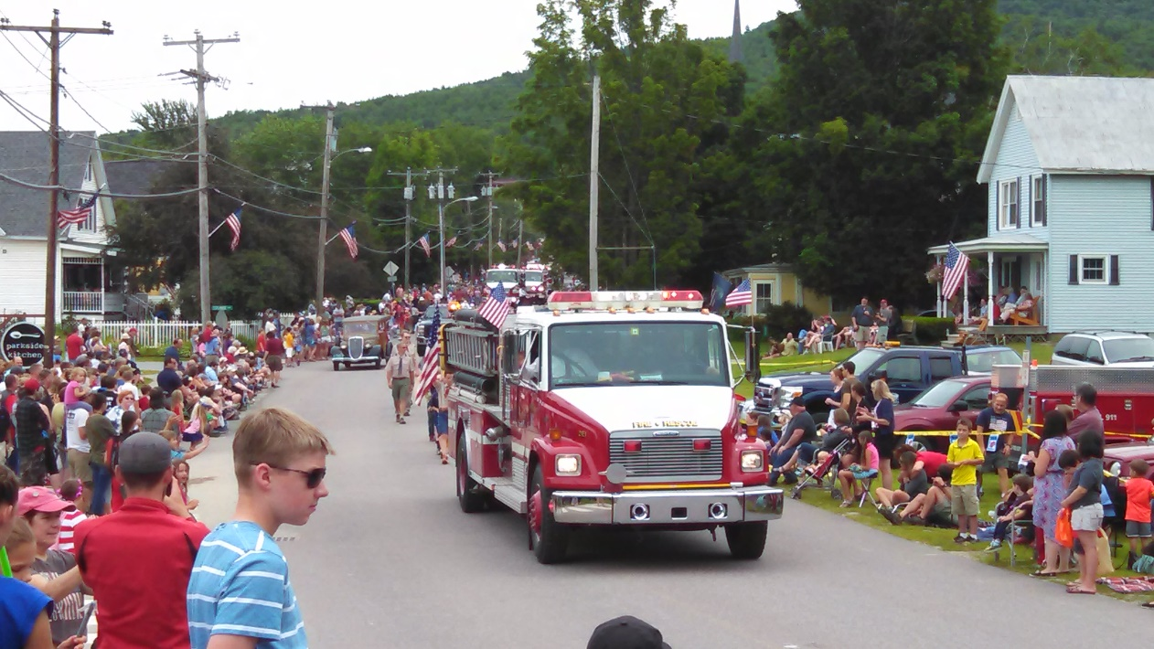

Using this Plan

The structure and format of this plan are different from those of Richmond’s past municipal plans, and different from those of many other community plans in Vermont. This format was chosen based on the feedback that was received in the planning process. The information below will help orient readers to the new features and sections included here, and explain how to easily navigate its sections.

Plan Structure and Features

From Vision to Action | The vision and values are the highest-level articulation of what Richmond’s community members value and want for the future. All community actions, policies, and decisions should be evaluated against the vision and values:
Action Plan | The Action Plan details the specific goals, policies, and actions Richmond will use in order to advance the vision. The section includes three main components:  - Technical Plans on topics that state statutes require us to address. These plans bring together actions and relevant connections to state and regional plans.  - The Goal and Action Tables, which list goals and actions for each technical plan.  - The Implementation Plan, which serves as a roadmap for how we plan to accomplish the actions
Richmond Almanac | The Almanac is an innovative companion document to this plan, unique to Richmond. The Almanac includes statistics, inventories, and information about many aspects of the community. The information in the Almanac informed the development of this plan, and it is intended to be a reference moving forward.

Planning Process
In late 2014, the Town of Richmond successfully applied for a Municipal Planning Grant from the Vermont Department of Housing and Community Affairs (DHCA) to help fund the development of this new town plan. Emphasis was placed on defining a new community vision, extensive community engagement, and the creation of a shorter, more accessible and engaging, action-orientated town plan.
In early 2015 the town contracted with Community Workshop LLC to assist with the town plan project. A steering committee was formed to help guide the process. Along with the planning commission, the committee defined process goals and branding, and Planning Commissioner Marc Hughes designed a logo. By late spring, the town launched the Richmond: Our Town, Our Future planning project.
In order to lay the foundation for this new town plan, Richmond: Our Town, Our Future undertook a variety of outreach and engagement activities. Most notably, we received 394 completed surveys, hosted a community vision forum to share the vision statement; organized a resilience fair to increase awareness of flooding and emergency preparedness; facilitated a series of rapid-fire planning nights to review goals and identify action items; and coordinated a mapping workshop to inform the Future Land Use Map. This plan aims to distill the tremendous number of public comments and ideas and the feedback gathered from many voices and perspectives for a unified vision for the future.
Outreach and engagement by the numbers:
- 2,200 postcards mailed
- 394 surveys completed
- 387 action ideas identified
- 370 chalkboard comments
- 300 responses to youth survey
- 250 pencils and lollipops distributed with project info attached
- 180 subscribers to email newsletter
- 65 attendees at September community vision forum
- 58 goals generated
- 53 vision cards written
- 50 posters displayed to advertise events
- 55 unique attendees at rapid fire planning nights
- 45 participants in mapping workshop
- 32 one-on-one interviews conducted
- 25 attendees at fall resilience fair
- 18 email newsletters developed
- 5 Rapid Fire Planning Nights hosted
- 2 articles in the Times Ink
- 1 mention on Vermont Public Radio’s Public Post

Responsibilities

Planning Commission
The Richmond Planning Commission (PC) is responsible for preparing the plan, holding public hearings on the plan and submitting the plan to the Selectboard for final approval and adoption. The planning commission consists of seven voting members, appointed by the Selectboard to represent a diverse range of skills, interests, and areas of town.
Moving forward, the planning commission will prepare and annually update the capital budget program; conduct studies and make recommendations on land development, urban renewal, transportation, community development, beautification, design, historic and scenic preservation; conservation of energy, and development of renewable energy; participate in regional planning programs; retain staff and consultants; recommend fees to the legislative body; and hold public meetings.
Town Plan Steering Committee
The Town Plan Steering Committee was appointed specifically to guide this planning process, and to help reach many more (and more diverse) community members than planning efforts typically do. The Town Plan Steering Committee included representatives who could reach many distinct community groups. The committee’s responsibilities are complete with the publication of this plan, and the committee will dissolve.

Selectboard
The Selectboard must officially approve or endorse this final plan, and is responsible for setting most of the town policies and making critical decisions to guide the plan’s implementation. In many cases, the board is asked to evaluate and decide on proposals, and will use this plan as a tool in doing so.

Town Staff
Town staff have provided staff support and guidance throughout this planning process, including helping to organize and publicize events and opportunities to engage the public. They are also charged with leading many of the implementation steps, and with supporting and following the plan in carrying out their responsibilities.

Town Boards + Committees
Richmond’s many town boards and committees each oversee particular aspects of the community (such as conservation or development review). Each board provided input into relevant goals or plan sections, and each is responsible for leading or implementing actions related to its area of expertise.

Community Members + Other Groups
This plan goes much further than previous plans in terms of engaging the community and identifying a broadly supported vision. Implementation will in turn require the support and involvement of many more community members and groups. The community was responsible for providing the input that shaped the vision, actions, and priorities, and will be subject to the policies and actions that the plan defines. Many actions cannot happen without resources and energy from local nonprofits or businesses, schools, or community members, and the plan is intended to make it easy for people to get involved and take responsibility for making Richmond a better place.

