TECHNICAL PLANS
VISION CONNECTION
- Affordability: Most housing in Richmond costs more than the affordable housing benchmark – 30% of household income.
- Community for All Ages: Our aging population needs new housing options, as do younger residents with limited income or different priorities.
- Economic Opportunity: Adequate housing near job sites and convenient transportation, is one of the top indicators of economic growth and opportunity.
- Mobility: The location of housing can dramatically impact people’s mobility and options.
- Vibrant + Appealing Downtown: Many people want to live in walkable, vibrant neighborhoods, close to businesses and services. More downtown housing can help meet other downtown goals.

housing
Chittenden County’s 2018 ECOS plan notes that diverse housing is essential for community sustainability, workforce development, vibrancy, and minimization of personal stressors. Housing stock is greatly in need of improvements and change, according to both input from community members and an analysis of data and trends. Across Vermont, communities are wrestling with strategies to improve and update an aging housing stock, increase the diversity and affordability of housing options, and ensure that new housing is sited and designed to support other goals such as downtown vitality, energy and transportation efficiency, and community connections.
Housing can last decades or even centuries. That means much of our housing today was designed for a different time and context – for larger families, with less mobile and transitory populations, and using now-outdated techniques and materials. We currently seek to have housing stock that meets the needs of our current residents and expected future generations. The majority of Richmond’s current housing stock consists of scattered, single-family homes. Our current one-acre zoning supports that pattern. While many people value our older, rural housing for its character and historic value, we lack a diversity of housing types and sizes, energy-efficient housing, and housing options near transit and amenities. In particular, Richmond lacks rental units and units of smaller sizes (such as apartments or duplexes), and housing options in denser village centers within walking distance of municipal and commercial services.
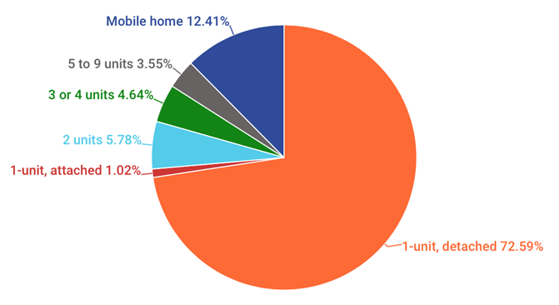
In addition to housing types and number of units, other characteristics have major impacts on the community. The median cost of housing in Richmond is higher than the median in both Vermont and Chittenden County, and Richmond’s most common housing type (single-family homes) tends to be the most expensive type of housing. That has major implications for affordability and for ensuring that people can come to, and continue to live in, town. Older homes tend to be less energy efficient and require more heat; much of our housing is scattered throughout the rural town, which leaves residents dependent on personal cars; and housing built in unsafe locations like floodplains often results in expensive, repetitive losses and damage. Housing costs are also affected by many independent factors, such as fuel and transportation costs, energy and other utilities. Affordable housing for the region is anywhere from $180,000-$200,000 for 3-bedroom single family home. Most single family homes are reaching $300,000-$400,000 in price. The same goes for rental housing. The affordable rate for a 1-2 bedroom rental unit is $1000 per month without utility costs. Rental unit rates are currently upwards of $1500-$2000 for a 1-2 bedroom unity. These are major gaps that organizations like the Champlain Housing Trust are trying to close by keeping certain housing stock at perpetually affordable levels. Housing also impacts other values and community characteristics, including affordability and character. We can control municipal costs by incentivizing housing types and locations that require less support or infrastructure from the town. Appropriate siting and design can also help us reduce congestion, spur economic growth, build a vibrant downtown, and reduce energy use.

GOALS & ACTIONS
GOAL 1: Strive to have diverse, affordable, and quality housing options for residents and potential residents from all walks of life
ACTIONS:
- When updating zoning regulations, identify opportunities to remove regulatory barriers to the development of these housing types, for example allowing mixed residential and commercial use in certain districts, higher unit density, or unique accessory housing
- Create a town housing committee that can identify needs and partner with organizations to help secure funding and identify opportunities for construction or conversion of housing stock, as well as aid in the creation of zoning regulations or incentives that are attractive to affordable housing developers and residents alike
- Encourage concentrated affordable residential development in and near the village center to increase walkability for non-drivers and reduce need for single occupancy vehicle traffic
- Consider participation in the FEMA Community Rating System which can lower overall home insurance costs for homeowners in the Special Flood Hazard Area
- Support, and share information about, programs and resources that assist seniors or low mobility residents remain in their homes such as HomeShare Vermont, Meals on Wheels, and Neighbor Rides
- Support, and share information about, programs and resources that help to lower cost of home ownership such as energy conservation, weatherization, and utility assistance
(see also Future Land Use, Economic Development, Transportation, Energy)

