TECHNICAL PLANS

Energy
VISION CONNECTION
- Affordability: Energy is one of the greatest costs for nearly all Richmond residents. Conservation and renewable energy sources will help reduce costs.
- Economic Opportunity: The renewable energy sector is growing rapidly, and represents high potential for Richmond to grow jobs and businesses.
- Mobility: Some of the greatest opportunities lie with transportation –creating opportunities for sustainable transportation.
- Safety + Resilience: Reliance on fossil fuels is a challenge to our resilience every day, and our use of fossil fuels globally is directly leading to more climate-related hazards.

Vermont’s CEP (Comprehensive Energy Plan) states: “Energy adequacy, reliability, security, and affordability are essential for a vibrant, resilient, and robust economy.” Energy is one of the greatest expenses for the Town of Richmond and most households – as well as the state and the planet.
A majority of Richmond residents utilize traditional electricity sources from VEC, and Green Mountain Power. They also utilize the Energy Co-Op of Vermont (Richmond-Bolton). Energy used in Richmond is obtained from a variety of sources and is used to heat and cool buildings; to operate appliances, equipment, and lighting; and to transport people and products. Out of the total amount of energy used in Richmond, the most use is seen in the transportation sector, which now consumes nearly as much energy as residential and commercial uses. Richmond’s energy footprint could be greatly improved through targeting our highest demanding sectors, which coincides with the state and regional energy goals.
The Chittenden County ECOS Plan states: “A transition to renewable energy will require electrifying the heating and transportation sectors by generating more electricity from renewable sources.” Renewably sourced electricity would make the deepest impact on energy consumption and emissions for those sectors locally, regionally, and statewide.
The State of Vermont has adopted a number of energy goals through both statute and as guiding principles of its CEP. The recently adopted Renewable Energy Standard, for example, requires electricity to be derived 55% from renewable sources by 2017, rising steadily to 75% renewable by 2032. That same legislation sets an aggressive goal for the amount of electricity obtained from locally distributed energy generation. State law also calls for major reductions in contributions to greenhouse gas emissions, weatherization of 80,000 housing units by 2020, and an increase in the amount of in-state renewable energy obtained from farms and forests. This energy plan targets the 90 by 50 goal, using that objective as a basis for determining the amount of conservation and fuel conversion required in each energy sector as well as the amount of new renewable energy generation required across the state.
COMMUNITY ENERGY DASHBOARD
The Vermont Community Energy Dashboard is a new tool that helps Vermont communities understand and track their energy use, share stories, set goals, and identify and track actions. The free website is available at vtenergydashboard.org

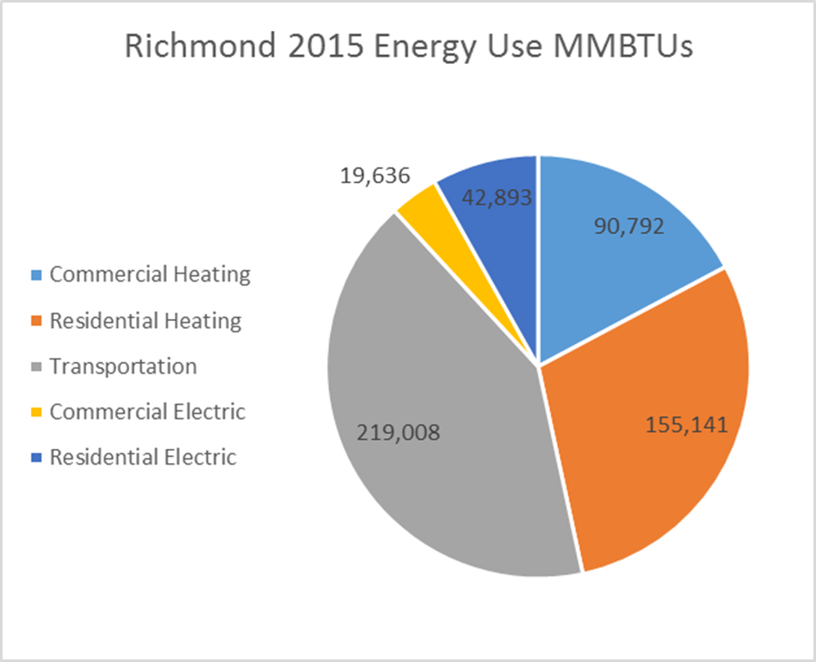
The 2016 Vermont CEP includes several additional goals that define benchmarks toward attainment of the 90 by 50 goal:
- Reduce total energy consumption per capita by 15% by 2025 and by more than one-third by 2050.
- Meet 25% of the remaining energy need from renewable sources by 2025, 40% by 2035, and 90% by 2050.
- End-use sector goals for 2025: 10% of transportation energy demand, 30% of building energy demand, and 67% of electricity energy demand met from renewable sources.
Richmond endorses the Vermont energy goals enumerated above, and will pursue policies and actions intended to achieve or exceed them.
This energy plan includes the following goals to further guide actions related to energy conservation and efficiency in our communities:
- Reduce total energy consumption while maintaining a high quality of life and a vibrant economy.
- Encourage energy conservation in the residential, commercial, industrial, public/institutional, natural resource, and transportation sectors.
- Increase opportunities to make energy choices at the local level.
Vermont has also adopted Residential Building Energy Standards Vermont’s Residential Building Energy Standards (VT-RBES) require all new residential construction, renovations, alternations and repairs meet specific energy conservation and efficiency measures. State statute requires that builders file a copy of the certificate with the town, as a condition of a local Certificate of Occupancy permit.
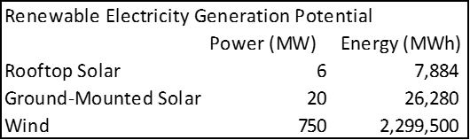
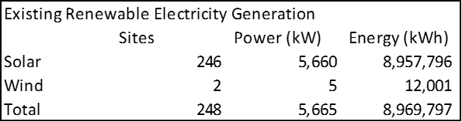
Currently Richmond is home to the following renewable generation and potential generation:

Goals & Actions
GOAL 1: Richmond will have 10%, or greater, renewable energy use in transportation
- Adopt zoning regulations that are based on “smart growth” principals including concentration of development
- Support private installation of electric vehicle charging stations, and consider the installation of a public station at or near the town center
- Support bike and pedestrian transportation through “complete streets” policies and projects
- Support public transit, carpooling, and ridesharing opportunities for Richmond residents
- Prioritize fuel efficiency and low emissions when making municipal vehicle and equipment purchases
- Seek out funding opportunities, such as the VW Settlement funds, to financially assist the implementation of these actions
(see also Transportation)
GOAL 2: Richmond will have 30%, or greater, renewable energy use in heating and cooling buildings
- Continue to require Vermont Residential Building Energy Standards (RBES) certification as a condition for Certificates of Occupancy that are given through the zoning administrative process, and add this statutory requirement to Richmond’s bylaws
- Incentivize development that exceeds state energy standards
- Implement energy saving projects from the facilities assessment of the town center, fire station and library, and assess the remaining town facilities for potential projects
- Provide or support educational opportunities regarding energy efficiency and conservation for town residents and/or employees
- Utilize community resources such as Efficiency Vermont and the Community Energy Dashboard
GOAL 3: Richmond will have 67%, or more, of the electricity demand met by renewable energy sources
- Adopt zoning regulations that allow for off-grid renewable energy projects, including impact mitigation, siting, and project management. Impact considerations would include but are not limited to wetlands, habitats, scenic viewsheds, forests, waterbodies, etc.
- Utilize the wind and solar ideal siting maps to identify potential sites for renewable energy projects in Richmond
- Support net-metering opportunities for residents, businesses, and organizations
GOAL 4: Richmond will have a sustained volunteer Energy Coordinator position that informs town decisions and policies and help achieve above mentioned goals
- Develop a standalone Energy Plan for Richmond that extends beyond this technical plan
- Work with town staff and boards to draft energy policies
- Identify investment opportunities for the town in renewable energy projects or resources
- Maintain energy conservation and consumption data for the town
- Analyze energy costs and opportunities to reduce costs for the town
- Educate the community on energy conservation techniques and options in conjunction with the Richmond Climate Action Committee
- Assist in grant applications and securing funding for energy related projects
- Lead the implementation of the 2007 Town Energy Conservation policy
(see also Future Land Use, Natural and Cultural Resources)

