RIchmond Almanac
A companion resource to the Richmond Town Plan

contents

- Introduction
- Community OvervieW
Geography + Land Use
Demographics
History
Government
Education
Community Facilities + Recreation
- Economy
- Basic Needs + Services
Housing
Transportation
Energy and Utilities
Healthcare
- Environment + Conservation

Introduction

How can you get very far, If you don't know who you are? How can you do what you ought, If you don't know what you've got?
- benjamin hoff, the tao of pooh

In 2016 and 2017, the Town of Richmond launched Our Town, Our Future – a broad community visioning process that engaged hundreds of community members in describing the future they want for Richmond. The new vision serves as the framework for Richmond’s 2018 Town Plan – a guiding document that maps out a path to achieving our vision.
Extensive community input is crucial to charting that path and identifying the needs, opportunities and strategies that lie ahead. Equally important is data – quantitative and qualitative information about conditions in the community today, an inventory of assets and characteristics, historic trends and patterns, and future projections.
The Richmond Community Almanac is a place to pull together all of that data and information. It is essential to informing and underlying our Town Plan and our strategies moving forward. It serves as a snapshot of the community at this moment in time. And we hope it will become an important community resource, of interest and value to a wide variety of community members and leaders.

geography + land use
The natural diversity of the 22,022 acres (34.41 sq. miles) that comprise Richmond's landscape is a reflection of the town's location astride the boundary of two of Vermont's physiographic regions: the Northern Green Mountains and the Champlain Lowlands. The landscape is dominated by foothills, which reach 1,640 feet at the town's highest elevation, and is bisected by the Winooski River, which carves out the town's lowest point at 250 feet where it flows through the lowlands into Jericho. With the exception of the extreme southwest corner of the town (which eventually drains into the LaPlatte River), the Richmond landscape is contained within the Winooski River Watershed.
The foothills are given their shape by the underlying metamorphic bedrock, which has slowly been eroding since its formation over 500 million years ago. The bedrock is part of the Mansville Complex, and is composed primarily of the Pinnacle Formation (mainly metawackes) and the Underhill Formation (mainly chlorite schist). Although the bedrock can be seen outcropping in numerous locations throughout the town, it is largely mantled by sediments left behind as the Laurentide ice sheet retreated from the landscape 10,000 years ago. Glacial till, a mix of particles ranging in size from clay to boulders, is the dominant surficial material above 600 feet, whereas gravels, sands and silts are common in the valleys where ancient river terraces and deltas are exposed. Clay deposits can also be found in the lowlands, evidence that Lake Vermont (a precursor to Lake Champlain) once inundated the major river valleys with glacial meltwater for a period about 12,000 years ago.
The 74 different types of soil found in Richmond are a manifestation of the underlying geological diversity. The youngest (and most fertile) soils are found in the Winooski River floodplain, where frequent high-water events deposit fresh alluvial material on a regular basis. The soils in the higher elevations that formed in glacial till are rocky and of moderate fertility and most were abandoned agriculturally over 100 years ago. The Richmond landscape, which is approximately 80% forested, supports a diversity of natural communities. Northern hardwoods, with major components of sugar maple, red oak, white pine, and hemlock, dominate the uplands. The lowland areas that are not developed or in active agriculture are composed primarily of silver maple-dominated floodplain forests.
With the completion of the interstate in the 1960s Richmond became more readily accessible from Burlington, Montpelier and other majors centers of employment. This coincided with the development of the IBM facility in Essex Junction. Together, these two factors translated into a significant increase in residential development in Richmond in the 1970s and 1980s. Some of this newer development has followed the typical linear pattern along rural roadsides. However, several subdivisions of 20 lots or more have also been constructed in the last two decades. Generally, these subdivisions offer a more compact pattern of development, in some cases incorporating open space to be protected for the future.
Many land parcels in Richmond have been broken up into tracts of 5 acres and less. Large parcels still exist in town, principally in floodplain areas, where most of the land is devoted to agriculture or recreation, and in steep upland areas which are not suited to development. The upland parcels are most commonly managed for timber production. Land suitable for development has become scarce in Richmond and surrounding towns because of growth and topography, resulting in more pressure to subdivide large parcels. Looking to the future, the commercial and residential growth that has taken place in neighboring towns is likely to put further pressure on land values in Richmond.
Due to the presence of excellent river valley soils and a relatively moderate climate, agriculture has always been an important land use in Richmond. Despite the development pressures of the last several decades and the decline of small family farms, Richmond still has an active agricultural community, with 21 parcels classified as “Farm” in the 2005 Grand List. These include dairy farms, beef farms, vegetable and fruit farms, and other agricultural operations. Several farm properties have more than one product. In addition, several landowners in Richmond harvest timber periodically from their land.
Richmond village has typical small town housing density with interspersed business and commercial units. Approximately 275 (or 18%) of the Town’s 1,500 dwelling units are located in the central village. This village has seen a revival of its commercial core in recent years, with the renovation of the Goodwin Baker Building for offices, several new businesses and restaurants along Bridge Street, new commercial and residential development in the Railroad Street area, and new residential development at the end of Church Street. Additionally, the old cheese factory lot on Jolina Court is slated for redevelopment. The Jonesville area has small village housing density with approximately 70 houses, two apartment buildings and a small group of commercial buildings. Riverview Commons, the Town’s largest mobile home community, has approximately 150 units.
Finally, Richmond has seen a significant increase in the amount of land devoted to recreation in the last 15 years. Volunteers’ Green has expanded to include approximately 22 acres of land for baseball, soccer and other recreational sports, as well as a playground and band shell. The Richmond Land Trust has conserved parcels totaling approximately 660 acres, many of which are available for hiking, cross-country skiing, swimming, nature study and other recreational pursuits. Hunting and fishing continue to be popular both on public and private lands. The Town of Richmond Recreation Path Committee and the Richmond Land Trust have developed approximately 7 miles of recreation paths along the Winooski River, Old Jericho Road and upland parcels. These trails are used year round and have become an important recreational asset for the Town. Even though the Town and the Land Trust have made significant gains as noted above, there is still a shortage in the amount of land available for more developed facilities and programs, such as those needed for school sports and adult and youth league sports.

DEMOGRAPHICS
As of the census of 2000, there were 4,090 people, 1,504 households, and 1,100 families residing in the town. As of the 2010 census, there were 4,081 people, and 1586 households representing a slight decrease in overall population. The projection for increase from 2000 to 2015 was about 6,000 new people. In the 2010 census the village population was 723. In 2000, racial makeup of the town was 98% Caucasian and less than 1% each: African American, Native American, Asian, Pacific Islander, Other. Hispanic or Latino of any race were less than 1 % of the population. There has only been a slight change in these statistics: 97% Caucasian, and remaining races still all less than 1%.
In 2010, there were 1,586 households out of which 35.1% had children under the age of 18 living with them, 59.7% were married couples living together, 9.3% had a female householder with no husband present, and 27.2% were non-families. 4.7% households had someone living alone who was 65 years of age or older. The average household size was 2.56 and the average family size was 2.94.
In the town, the population was spread out with 27.3% up to the age of 19, 3.2% from 20 to 24, 25% from 25 to 44, 34.9% from 45 to 64, and 9.5% who were 65 years of age or older. The median age was 41.7 years. For every 100 females there were 95.7 males. For every 100 females, there were 96.0 males.
As of 2015, the median income for a household in the town was $57,499. Males had an average income of $66,270 versus $48,729 for females. About 10% of the population were below the poverty line.

history
The first inhabitants of Richmond were indigenous people, who utilized the natural resources and topographic features important for travel, hunting, and food. Paleo-Indians are believed to be the first Vermonters and undoubtedly traveled through and hunted in Richmond. They were hunters and gatherers and lived in the Champlain Lowlands between 12,000 and 9,500 years ago. Archaic Indians lived here from 9,500 to 3,000 years ago. The Winooski River was also a common highway for the Abenaki Indians after 1,000 A.D. between Lake Champlain and the Connecticut River.
An important archaeological site was discovered in 1809 in Jonesville, with arrowheads and stone utensils discovered in an area off Wes White Hill Road. In 1995, a nearby site was excavated as part of the engineering project to replace the bridge over the Huntington River. At that site, new findings showed the site was used on a seasonal basis by Abenaki Indians beginning around 1400 A.D., who developed a small camp or residential base for gathering food and hunting for a wide variety of fur-bearing mammals. Excavation showed that at least 11 different species of mammals were brought back to the site, including bear, deer, beaver, cottontail rabbit, chipmunk, red squirrel, muskrat, porcupine, fisher, mink, and skunk. The seasonal residents hunted within the Winooski River Valley and more upland areas, particularly the Green Mountains and area around Gillett Pond and its surrounding wetlands. Artifacts at the site also showed evidence that the Abenaki Indians had some contact with St. Lawrence Iroquois and perhaps with areas of New York near the Hudson River.
Throughout the 17th and well into the 18th century, Vermont served as a passageway for the French and Indian raiding parties harassing English settlers to the south and east, and also served as a slave corridor where captured whites were driven north to Canada. European settlement of Vermont did not begin until the Treaty of Paris ended the French and Indian War in 1763. In 1793, Governor Wentworth of NH granted a significant area of southern Williston to Solomon Bates. This became part of Richmond when Richmond was granted township status in 1794. The Bates farm remained in the Bates family until 1986. The farmhouse remains today and the barn is now Birds Eye Building Co., which was restored to modern use. In 1775, Amos Brownson and John Chamberlain established homesteads in the area known as "the flats" which was at that time a part of the Williston Township. This early settlement coincided with the advent of the American Revolution when Vermont settlements on the borders of civilization were vulnerable to Indian attack. A man and a child were killed at the Chamberlain homestead before Richmond's settlers, along with nearly all the other families in Chittenden County, abandoned their new homes and fled to the south for safety.
After the Revolutionary War in 1784, Brownson and Chamberlain returned, other settlers arrived, and settlements were built in areas which were then portions of Huntington, Bolton, Jericho and Williston. Portions of these settlements formed what became Richmond. After petitioning the State, Richmond was granted township status in 1794, and has the distinction of being the first town chartered by the newly formed State of Vermont. By the time the census was taken in 1800, Richmond had grown to a population of 718. Formal community responsibility began with the first Town Meeting in March 1795.
Two forms of commerce were visible in early Richmond: agriculture and trading. The latter was secondary to farming, dependent primarily upon the produce raised by local farmers. Wool and grain, the chief commodities in the early years gave way to milk and dairy products in the mid- 1800's. Cheese and butter were made in local factories and shipped to market. Business activity was enhanced by Richmond's proximity to the Turnpike Road (US Route 2). Travelers on the difficult 60-mile trip between Burlington and Montpelier found Richmond a natural over-night stop.
The farmer, needing the cash to pay for the products and services offered in town, found his woodland could bring him some revenue. Lumber was in demand, and ships sailed daily from Burlington carrying away much of the wealth of Vermont's forests. Hardwood not sold as lumber was burned to make potash. Smoke spiraling upward behind many farm homes told of the stripping of forestland. Within 100 years after the first settlers arrived, the valleys and hillsides were denuded of their ancient cover. The loss of this resource paved the way for the devastating floods of the twentieth century. As the community grew to a population of 1,453 in 1850 transportation and communication became important. The turnpike was improved in 1849, the same year that the railroad was completed. Richmond's business district began to shift to the north of the river to be nearer to the turnpike and the railroad. Telegraph service linked Richmond with the rest of the country also in 1849.
With new and expanded markets available, it became profitable to operate factories and businesses in Richmond. H.C. Gleason opened a creamery in 1885, the Borden Company established a milk processing plant, and a cooperative creamery began to operate. At that time, Richmond was the second largest shipper of butter and cheese in the State of Vermont. The creamery site is now being rehabilitated. Other industries in this thriving community of the 1800's were: a carriage manufacturing steam sawmill, furniture factory, paper mill, spool factory, woolen mill, spoke factory, cider mill, several grist mills, and a steam mechanics shop. Businesses dealing in drugs, furniture, dry goods, groceries, hardware, tin ware, harness making, jewelry, millinery, blacksmithing, confections, boots and shoes, marble and woodenware were available to the Richmond resident.
One of the items of business transacted at Town Meeting on December 6, 1796 was the decision to obtain a site for a meetinghouse. Isaac Gleason and Thomas Whitcomb donated land on which to erect a structure that could serve as a combined meeting house and house of worship. Construction was begun in 1812 on what was to become Richmond's most famous building, the Round Church. Money to pay for the building was raised by selling pews, with no preference given to anyone because of religious creed. Because of the several religious denominations contributing time and money toward building the church, and holding services there, it has been referred to as the first "community church."
The Round Church ceased to be used for religious services in 1879 but continued to serve the town as a meetinghouse until 1973 when State regulations declared the church unsafe for public use. In 1976 the town deeded the church to the Richmond Historical Society for forty years so that restoration could proceed with federal assistance.
Education has deep roots in Richmond. One of the first examples of community responsibility occurring at the June 5, 1795 Town Meeting was the division of Richmond into six school districts. Each of the six schools was then supported by voluntary taxation until 1826 when taxes were levied to cover school expenditures. In 1903, three young women formed the first class to graduate from the newly built Richmond High School.
At the turn of the century, Richmond began to acquire some of the hallmarks of twentieth century living. In the early 1900’s R. J. Robinson opened the first electric light plant on Dugway Road at the Huntington Gorge, which was subsequently purchased by Green Mountain Power. Western Telephone and Telegraph offered their service from an office in the old Jonesville Hotel. Later, a movie theater on Bridge Street, advertised "good clean pictures for young and old" on Wednesday and Saturday evenings. This theater building was later converted to a shirt factory, and now stands empty.
Several companies in the early 1900's provided jobs for those seeking employment off the numerous farms in Richmond. The Layfield Underwear Factory employed 150 women in the building, which later became the Cellucord Factory and is now the Goodwin Baker Building. Borden Milk Products Company bought and expanded the Vermont Condensed Milk Company and provided work for 125 men. Other employers were the Richmond Cooperative Creamery and Harrington's smokehouse, and Plant & Griffith Lumber Company and Lane's Woodturning Plant.
A catastrophic fire blazed in the Incorporated Village of Richmond on the night of April 23, 1908. Flames destroyed much of the business section of the town including: two hotels, a drug store, a meat market, fruit store, hardware store, town offices, library, dentist's office and several residences. In just a few hours the whole Masonic block and more was blackened and useless. Showing a true spirit of resiliency, the people soon began rebuilding, but much of what was lost could not be replaced.
Another disaster, a devastating flood, overwhelmed Richmond in November 1927. Damage in Richmond alone was set at $239,000. Losses included two large bridges and eight small ones (including two covered bridges), long stretches of highway and railroad tracks, Lane's Wood Turning Plant in Jonesville, and many houses, barns and livestock. Many businesses and the school suffered heavy damage, but were able to reopen. In September 2011, tropical storm Irene struck the region causing devastating damage to the Winooski River basin and much of Richmond.
As was the case with many small Vermont towns, Richmond’s population began a steady decline during the Great Depression. This trend was reversed in the 1960s as a result of new regional employers coming into Chittenden County. Since then, Richmond’s population has continued to grow. (See Figure 3.1, Demographics and Housing) In 1989, voters in the Incorporated Village of Richmond and the Town of Richmond voted to merge the two municipalities. Currently Richmond boasts a number of fine traditions as evidence of its community spirit. Examples include the annual July 4th Parade and the annual Pilgrimage at the Round Church. Additional community activities are centered on Volunteers’ Green, home to a very active Little League, a growing youth soccer program, a summer concert series, and Richmond’s Farmers Market. In 1999, the Town hosted the first State Veteran’s Day Parade. The historic village pattern, essential to the quality of life in Richmond, is threatened by suburbanization and auto dependence.
With a growing population and changes in development patterns, traditions that encourage small town neighborliness and civic involvement are threatened. Although the community benefits from the aesthetic value of historic buildings in Richmond, the expense of maintaining them falls to private landowners. Richmond’s residents enjoy the benefits of open lands, farms and forests, but the financial burden to maintain these lands rests almost solely with the individual landowner. Richmond’s historic truss bridges add to the aesthetic and historic character of the town and provide traffic calming benefits. It is expensive for the town to maintain these bridges. Richmond’s archeological sites are important cultural resources that are threatened by increased development.

government
Richmond’s town government currently consists of a selectboard, town clerk, town manager, town manager assistant, financial director, zoning administrator, town planner, highway department, water and sewer department, police department, and fire department. There is a conservation commission, a planning commission, and a development review board. The elected and appointed officials who serve the Town of Richmond are a dedicated group who are committed to serving the public.
Richmond operates under a town manager form of government, whereby the Selectboard serves as the town’s chief elected legislative body and the town manager acts as the municipality’s chief administrative officer. Under this system, the Selectboard sets policy, while the manager implements policy, oversees the day-to-day operations of town government, and has many other statutory duties. Departments under the town manager’s responsibility include administration, fire, highway, police, wastewater, and solid waste.
Much of the public safety in Richmond relies on the Richmond Police, Fire Department, and Highway Department, with support from the Chittenden County Sherriff, and Vermont State Police. Crime rates are low in Richmond compared to other Chittenden County towns, but Chittenden County overall has a higher crime rate than most other counties due to its more urban nature than others.

education
Richmond belongs to the Mount Mansfield Modified Union School District. Over the years, the Richmond Elementary School, Camels Hump Middle School and Mount Mansfield Union High School have gained the reputation for providing a quality education. This is reflected in both State and National Awards. The excellent reputation of our schools continues to be due to the dedication and hard work of the teachers and support staff, the members of the School Boards, the school administrative staffs, the willingness of the residents of the Town to support their efforts, parent volunteers, and the students. Every effort must be made to maintain an excellent educational experience for all students. The mission of the MMMUSD is to provide learning opportunities that are relevant and meet high standards.
The Richmond Elementary School (RES) was constructed in 1987, with an addition in 1995. There are 23 classrooms. The gym holds 144 individuals and the cafeteria 100. There is no auditorium. The Camels Hump Middle School (CHMS) was built in 1972, with an addition in 1994. It is one of two middle schools in the district, along with Brown’s River Middle School. There are 25 classrooms, and a gym/auditorium that holds up to 175 individuals Mount Mansfield Union High School (MMU) was constructed in 1967, with an addition in 1997. There are 56 classrooms, a gym that holds 780 and an auditorium that holds 450. A relatively small number of Richmond Students are in Home Study Programs.
Richmond faces a difficult problem in transporting students to their respective schools. In order to be accomplished efficiently, elementary, middle and high school students all need to share buses from their neighborhoods. This creates a system of bus runs that are planned by numbers of students, length of route and time spent picking up and discharging students guided by a strict schedule. The School District covers a large, elongated area and the logistics of transporting students are challenging. Though it is not mandated by the State, District School Boards always have supported the provision of transportation, especially given the spread-out nature of our District.
Community volunteerism also continues to be a vital part of our school system. This involves the extensive activities of Richmond residents individually and through the PTO, active community involvement in the several fund-raisers that take place annually, and the involvement and support of many local businesses. The community partnership sponsors many school-based and community events in the five towns with business, government, faith, parental and youth involvement, and funding through grants and volunteer efforts.
The Schools provide a number of non-educational services to the Town. These include a location for Town meetings, rooms in which various local government and non-government groups meet, both indoor and outdoor recreation facilities, and emergency evacuation sites (CHMS and RES).
Camels Hump Middle School is typical of many school buildings within the state in terms of resources available during times of emergency, having a generator, an auditorium, parking, bathroom and shower facilities, a kitchen and smaller areas such as classrooms, which can be used for overnight accommodations. Richmond Elementary School has all of these with the exception of showers, auditorium, and generator capacity. A recent inspection of the generator capacity at CHMS, however, indicated that although it provides sufficient power for emergency lighting it does not have sufficient capacity to run a heating system, water supply or lighting for emergency use.
In addition to education for school-aged children, child care is an important element of Richmond’s educational infrastructure. Child care is especially important for families in which both parents work and single-parent headed households, particularly during the summer months and after school hours. In addition to their social benefits, childcare facilities provide local employment opportunities and can help to build the Town’s grand list.
As required by State law, Small Day Care Homes serving no more than six children are permitted wherever single family homes are permitted, and require no additional permit if occurring within an existing single family home. Larger Day Care Centers are allowed as permitted uses with DRB site plan review in the Village Commercial and Commercial Zoning Districts and as a conditional use in all other zoning districts except the Industrial/Commercial Zoning District. This additional review for larger facilities is necessary to address issues such as screening, parking and traffic that may have an impact on surrounding properties.

community facilities + recreation
The Town recognizes that conservation, outdoor recreation and open space lands are increasingly important to the wellbeing of Town residents. In order to facilitate preservation of these lands while respecting the property rights of their owners, the Planning Commission will explore creative development techniques which may include building envelopes, planned unit and planned residential development, clustering, fixed area and sliding scale zoning, overlay districts, conservation subdivision design, and transfer of development rights.
Recreational activities and facilities within the Town of Richmond are organized Recreation Path Committee and the Recreation Committee. The Recreation Path Committee, as its name implies, focuses its efforts on trails and related amenities within Richmond. These include the trails at Volunteers’ Green, the Rivershore Path, the Safford Preserve Trail, and the Old Jericho Road trail.
In addition to the variety of publicly owned areas, there are many privately owned amenities available to Richmond residents. The Richmond Land Trust (RLT), a nonprofit group, allows for public access to many of its owned parcels including areas along the Winooski River (Warren and Ruth Beeken Rivershore Preserve), the Safford Preserve, and the Rochford-del Bianco Preserve. Other private facilities require fees for their usage or have established easements related to certain uses (e.g. Vermont Association of Snow Travelers. [VAST] trails). Richmond also exhibits an active hunting and fishing community that enjoys the quality of publicly accessible forests and streams, as well as the generosity of private landowners allowing use of their lands. Hunting and fishing are traditions for many residents, and can serve as an integral part of wildlife management. These activities also attract a number of visitors to the town.
Publicly owned sites
Richmond Elementary School Ballfield, playground, gym
Camels Hump Middle Ballfield, gym, presentation center, outdoor basketball court
Mt. Mansfield Union High (Jericho) Ballfield, track, nature trail
Volunteers Green Ballfields, playground, picnic area, canoe access, band shell, primitive paths, restrooms, snowshoeing
Brown’s Court Ballfield
Old Round Church Green Benches
Old Jericho Road Path Recreation path
Lake Iroquois Public beach, fishing, bathhouse and concession stand
Robbins Mountain Wildlife Area Hiking
Privately owned sites
Gillett Pond Canoeing, skating, picnicking, bird watching, fishing
Safford Preserve,
Rochford-del Bianco Preserve,
Huntington River Lower Gorge Canoeing, hiking, nature study, swimming, picnicking, hiking, mountain biking, snowshoeing, fishing
Warren and Ruth Beeken
Rivershore Preserve Canoe Access
Huntington River, Upper Gorge Swimming, picnicking, photography
Twin Hills Girl Scout Camp Camping, hiking
Long Trail Hiking
VAST Trails Snowmobiling
Trail under power lines to Pinnacle Hiking
Chittenden County Fish and Game Club Fishing, camping, picnicking, archery, snowshoeing, hiking, shooting range
Cochran Ski Area Skiing, Mountain Biking
VYCC Monitor Barn Property Outdoor Education
Prelco Property Hiking only

Access and allowed uses vary from property to property. Use of some properties may be restricted based on organizational membership or fees. Inclusion in this table does not necessarily signify public access.
The Richmond Free Library was established in 1888 and is currently housed in the renovated Universalist Church, now owned by the Town. Since 1979, the library has met Vermont Public Library standards. Music rooms on the third floor can be used for music lessons, tutoring, and small group meetings, while the community room on the second floor is available for larger meetings and assemblies. The library continues to need additional floor space for new shelving, computers and multi-media storage.

economy
In order to develop its economy, protect its environment, and preserve its sense of place, Richmond will continue to develop as dynamic village areas, including the village, an additional village center in Jonesville as well as smaller residential hamlets in other areas of town, and several outlying areas that have been designated “commercial” and/or ‘‘industrial” through the planning process, surrounded by a rural landscape. Development will be encouraged in existing village areas to maximize the efficiency of town services, to promote accessibility to existing services and resources, and to minimize the fragmentation of our rural areas. The Richmond village will serve as the social and economic hub of our community and efforts will be made to maintain the historical integrity of our growth center.
Trends in transportation costs and fuel prices could make Richmond’s farms and forests even more valuable, as more people turn to local sources for food, and more homes and businesses switch to burning wood to save on heating costs. However, other trends in our global economy make it more difficult than ever for small farms and forestry operations to make a profit. Reversing these trends will take not only innovative public initiatives but also the conscious effort of residents to buy locally produced foods whenever possible.
Most Richmond businesses continue to thrive and several new businesses have cropped up in the last five years. Local small business is crucial to the success of Richmond as a community and as an economy. Employment within Richmond itself is scarcer than in the surrounding communities. More employment opportunities lie in the greater Burlington and Montpelier areas.

housing
Trends in housing construction and stock in Richmond closely track changes in demographics and the economy. The amount, type and location of housing in Richmond has changed significantly over time, as the population has shifted and the economy has changed. What’s available today primarily reflects the needs during Richmond’s greatest period of growth – the 1960s. Our challenge moving forward is to ensure that Richmond’s housing stock meets the needs of today and tomorrow.
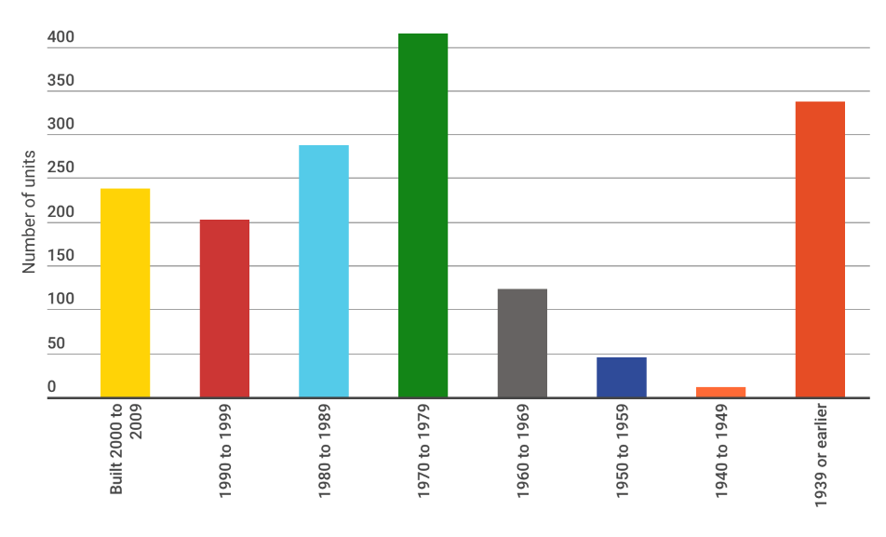
From the founding of Richmond to the 1950s, most housing consisted of single-family homes and farms. Homes were clustered in village centers (such as Jonesville and Fay’s Corner), and farms were distributed across the rural landscape.
The 1960s-1980s marked a period of rapid growth in Richmond, with the population growing from 1,303 to 3,159 (including an increase of more than 70% in the 1960s alone). Housing stock likewise grew rapidly to accommodate the increase in residents. More than 400 housing units were constructed during the 1970s, and this mid-century housing still forms a large percentage of Richmond’s housing stock today.
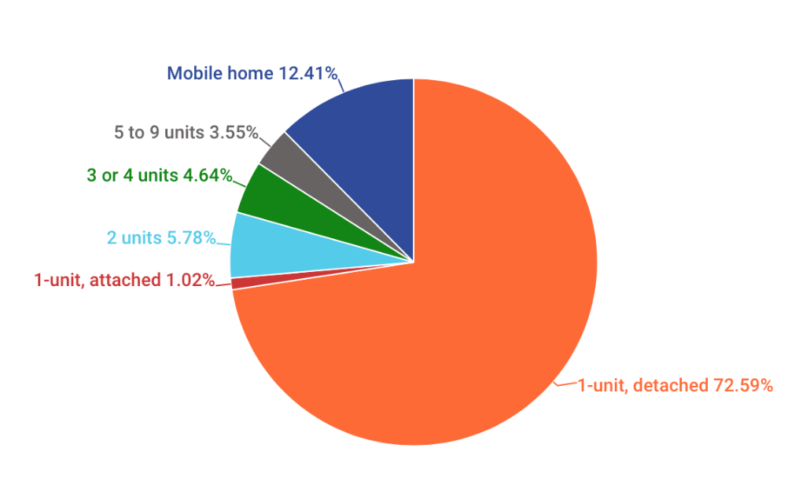
Growth slowed in the early 2000s for the first time in 50 years, in conjunction with the economic downturn. Since 2010, the town has experienced very little population growth (an increase of about 50 people from 2000 to 2014), and housing units have only increased 8% in that time.
The majority of the housing stock today consists of low-density single-family homes that were built in the latter half of the 1900s. The majority is located throughout the large geographic area defined as the Agriculture/Residential Zoning District, where the minimum lot size is 1 acre. Richmond is more rural than most of Chittenden County, with housing more spread out across the landscape, but housing density is greater than in adjacent towns like Bolton and Huntington. Most homes in Richmond are owner-occupied housing, and that number increased slightly from 80% in 2000 to 82% in 2010. This is significantly higher than Chittenden County overall at 65%, where many more homes are occupied by renters.
That corresponds with demographics: younger residents (25-34 years of age) are more likely to live in renter-occupied units. Richmond’s vacancy rate is lower than that (4%), meaning that options are limited for people seeking housing.
A “healthy” housing vacancy rate is 5%.
Aside from single-family homes, mobile homes are the most common alternative. Most (75%) are concentrated in the Riverview Commons Mobile Home Park, which has 150 lots.
Richmond’s population predictions show a relatively stable population over the next 10-15 years (ranging from a decline of about 180 people to an increase of about 35 people). That means that there will not be a significant demand for new housing based on population alone. Richmond’s demographics will change significantly, however, which will create demand for different types of housing. The number of older residents is increasing, while the number of children and young adults is shrinking.
Housing costs are a major component of affordability overall. They generally include mortgage or rent, property taxes and insurance. Additional costs related to housing include heating and cooling, power and electric, and other utilities such as water and sewer. Based upon Vermont State Statute, "affordable housing" means “Housing that is owned by its inhabitants whose gross annual household income does not exceed 80 percent of the county median income.”
Housing is considered affordable when less than 30% of household income goes toward housing costs.
Richmond home values and rental costs are higher than in other Chittenden County towns. “Affordable housing” in Richmond is very limited in part due to the types of housing stock. But even housing that is traditionally considered affordable costs more than average in Richmond.
Rental costs for Richmond specific apartments is not available, but in 2015, the average fair market rent for a 2-bedroom apartment in the greater Burlington area was $1,328 a month. A renter would need to earn $25.54 per hour to afford that rent, or $53,120 per year. In Richmond, the median household income for renters is only $34,444, which is particularly challenging for low-income families, single-earner households, seniors, or young adults entering the workforce.
“Workforce housing” is another way of evaluating affordability. Workforce housing is generally considered to be housing that is affordable for people who fill core community jobs, such as police officers, teachers, cashiers, trades people and highway maintenance workers. The Richmond Annual Report (FY 2014/2015) shows that highway personnel earn $10 - $17 an hour and police officers earn $14 - $23 an hour, which is far below the income needed to afford most Richmond housing.
The median income of renter households in Richmond is $34,444, which is $18,676 less than what is needed to afford that average fair market rent. Additionally, based upon census data 49% of Richmond renters do pay 35% or more of monthly income for rent.
Mobile homes tend to be an affordable option in Vermont, but Riverview Commons is one of the largest – and most expensive –mobile home parks. The average lot rent at Riverview Commons increased by 8.9% from 2010-2014, and is now $420 per month – 31% more expensive than the state average (according to data from the Vermont Department of Housing and Community Development).
The Vermont Directory of Affordable Rental Housing shows a total of 32 affordable units in Richmond, representing less than 2% of Richmond’s housing stock; half are reserved for elderly and/or disabled residents.
Most homeowners have home insurance that covers the structure and the owner’s possessions; basic insurance is typically required in order to get a mortgage. Renters may choose to purchase Renters’ Insurance, which covers personal property kept within the rented unit. Homeowners living in floodplains and flood-prone areas may choose (or be required to) take out flood insurance as well.
Flood insurance costs are typically high, but Richmond is a participating member of the National Flood Insurance Program (NFIP), which means that homeowners can purchase NFIP flood insurance. As of September 30, 2015 there were 56 residential properties that carried flood insurance in Richmond. Richmond is one of the top 10 towns in the State with the highest number of structures in the floodplain. Based upon information from the National Flood Insurance Program (NFIP), two inches of floodwater in the living area of an average 2,000 square foot home would result in over $20,000 of damages.
Flood insurance costs are getting even higher due to changes in the NFIP and increasing losses and claims across the country. The long-term rates and costs are still uncertain, but it’s clear that living in a floodplain is a costly business. In order to participate in the NFIP, Richmond is required to administer specific floodplain zoning regulations. Currently, the Richmond flood hazard regulations exceed the NFIP’s threshold requirements and do not allow for any new housing units to be built in the floodplain. Furthermore if a home has sustained substantial damage or is planning a substantial improvement the home must seek zoning approval and incorporate flood-proofing measures to reduce risk, which also reduces insurance premiums.
FEMA Flood Mitigation Funding at Work
In 2014 Richmond bought out a home on Cochran Road with this funding, and removed the structure from the floodplain. In 2014, the Town applied for funds to help elevate a handful of homes above the floodplain.
The Federal Emergency Management Agency (FEMA) provides funding to NFIP municipalities to purchase and remove structures in the floodplain and provides funding to help elevate houses above the base flood elevation, which eliminates or reduces the potential for future flood damages.

Transportation
Most Richmond residents have and rely on standard cars, but demand is increasing for a wide variety of transportation options, from bus and rail service to bikeable and walkable streets and trails and electric vehicles.
Richmond includes some infrastructure or support for a diverse range of transportation modes, but options are limited for anything other than personal vehicles. Most Richmond residents own at least one car, and we have approximately 85 miles of roadway (including state-owned, town-owned and private). We also maintain extensive road infrastructure to support them, including more than 30 bridges and 712 culverts. Richmond also maintains numerous parking spaces and lots; a 2015 study showed that most public lots are sufficient for parking volumes, but the Depot Street Lot is overburdened. While electric vehicle popularity is growing, there are currently no known public charging stations for electric vehicles in Richmond (or anywhere between Montpelier and Williston).
Changing demographics and regional growth do impact traffic patterns and volumes locally. Traffic counts overall are relatively stable, or even decreasing on many roads. At the same time, increased volumes and congestion are causing problems on certain key community routes and choke points– such as the Route 2 and Bridge Street intersection, which also has the worst safety rating in town. The majority of Richmond residents (82%) commute out of town for work, the largest employment centers are Williston/South Burlington/Burlington, and Waterbury/Montpelier.
Richmond has a popular Park N Ride near Interstate 89, which enables carpooling and access to an I-89 commuter bus, but most commuters (88%) still travel in personal vehicles. There is no weekend or evening bus service and no stop or access point in the downtown or villages. A rail line runs through Richmond, carrying freight and the once-daily Amtrak passenger service, but there are no stops in Richmond. The supplemental ride service Neighbor Rides helps fill transportation gaps for seniors or those with disabilities or special needs, but there are no supplemental ride services for most residents.
Active or human-powered transportation (primarily biking and walking) is increasingly popular among many residents, for its many benefits – recreation, health, sustainability, convenience, affordability, energy efficiency and more. Richmond has a sidewalk system in the village area, which helps improve safety and vibrancy downtown, but there is no dedicated infrastructure to support biking or walking outside the village, or to make these options safer. Richmond has long held a goal of improving bikeability and walkability, and it was one of the most common themes during the visioning process. Several studies, including our Bike and Pedestrian Master Plan, detail specific recommendations and locations for bike lanes, signage, sidewalk extensions and other high priority improvements. Richmond conducted a pop-up installation of high priority enhanced crosswalks in the village during this planning process, and found a need for updated and potentially relocated crosswalks in the village.
Road maintenance and construction are among the greatest costs to the town; reducing vehicle use and improving road resilience are critical strategies for controlling municipal costs and tax rates and meeting energy goals. Improvements to transportation infrastructure are also expensive, but can be minimized by integrating them into other planned upgrades (such as paving projects or bridge replacements) and by using pop-up design demonstrations to test and refine designs before final installation.

Energy and Utilities
Richmond has two major electrical providers: Green Mountain Power and Vermont Electric Co-Op. Richmond also has its own municipal village water and sewer system. Energy is one of the greatest expenses for the Town of Richmond and most households – as well as the state and the planet. Vermont released a Comprehensive Energy Plan (CEP) in 2016 that recognizes the importance of energy to our communities, and the “urgent need to mitigate the global climate change that is resulting from greenhouse gas emissions…” The CEP includes a statewide goal of ensuring that 90% of Vermont energy will be derived from renewable sources by 2050.
THE TABLES BELOW SHOW THE TRANSITION IN THE AMOUNT OF ENERGY OBTAINED FROM VARIOUS FUEL SOURCE NEEDED TO MEET THE GOAL OF THE VERMONT ENERGY POLICIES:
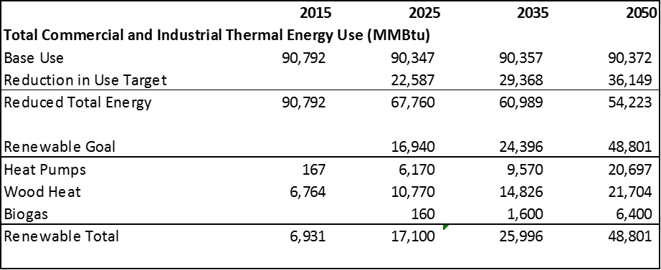
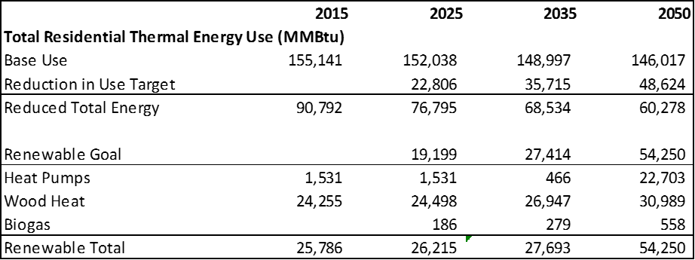
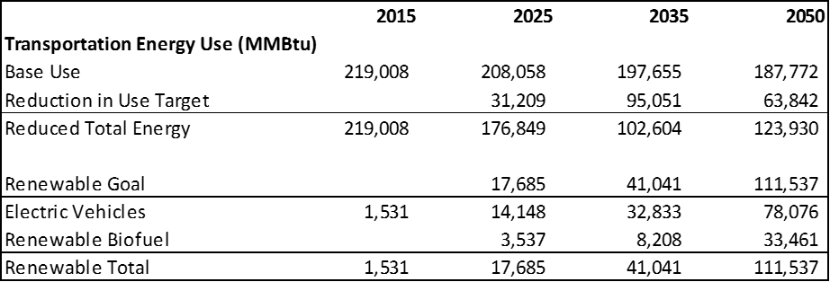
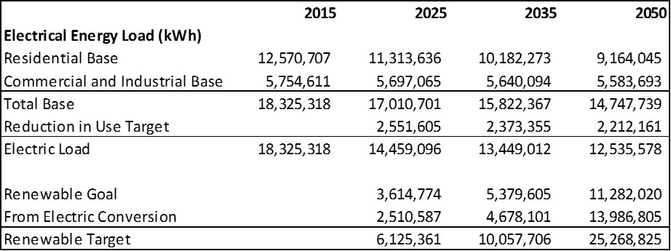
Areas within the former boundaries of Incorporated Village of Richmond are served by municipal water and sewer. The village is served by a municipal water system. It is a treated, gravel-packed well and tanks with a 250,000-gallon storage capacity which serves approximately 300 structures comprising 720 individual units. Waterhouse upgrades were completed in 1999 adding an aeration system to reduce lead and copper levels for improved water quality. Approximately 70,000 gallons are consumed daily, equaling less than 30% of the total capacity.
The village is also served by a municipal wastewater treatment facility located on Esplanade. The wastewater collection system was expanded in 1999 along Cochran road to cover the remainder of the homes in the service area. The plant was upgraded in 2005, when a $3.9 million project to reduce phosphorous discharged to 0.8 mg/l was completed.
An ordinance governing the water/sewer district of the Incorporated Village of Richmond went into effect in 1972 and is on file in Town Clerk’s office. It specifies required uses in the service area, the requirements for hookups, states that all expenses are the responsibility of the users and states the power and authority vested in the inspectors. In 1993 an ordinance was adopted for the allocation of future hookups depending on use, consumption and other criteria.
Transfer of the ownership and management of the Incorporated Village of Richmond sewer/water system to the Town of Richmond accompanied the merger of the Town and Village in 1989. Transfer was subjected to all indebtedness and liabilities and placed the District under control of the Selectboard. The Selectboard has the authority to appoint three to five water and sewer commissioners or to constitute themselves as the board of commissioners. In either case, they have the responsibility of overseeing the operation of the system and of establishing rates and charges.
At present, the Selectboard has chosen to serve as board of commissioners. The 2006 Town Charter change allows up to two customers to serve on the board of commissioners. Day to day operation is the responsibility of the full-time paid superintendent and his two full-time staff. The Selectboard also has the authority to designate areas of the Town as special water and sewer system districts if approved by a majority of all voters residing in the proposed district at a special meeting. The Water and Sewer Commission has the authority to specify an annual service tax to cover all expenses related to the system. These moneys cannot be used for any other purpose. The municipal water and sewer systems are an asset to the village not available in many surrounding communities.
In addition to the municipal water supply, there are five public water supply wells in Richmond, each serving at least fifteen full-time hookups or 25 individuals. These five public water systems are maintained privately by either a homeowners association or by individual owners of wells. The State of Vermont Water Supply Division requires routine inspection of existing community systems. These systems are listed in the Natural Resources Section of the Town Plan under “Groundwater.”
All development outside of the municipal sewer system relies on sub-surface waste disposal systems: i.e. septic systems. In 2001, Richmond updated its ordinance, which sets local standards for septic system design, construction and maintenance. A failed septic system is a health hazard, as untreated sewage may flow onto the ground and pollute surface water or wells. Many replacements occur when properties are being sold, as many buyers are more aware of potential problems or are advised by their Realtors to have a septic system inspection prior to purchase. As a rule, a properly designed and installed disposal system generally lasts about 15 to 20 years. However, a properly maintained system in a well-drained soil could last decades.
In 2002, Vermont amended the laws governing the regulation of on-site septic systems. These laws no longer always allow development on a parcel that exceeds 10 acres in area, regardless of the suitability of its soils for a septic system. To offset the elimination of this exception, the State revised the rules related to the construction of septic systems on “marginally suited” soils and instituted rules that would allow property owners to propose innovative approaches for on-site wastewater treatment. The allowance of innovative and alternative approaches and the construction of systems on “marginally suited soils” may allow additional development in certain areas of town. However, new treatment techniques may also allow clustering of units to preserve more sensitive surrounding areas
Richmond is a member of the Chittenden Solid Waste District (CSWD), which operates a drop off site located on Rogers Lane in Richmond. The major issue facing the District at this time involves sighting of a new regional landfill. In addition to individual trash removal and recycling by local residents, many of Richmond’s residents employ private haulers to remove household refuse and recyclables.

Healthcare
A majority of healthcare for Richmond residents is found elsewhere, especially with the University of Vermont Health Center hospital in nearby Burlington. Within Richmond, there is a general practitioner, assisted living facility, physical therapy, and Richmond Rescue. Currently the cost of healthcare is the largest burden versus the access to it. The federal Affordable Care Act was passed under the tenure of President Barack Obama, but is currently under scrutiny and possible repeal by the Republican-Majority congress. Right now, the future of that coverage program is up in the air. Richmond has a strong desire for a pharmacy to be built or placed somewhere in town, as this need can only be filled by traveling to neighboring towns. Richmond is an overall healthy but aging community. Access to facilities and prescriptions for residents will be a crucial component of Richmond’s progress moving forward.

Environment + Conservation
Since the late 1970s, Richmond has recognized the importance of regulating and planning for our land use in protecting our community character and quality of life. But Richmond’s zoning map and land use regulations have changed little since they were enacted during that time, and the regulations are not necessarily in line with Richmond’s land use goals today.
Today, Richmond is poised to proactively direct future growth, investment and land use, which will help the Town strategically advance the vision and the goals, targets and actions contained within this plan. Revisiting and adjusting our land use regulations will help us build vibrant village centers, maintain our rural character and working lands, create efficient transportation options, and improve affordability.
Richmond’s land use is primarily a combination of undeveloped and agricultural land, scattered homes and compact neighborhoods, and areas of denser mixed-use or commercial development in village centers and along Richmond’s main transportation corridors.
Richmond’s land use is also impacted by trends across the region. Our location on the eastern edge of Chittenden County means that Richmond is part of a regional growth center. We face far less pressure than towns closer to Burlington, but if Burlington continues to grow and housing prices to rise, more people will be seeking housing in Richmond and towns on the outskirts of the County. Williston has become the regional center for major chain stores, which means that Richmond is unlikely to face that type of development pressure. Richmond borders three towns that are even more rural (Huntington, Hinesburg and Bolton), so the outlying agricultural areas are unlikely to face growth pressure from adjacent towns.
The Town of Richmond currently has a comprehensive set of zoning regulations. The zoning regulations evolve in conjunction with the town planning process. In order to implement the town plan, zoning regulations must match the intentions and goals provided in this document.
Richmond is a town with many and varied natural resources, among them diverse wildlife habitats, working farms and forests, unique shoreline environments and outstanding natural beauty. Our town’s location in the eastern uplands of Chittenden County places us in an area noted for some of the richest habitat diversity in all of Vermont. The Winooski River and its wide, fertile floodplain provide many ecological, economic and aesthetic benefits of their own.
All told, the quality of life Richmond residents enjoy and have stated they want to protect is closely tied to the quality of the town’s rural character and natural resources. In 2005, Richmond voters approved the creation of a conservation reserve fund to be funded by town taxpayers for five years.
Richmond is located within three watersheds, the Winooski River watershed, the Huntington River watershed and the LaPlatte River watershed. The Winooski watershed (excluding the Huntington River portion) encompasses roughly two-thirds of the town and receives drainage from those areas of town generally north of Bryant Hill (above Cochran's Ski Area) and Owls Head. The Huntington River watershed collects water from uplands surrounding the Huntington River, and the LaPlatte River watershed contains a small portion of Richmond in the vicinity of Lake Iroquois.
Two of Vermont’s major rivers flow through Richmond, a portion of Lake Iroquois is located in Richmond, and there are also a number of ponds, streams, brooks and unnamed tributaries. The quality of these waters is essential to Richmond in many ways. They serve as a source of recreation, provide visual amenities that enhance the rural character of the town, and support a wide variety of fish, wildlife and plant species, greatly contributing to the natural diversity in Richmond.
Surface waters with a designated shoreline as identified by the State of Vermont include:
- Gillett Pond
- Richmond Pond
- Huntington River
- Winooski River
- The Oxbows
- Lake Iroquois
Other prominent surface waters include Donohue Brook, Johnnie Brook, Snipe Island Brook and Mill Brook.
Since 2002, the Huntington Conservation Commission has coordinated regular water quality testing at approximately 20 sites along the Huntington River in Huntington, with funding from the Vermont Agency of Natural Resources. In winter of 2005, Richmond and Huntington began a collaborative public outreach effort to educate residents in the Huntington River Watershed of potential threats to the watershed and positive steps they could take to address these threats. To better understand and monitor the condition of the Huntington River, the Richmond Conservation Commission began coordinating regular water quality testing along the Richmond portion of the river in the summer of 2006.
A floodplain is the area bordering a lake or river that is subject to flooding. In 2006, Richmond began identifying waterways susceptible to erosion through a Fluvial Geomorphology study conducted by the Chittenden County Regional Planning Commission. Floodplains not only protect property and life by reducing the severity of flooding but also provide wildlife habitat and serve as corridors for animal movement. They also represent some of the richest and most viable agricultural land in Richmond because of a concentration of alluvial deposits left by past floods.
Clean and plentiful groundwater is a critical resource for the health and wellbeing of Richmond’s residents. Statewide, 66% of Vermonters depend on groundwater for their primary water supply. This number is significantly higher in Richmond, where nearly all residents obtain their water from public and private wells and springs. The most significant quantities of groundwater are found in aquifers, which are geologic formations that have the capability to store, transmit and yield useful quantities of water to a well or spring.
In Richmond, the importance of groundwater to the health of Town residents, present and future, makes protection of groundwater resources a top priority. Higher quality water is also less expensive to treat. The VERMONT Department of Environmental Conservation (DEC) has published a groundwater protection handbook , which is an excellent source of information about groundwater resources, threats to groundwater and tools local governments can use to protect groundwater. The DEC also has a model Groundwater Protection Ordinance that can be used as a guide for regulations protecting groundwater. In 1996, the Town adopted a Water Supply Source Protection Ordinance setting forth protective regulations for the municipal water supply.
Richmond’s geological features, including hills and ridgelines, are an important part of the town’s heritage that provide recreational and aesthetic enjoyment, educational and research opportunities, and protection of immediate and surrounding natural resources. Some of these hills and ridgelines are characterized by steep slopes, which are generally defined as slopes in excess of 15 percent. Disturbance of steep slopes can result in soil instability, slumping and erosion, conditions that can degrade surface waters and threaten human life and property.
Richmond offers a diverse array of wildlife habitats. Many parts of Richmond still see relatively little human use, allowing flora and fauna to exist and interact in naturally functioning, complex communities. In particular, the town is home to black bear, bobcat, otter, fisher, mink, and moose – animals high on the food chain that require large and varied areas to survive and which therefore are indicators of the overall health of the local ecosystem. Black bear production and seasonal habitat consists of extensive, remote forestland with special areas, such as mast production areas (stands of nut-producing trees), wetlands and travel corridors. Perhaps more than any other species known to occur in Richmond, the black bear stands as a symbol of wilderness. Large, unbroken tracts of forest connected by forested travel corridors are favored to accommodate this wide-ranging species. Deer wintering habitat consists of areas with pure softwood or mixed softwood and hardwood cover at low or middle elevations with south or west facing slopes and lacking human disturbance. These areas are critical to deer during the winter months because they provide relief from harsh winter conditions. Certain Richmond streams support populations of native trout, which are excellent indicators of a healthy aquatic environment. Native trout are extremely sensitive to increases in sedimentation and temperature that may result from incompatible land use activities. Some local streams are also home to stocked fish.
Rare or uncommon species found in Richmond include certain plant species associated with rich northern hardwood forests or floodplain forests. Among them are 200-year-old hemlocks near Gillett Pond, locally rare pitch pines on Chamberlain Hill, the rare broad beech fern by the Snipe Island Cliffs, and another rare fern, the slender cliffbrake, growing along the East Cliffs near Dugway Road. In addition, Richmond is home to at least one rare insect and one rare reptile.
Through the State’s voluntary Current Use Program, owners of farm and forest land can reduce their property taxes as long as they keep their land in production. Despite the opportunities, though, economic pressures and other reasons continue to cause farmers to sell off parts of their land to development. Economically healthy, environmentally responsible farms and forests have benefited Richmond residents since our town was founded. They remain a vital resource for our community, helping us become more self-sufficient in producing food, fuel and construction materials, providing customers for local businesses and protecting many critical natural resources, including prime agricultural soils and wildlife habitat that are disappearing elsewhere.
Trends in transportation costs and fuel prices could make Richmond’s farms and forests even more valuable, as more people turn to local sources for food, and more homes and businesses switch to burning wood to save on heating costs. However, other trends in our global economy make it more difficult than ever for small farms and forestry operations to make a profit. Reversing these trends will take not only innovative public initiatives but also the conscious effort of residents to buy locally produced foods whenever possible.
Sand and gravel deposits are important natural resources. Utilization of these resources is often hindered by land use regulations and by public attitudes toward sand and gravel extraction. Identification of the highest quality sand and gravel deposits as part of the town planning process should help to avoid conflicts in the utilization of these resources in the future. Extraction of sand and gravel can pollute surface and groundwater resources while also having adverse effects on other resources and adjoining land use. Erosion and runoff controls combined with restoration of sites after operations can minimize the damage that is caused.
Two major features dominate Richmond’s landscape: the foothills of the Green Mountains and the Winooski River Valley. Much of Richmond's rural character and appeal results from the scenic vistas that can be observed in many parts of the town and that include an interplay of villages, mountains, forested hills, unbroken ridgelines, farms, fields, rivers, streams, ponds and woodlands. Richmond is also fortunate to have many tree-lined streets in its village and along its outlying roads. Trees provide shade, beauty and habitat; can serve as food sources, and reduce air and noise pollution. Properly sited street trees can also have important traffic calming effects and improve pedestrian safety. In addition to these benefits, street trees can improve neighborhood property values. Species in Richmond include the stately sugar maple and at least one rare American elm.

