CONCERNS AND QUESTIONS REGARDING HILLVIEW HEIGHTS SKETCH PLAN FROM HILLVIEW NEIGHBORS
# | Concern | Name | Related links/ documents
1 | Questions to the DRB  The Warranty Deed for the sale of the property from Wesley Atwood to Hillview Heights was prepared by Stackpole & French Law Offices. David Sunshine, DRB Chair, appears to be affiliated with Stackpole & French Law Offices. I would like David Sunshine to outline the scope of his involvement in this property, if any, and the scope of his firm's involvement, if any, and whether or not he believes this presents a conflict of interest or the appearance of a conflict of interest. | Bradley Holt / Jason Pelletier
2 | Lessons Learned for the Town of Richmond from other similarly sized developments.  Although the sketch plan outlines only 9 lots for subdivision, Lot 9 with 60+ acres includes flat pasture land and thus is a likely candidate for further subdivision, especially given the orientation and size of the proposed “driveway/road” to lots 6-8. The sketch map also shows additional, previous Atwood land, across the street as “Other lands of Robert and Tammy Avonda”.  Hillview Heights (85 acres) plus land across Hillview road (another 188 acres) promises to be among Richmond’s top three largest subdivision projects. What has the town of Richmond learned and how can we do a better job to reduce the impact and lessen external costs to the town and nearby affected residents?  Southview: 70 homes  - Developer lacked adequate financing to finish the development  - Subsequent water problems forced residents to dig deeper wells at significant costs  - Substandard roads are an on-going problem for the town  Greystone: 20 Homes  - Stormwater runoff problems flooded Cochran Road near the Greystone entrance when the development was first put in and several years ago west of the Kemp Farm.The town and the property owners had to pick up significant costs to repair the road and prevent future issues.  - Colluvial fans developed on adjacent properties, owners were never compensated.  - Huge erosional gully formed from top of the hill to Cochran road- clean up costs were only partially covered by FEMA.  --  - Are the principals behind this development (or anyone else with interest in the property and/or project) willing to disclose other real estate or property developments currently underway or planned? Can these same parties speak to their past experience with real estate or property developments? | Fran Thomas Nathaniel Merrill  Marie Thomas  a) [questions about principals] Bradley Holt / Jason Pelletier
3 | Does the proposed sub-division conform to the town plan?  - This plan will negatively alter the character of the neighborhood and the natural features at the base of Owl's Head. The housing density of this subdivision is much greater than the surrounding housing density. The Sketch Plan lists a Lot 9 (remainder) that appears intended for future subdivision and development. The proposal also appears to include a private road connecting Lot 6, Lot 7, and Lot 8 to Hillview Road. It appears that this road is designed to be extended into a future subdivision on Lot 9. The Sketch Plan also indicates that the property across the street from Hillview Heights is "other lands of Robert & Tammy Avonda" (the presumed owners of Hillview Heights). It seems likely that they intend to develop a subdivision on these "other lands" as well. Without knowing their plans, it seems reasonable to speculate that they could be planning on developing many dozens of houses in total on these lands. This would most certainly change the rural character of the neighborhood and raises a number of concerns, such as the impact on groundwater and stormwater. I would like to hear more clarity from the developer on their future plans with these lands.  - How is this development compatible with the "low density residential development, agriculture and forestry uses" outlined in the Town Plan?  - Has the developer considered creative plans to “minimize visual and environmental impacts”?  - Subdivision does not conform to the town plan to retain the rural character of Richmond. The proposed housing density and future potential building plans turns our agricultural area into a suburb like S. Burlington. We would like to maintain the rural character of S. Hillview Road. | a,b) Bradley Holt / Jason Pelletier  c, d) Butterfield /Kauck | P. 7 Town Plan-”The most visible defining aspects of Richmond’s small town character are its landscapes and architecture. Scenic views and pastoral landscapes are important to the community, along with the authentic working farms and treasured historic buildings like the Round Church. Community members also value Richmond’s small size and scale. Land development can greatly affect community development. A small rural community like Richmond with the desire to stay small and rural must strike a balance between economic prosperity of the town and residents while preserving the town’s character.”  P 33- GOAL 3: Maintain Richmond’s rural character and scenic beauty  Action 2 - Encourage creative development that minimizes both visual and environmental impacts on the landscape  Action 3. Adopt zoning regulations that mitigate noise pollution and light pollution
4 | Aquifiers, waste-water management, and wetlands  - Is there evidence that once all the sub-division is done and dozens of homes are built that aquifers and waste-water management are sufficient to protect and service dozens of new wells as well as existing wells?  - The hydraulics and hydrology of this little valley need to be identified and evaluated. There are many intermittent and permanent streams, rivlets and drainages - beaver ponds, and high energy streams - as well as areas of sand all underlain by impermeable layers that are former lake bottom. We really need to understand the surficial geology and glacial history of this valley and the movement of surface and subsurface water, extent of the aquifer that supplies all of our water, before evaluating the impact of 8 to 20 new houses. Previously, there have been one or two houses at a time built - but the cumulative impact of all the past incremental development needs to be assessed along with the proposed addition of many new houses. What is the tipping point where there will not be enough water for the wells or the concentration of septic systems will begin to contaminate water supplies?  - The wetland delineation was done in fall (2020), a drought year. Should double check the limits of the ponding in the spring, especially if it is wet. Note places of surface water. This especially affects Lot 3 which is mostly underwater for several months -wetland delineation on the site sketch is not accurate for lot 3.  - Natural topography of lots 3 and 4 drain to class 2 wetland. How will driveway, septic and well plans ensure preservation of class 2 wetland?  - We’re concerned about the overall neighborhood water supply. In January of 2020 we had to add approximately 500ft to our existing well bringing the total depth to 815 total feet due to low water supply (low static level and less than 1 GPM. To put that into perspective, even with water conservation efforts, if we tried to do a load of laundry without waiting 2-3 days in between loads we would run out of water.) Extending the depth of a well requires drilling, excavation, a new pump system rated for new depth and static water level, potential electrical work, temporary water rental and landscaping with total costs that can exceed $20,000 or more per well. If a completely new well is necessary costs can exceed that of adding depth to an existing well. With either scenario a new water source is not guaranteed and the home may need to depend entirely on water delivery, a community water supply or need to be abandoned. | a)Butterfield/Kauck  b) Marie Thomas  c) M Thomas/Butterfield  d) Dan & Holly Bellerose  e) Charlie and Reiko Choiniere
5 | Storm water management, sedimentation and erosion control  - The stream located at the southern portion of Lot 9 naturally absorbs the watershed from the bulk of Lot 9 and Owl’s Head. There is already visible erosion seasonally that has affected my property and others with the movement of this stream and the velocity at which it flows during storm surging. With this development and the possible further development of Lot 9, what is your plan to ensure watershed from any development of the property doesn’t accelerate the already existing erosion and bank movement?  - Changes in topography - how much landshaping will occur? Will there be any sand mining of the hill? And how will this affect drainage/runoff?  - Stormwater runoff onto roads, other properties and increased erosion of the streambanks adjacent to other properties. This also relates to potential pollution of the waterways - If the new residents use pesticides, herbicides or too much fertilizer, there could be runoff that will enter the streams and add to the pollution load and phosphate contamination of Lake Champlain. Not to mention impacts on pollinators, birds, and wildlife. | - Dan and Holly Bellerose  b,c) Marie Thomas | See Town Plan Maps, hydrologic features where the corner of the property switches from.5-2 sq.mile drainage to an ANR river corridor.
6 | Protection for wildlife and wildlife corridors  - This area is habitat to many large animals including bear, deer, moose, coyote, and felines. We have seen bears in the vicinity on numerous occasions. Deer are very common, and these days we unfortunately see them more often than we see our neighbors. Our neighbors have caught moose on their wildlife camera. Coyotes are commonly heard throughout the area. A baby bobcat walked up to our front door one day, and we have seen very newly-born fawns on our property more than once. We even spotted a very rare Canada Lynx in 2017 on our property. What can we do about protecting this natural habitat and corridor?  - Per Richmond Subdivision Regulation section 500 item 2 concerns Undue Adverse Impact (UAI) on natural features - OwlsHead is a signature natural feature of Richmond. And item 11 concern for UAI on established large animal habitat and access. There are bear, bobcat and otter inhabitants as well as fox, deer, fishers and lots of raptors, woodcock and wetland inhabitants. Wildlife corridor - as the number of houses increases in the area, the space for wildlife decreases. We need to protect their habitat - for our own health as well as their longevity. Keeping houses close to the road, is an environmentally friendly policy. Not only is more land generally kept wild but energy is saved by not having to maintain a long driveway.  - There is significant wildlife activity in this area as observed by the residents - this will certainly be affected by the new homes. | - Bradley Holt / Jason Pelletier  - Joe & Martha McSherry  - Fran & Dave Thomas | 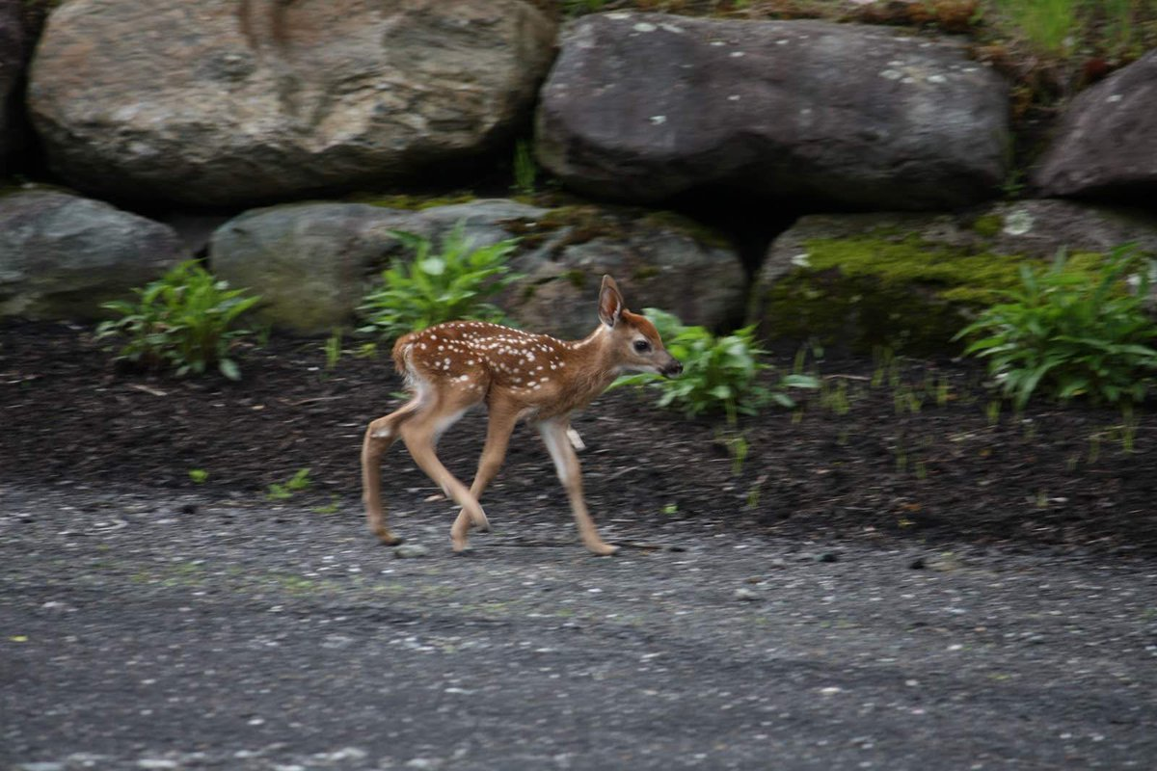  A tiny fawn on our property at 1931 Hillview Road that one of our neighbors reported seeing born that morning hours before.
7 | Traffic  - Hillview Road is a quiet rural road near the heart of Richmond, and it is enjoyed by many people who come to walk, run or bicycle. To have construction traffic on this dirt road would be disruptive enough, but the added traffic of new residents’ vehicles will be permanent. Moreover the layout of this sub-division suggests that more development will occur in the future, compounding the problem. If we are to maintain the desired character of Richmond, we need to keep these welcoming quiet dirt roads for people to enjoy.  - Increase in traffic on the road. We already have a significant amount of through traffic going to and from Huntington. There are many individuals who walk and bike on the road and the increase in traffic and the speed makes it dangerous for them. | - Jessica Arendt  - Fran & Dave Thomas
8 | Roads and driveways  - Road issues - with time and increased traffic, Hillview Rd has been substantially raised and widened between our house and barn, making the frontage for the barn very shallow and affecting water runoff. A curtain drain from the house (yes,we too have water issues!) has been buried by the road and the town’s ditches which no longer seem to be maintained. Let’s make sure we can handle the traffic we have now, before adding more.  - The slopes of some of the driveways will be very steep - what mitigation is proposed to prevent run off or rutting of the road? Specifically lot 2 and 3. Driveway of lot 3 should be combined with Lots 4 and 5. Too many driveways on a blind curve (Lots 1-3) will create a hazardous condition. Are sight lines to town specs?  - The driveway to Lot 4 may already be in existence, but it splits a Class 2 wetland in half, and was built before we chose to preserve wetlands. To add a second driveway for Lot 5 would seem incompatible with the regulations. Both driveways should be outside the 50-foot buffer zone.  - The current road/driveway to lots 4 and 5 is part of the cause of the ponding of water on both sides. If the road/driveway is to be expanded, proper culverts to allow water to flow would reduce the ponding.  - The driveway on Lot 2 (and perhaps on other lots as well) is clearly too steep and the hill on which the residence on Lot 1 would sit is also quite steep. This raises a number of concerns, primary of which is that the developer may plan to flatten the topography of the knoll. However, the Sketch Plan does not include any proposed contour changes. Flattening of the knoll (or other changes to the knoll) would negatively impact the viewshed, significantly alter the natural areas at the base of Owl's Head, change the rural character of the neighborhood, and have other potential negative impacts as yet to be assessed. I would like to hear what the developer plans to do in regards to the topography of the knoll.  - New road construction - would the road be gravel or paved? Improved drainage/ditching is needed to make sure it drains along the north side of Hillview Rd to the creek and not across the road.  - The width of the shared driveway to lots 6, 7 & 8 is much larger than required. Does this indicate that there are future plans to develop lot 9? If so, what are those plans? Will these three homes have to form an association for maintenance of the driveway?  - The number of new driveways accessing Hillview and the minimal line of sight for several of them, lots 1 and 2 and maybe 3, is a concern. | - Martha McSherry  - Marie Thomas  - Jessica Arendt  - R.Butterfield/ David Kauck  - Bradley Holt / Jason Pelletier  - R. Butterfield/D. Kauck  g,h)Fran & Dave Thomas
9 | Siting, density and viewsheds  - One of the goals outlined in the Town Plan is to protect scenic viewsheds. We share with several neighbors a scenic viewshed of Camel’s Hump, surrounding hills and mountains, and the knoll on the Hillview Heights property. What options do we or the DRB have to hold the developer to following the Town Plan in terms of not placing buildings and utility services in this viewshed and not altering the topography of the land within this viewshed, specifically the knoll?  - Viewscapes - I doubt that any of us want to see the top of Owl’s Head cleared to make room for a house with a fantastic view, such as was done across Huntington Rd. From the back of our property, we can peer right into the windows of the hilltop house, whose owners probably expected to have the ultimate in privacy. I’m not sure how that was permitted but we should be careful that it won’t be repeated on our side of Huntington Rd.  - Density of homes below Owl’s Head will disrupt wildlife corridors and influence landscape/view.  - While legally per zone regulations the minimum permissible lot size is 1 acre, the most recently approved multi home subdivision in the nearby area, on Blueberry Farm Road (off of Hillview Road), has building lots that are much larger in size, ranging from the smallest being over 4 acres to the largest over 100. This type of subdivision more accurately reflects the overall town plan while helping to maintain a low house density and helps to better protect woodland and natural wildlife habitats. | - Bradley Holt / Jason Pelletier  - Martha McSherry  - Dan Ryan  - Ryan & Rachel Gray | http://www.richmondvt.gov/documents/2018-town-plan/  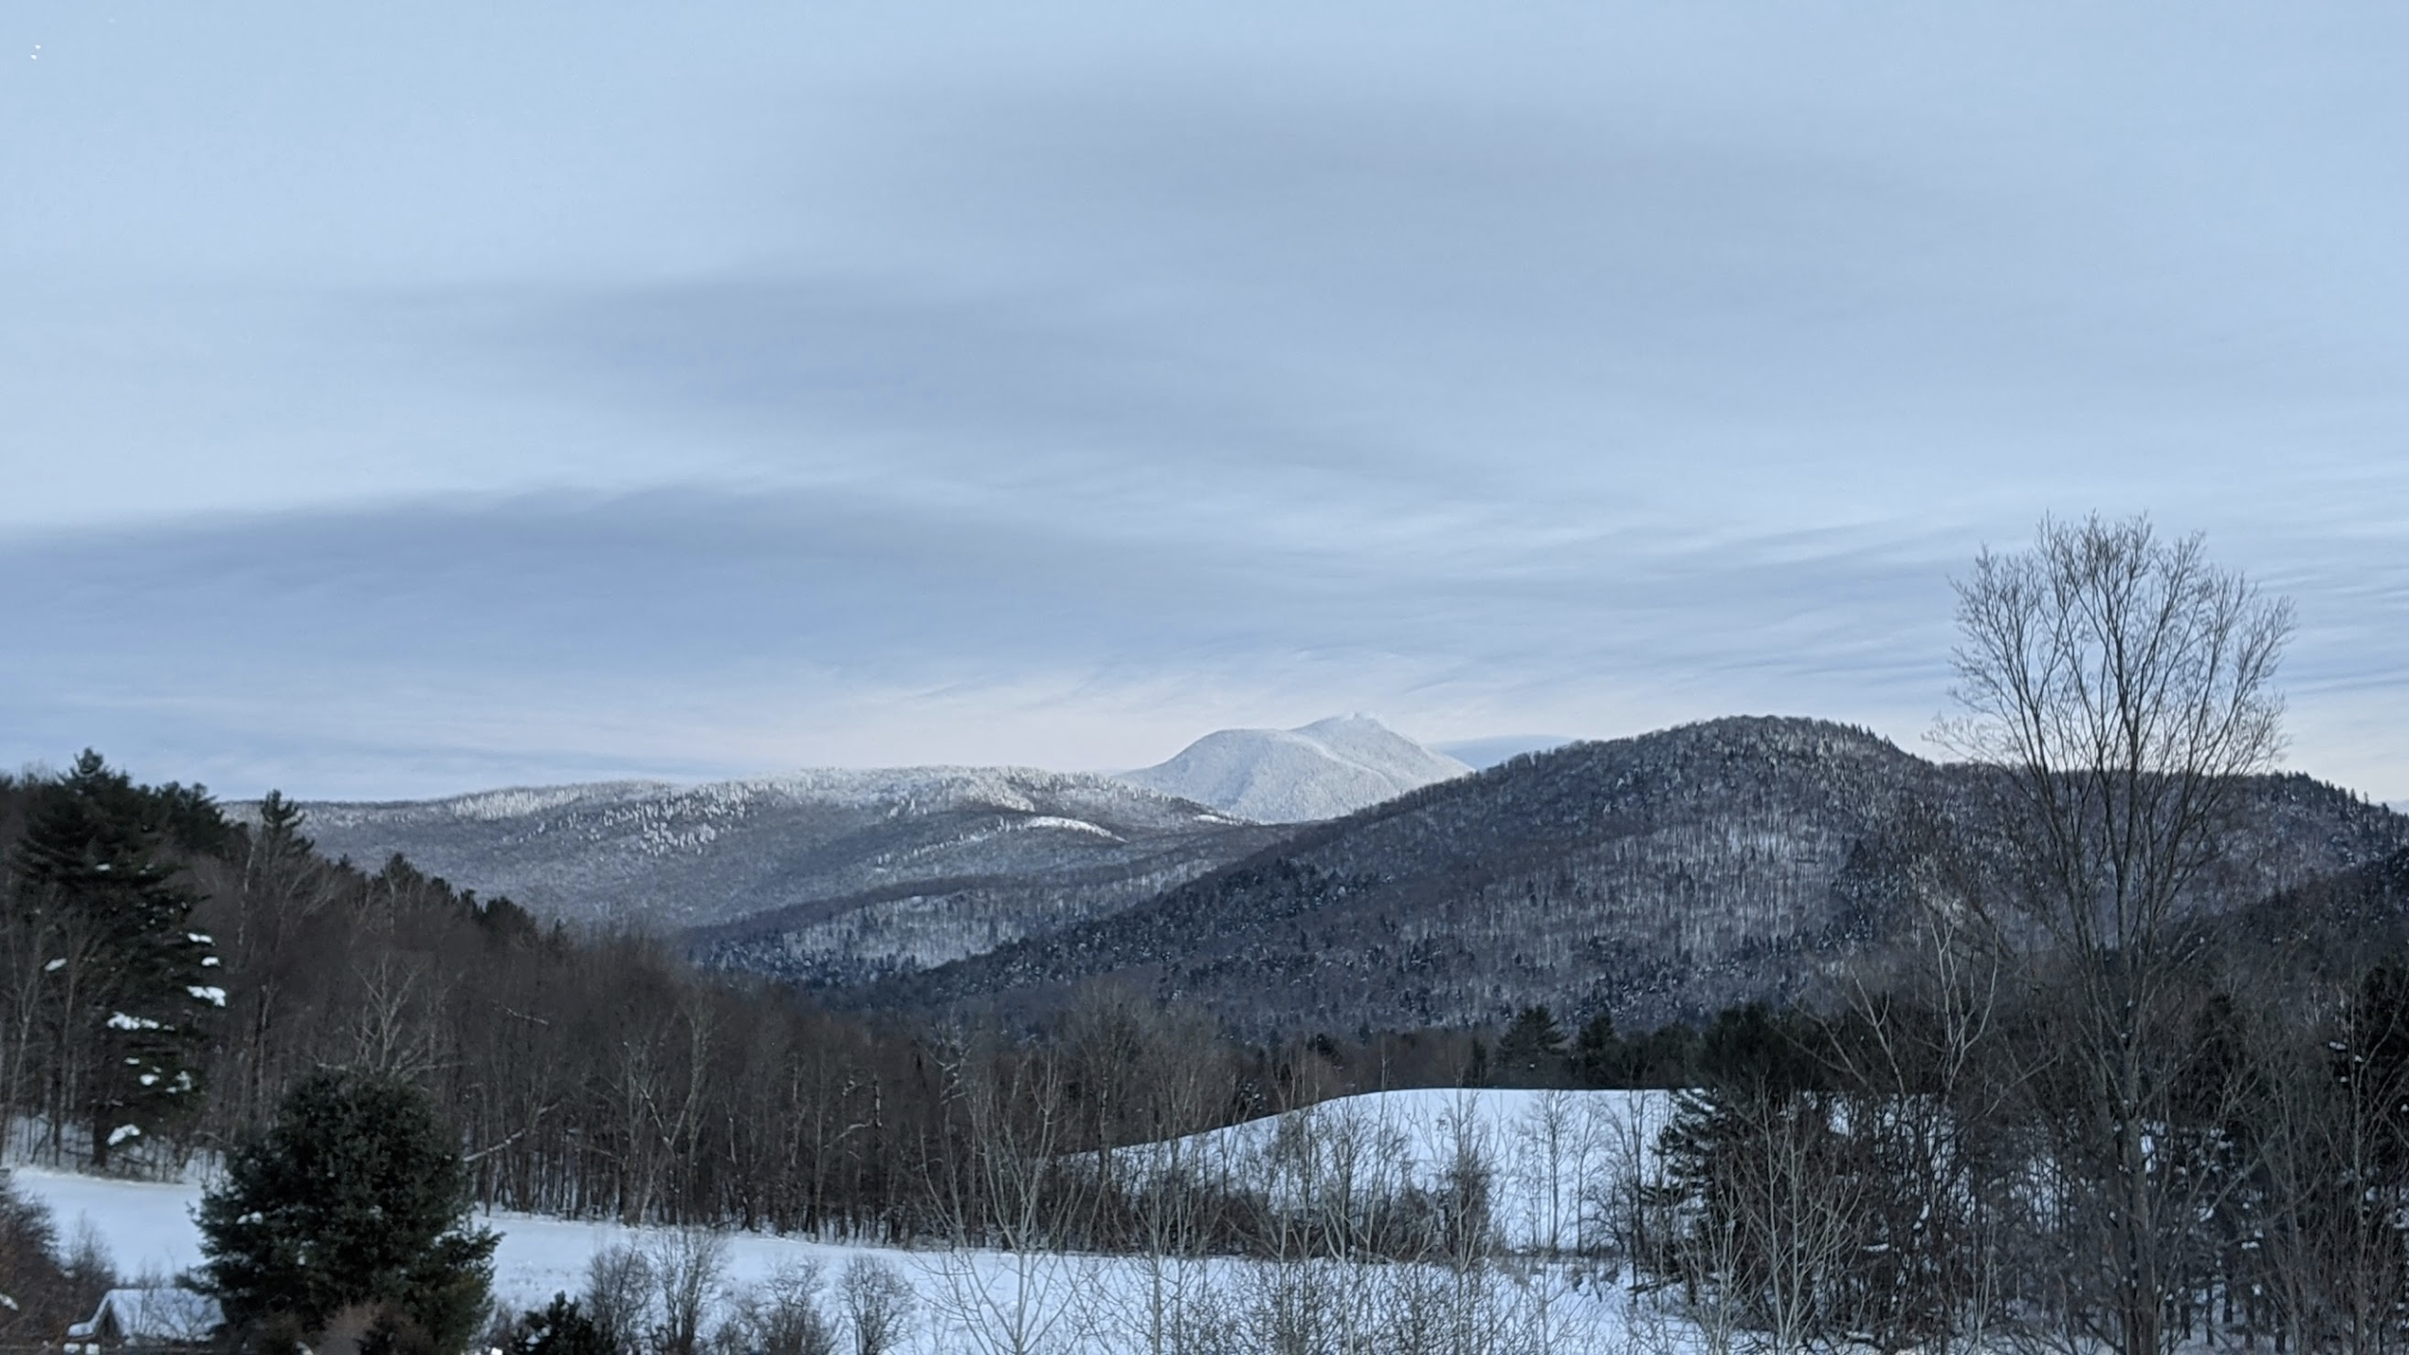  Scenic viewshed of Camel’s Hump shared by neighbors as seen from 1931 Hillview Road. The knoll pictured in the forefront spans the proposed Lot 1 and Lot 2 from the Sketch Plan, upon which two houses would be developed under this proposal.  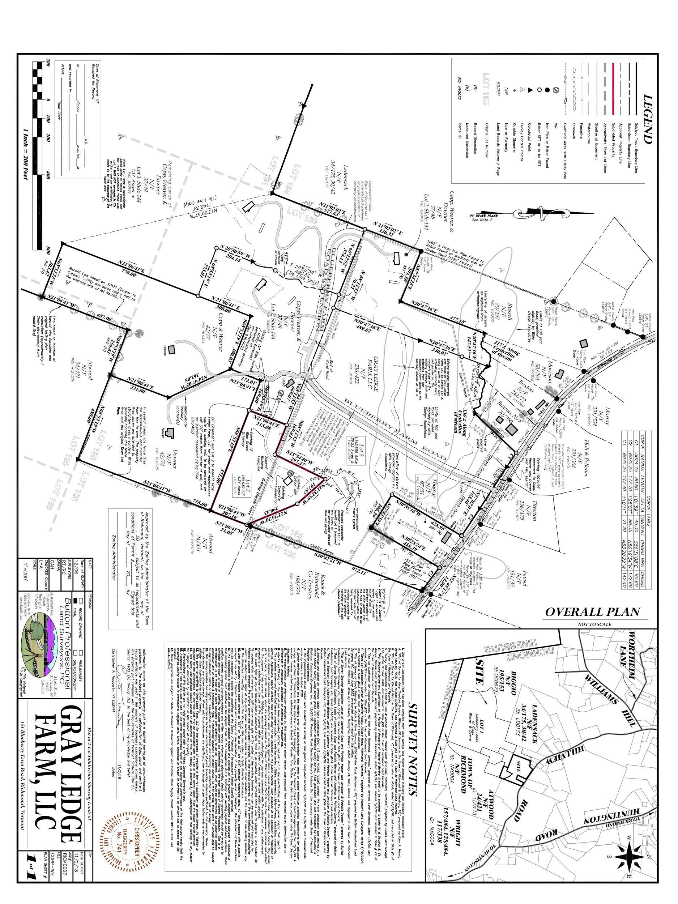
10 | Pollution concerns  - The town plan calls for maintaining its rural character (Goal 3) and Action 3 calls for mitigating noise and light pollution. Part of the rural character of Hillview Road is the bright star light due to absence of street lights and absence of outdoor flood lights as well as widely spaced housing. Will the developer follow dark sky best practices in keeping with the town plan? More info on dark sky best practices: https://www.darksky.org/light-pollution/light-pollution-solutions/  - Over the years the lands of the Hillview Heights property on the Sketch Plan have been home to many discarded items such as numerous old vehicles, tires, utility poles, and who knows what else. What responsibilities do the developers have to assess and mitigate any environmental impact from this activity before any development is allowed? | a) Butterfield  b) Bradley Holt / Jason Pelletier | P 33- GOAL 3: Maintain Richmond’s rural character and scenic beauty  Action 3. Adopt zoning regulations that mitigate noise pollution and light pollution
11 | Operational and implementation questions/concerns  - The old farmhouse does not appear on the Sketch Plan. Does this indicate that they intend to demolish the farmhouse? If so, has the developer addressed any historic preservation concerns? If they don't plan on demolishing the farmhouse, or cannot demolish the farmhouse for historic preservation reasons, what plans do they have to address safety, structural, or environmental issues with this neglected building? If they cannot tear down the farmhouse, how does this impact their development plans?  - What is the sequencing of lot preparation and building? Would all lots be worked on at once for water, septic and driveways and house building take place only once there is a buyer? What are plans to mitigate runoff, erosion, and sedimentation during the lot preparation phase?  - Are there any plans to conserve any of the land and in particular that which leads up to the top of Owls Head? Are there any plans for common land to be shared by the development?  - Are Utility services to be underground?  - Please respect posted roads and keep heavy equipment off of Hillview Rd. and out of construction sites until mud season has passed (can damage soils and drainage). | - Bradley Holt / Jason Pelletier  - Butterfield/Kauck  c,d) Fran & Dave Thomas  e)Butterfield
12 | Other general questions and concerns  - The Sketch Plan includes the Hillview Heights property and a property across the street labeled as "other lands of Robert & Tammy Avonda" (the presumed owners of Hillview Heights). Our understanding is that these two lots on the Sketch Plan were all one property. When and how was the land subdivided?  - Hillview Heights, LLC was incorporated on July 22, 2020. Two days later on July 24, 2020 Hillview Heights, LLC purchased the 85 acre property on the Sketch Plan for the amount of $500,000. Hillview Heights, as a newly-formed LLC, certainly had no assets of its own two days after its incorporation. It appears that $200,000 of this amount was mortgaged from the previous owner. I think we have a right to know who all the investors are in this development and anyone else who has an interest in the property and/or project. It would also be good for us to better understand how Hillview Heights is connected to other entities owned by the Avondas (e.g., the Sketch Plan Application lists a phone number and email address associated with Avonda Air Systems). This will help the DRB assess the financial capacity of the developer and determine if the DRB should require a bond, escrow account, or other surety of significant enough value that will assure completion of the subdivision.  - Are the principals behind this development (or anyone else with interest in the property and/or project) willing to disclose if they and/or any of their other business interests received federal and/or state grants and/or loans related to pandemic relief and/or recovery, including but not limited to the CARES Act, programs of the US Small Business Administration (e.g., Paycheck Protection Program, Economic Injury Disaster Loan), and grants issued by the State of Vermont via the Economic Recovery Grant Program? If so, will they provide details such as application date(s), date(s) of award, date(s) and amount(s) received, and status of any loans received (e.g., dates and amounts withdrawn, amounts of loans to be forgiven, amounts repaid and payment schedules)? This is additional public information that will help the DRB assess the financial capacity of the developer and determine if the DRB should require a bond, escrow account, or other surety of significant enough value that will assure completion of the subdivision.  - Has Hillview Heights requested and received a partial release from their mortgage holder allowing them to subdivide the land? If not, they may be in violation of their mortgage covenants and subject to foreclosure.  - The ongoing pandemic puts our neighborhood at a disadvantage in opposing this subdivision. Organizing is more challenging in many ways, as we cannot meet in person or gather as neighbors. Attending and speaking up at public hearings is more challenging in many ways as well. There will be no Town Meeting this year in March, and thus one fewer opportunity for a democratic review of our current town ordinances and policies in light of this proposed development. The added stress of the pandemic makes this a particularly difficult time for us and our neighbors to defend any rights we may have.  - Compounding this, there has been at least one occurrence where the process leading toward development of this property has gone forward in defiance of public health-related executive orders (which carry the full weight of law). Around April 4th, 2020 (give or take a few days) we witnessed what we believed to be a surveyor's truck on the knoll, which is part of the Hillview Heights property (though this was before the sale). This activity was in violation of the Governor's Executive Order No. 01-20 (declaring a State of Emergency in Vermont in response to the COVID-19 pandemic), Amendment 6 (issued on March 13, 2020) which ordered all Vermonters to stay at home or in their place of residence, leaving only for essential reasons. The same amendment ordered that, effective March 25, 2020 at 5pm, "all businesses and not-for-profit entities in the state shall suspend in-person business operations." | Bradley Holt / Jason Pelletier | https://governor.vermont.gov/sites/scott/files/documents/ADDENDUM%206%20TO%20EXECUTIVE%20ORDER%2001-20.pdf

THE CONCERNED CITIZENS AND INTERESTED PARTIES OF HILLVIEW ROAD
Resident's Name | Resident's Name | Address
Nathaniel Merrill | Sarah Volinsky | 1813 Hillview Road
Charlie Choiniere | Reiko Choiniere | 2520 Hillview Road
Jessica Arendt |  | 1971 Hillview Road
Jason L. Murray | Natasha Murray | 1819 Hillview Road
Peter A Thomas | Marie L.B Thomas | 2024 Hillview Road
Joe McSherry | Martha McSherry | 1613 Hillview Road
Ryan Gray | Rachel Gray | 267 Blueberry Farm Road
Fran Thomas | Dave Thomas | 1635 Hillview Road
Dan Ryan | Chantal Ryan | 1933 Hillview Rd.
Dan Bellerose | Holly Bellerose | 2529 Hillview Rd
Rebecca Butterfield | David Kauck | 2212 Hillview Rd
Tim Darling | Shari Darling | 2571 Hillview Rd
Katie Titterton | Kevin Titterton | 1800 Hillview Road
Carol Emery | Robert Emery | 1618 Hillview Rd.
Bradley Holt | Jason Pelletier** | 1931 Hillview Road

**Please note that Jason Pelletier is an employee of the State of Vermont; he serves as the Chief Marketing Officer, a role that is housed within the Vermont Agency of Commerce and Community Development (ACCD). The views expressed here are his own, and he does not represent the State of Vermont.

