Proposed for Andrews Community Forest Management Plan
Appendix Addressing Indigenous Land Acknowledgement and Land Use

Part 1: Statement of Land Acknowledgement

Land Acknowledgment (full length for management plan, website etc.):

Andrews Community Forest is located within Ndakinna (in-DAH-kee-NAH), the homeland of the Western Abenaki people, who have a unique connection to this land and have been its traditional stewards for millennia. For many generations before the European colonists arrived, the Abenaki people harvested animals, nuts, plants, berries, fiber, and timber in these forests, without degrading their ecological health. The Indigenous people who preceded the colonists created an extensive system of trails throughout the Green Mountains that attest to the extended relationships between the Abenaki people and other tribes, who also used these forests, and who took refuge here as the settlers drove them from their homes.

The Town of Richmond acknowledges that we have access to this land because it was taken without consent and that our ability to make decisions about its management rests on this historic injustice. The Andrews Community Forest therefore acknowledges the Abenaki people’s rights to use this land in perpetuity, and welcomes the Abenaki people as partners in our forest management. We aim to honor and respect the Abenaki people through responsible forest management and sustainable land use. We will strive to incorporate Traditional Ecological Knowledge into our management practices to foster a healthy forest community, and restore a healthy balance between our needs and the needs of the nonhuman people (see footnote below) of the forest. We say their name, and we name trails using the Western Abenaki language, to remind us that the Abenaki people are the Original People of the Dawnland, Ndakinna , out of respect for their culture and special relationship to the land, and to acknowledge their historic and ongoing contributions to our community.

Shorter Land Acknowledgement (to appear on kiosk, access points, trail maps, etc.):

The Andrews Community Forest is located within Ndakinna, the unceded homeland of the Western Abenaki People, who have a unique connection to this land and have been its traditional stewards for millennia.

Part 2: Indigenous Land Use Agreement

The Andrews Community Forest (ACF) Management Plan hereby affirms the following rights in perpetuity for persons of Indigenous ancestry:

1. Hunting and fishing rights for those holding the appropriate license (available free from the Vermont Fish & Wildlife Department to registered tribe citizens).
2. Rights to collect fungi, plants, and plant parts in a sustainable manner.
3. Use of the land for gatherings and ceremonies, including the erection of small, temporary structures relevant to ceremonies.

All collections shall occur within the following parameters:

- All gathering shall occur in a sustainable manner that ensures populations are the same size or larger the year following each harvest. (copied from Abenaki Gathering Agreement, Green Mountain Audubon Center)
- Only hand tools will be used during hunting and gathering activities. (copied from Abenaki Gathering Agreement, Green Mountain Audubon Center)
- Amounts harvested shall be able to be carried out by the person(s) collecting, in bags or baskets. Wheelbarrows, wagons or other wheeled or non-wheeled carts or devices may not be used to transport harvests on and from the ACF without prior permission of the ACF Committee. (adapted from Abenaki Gathering Agreement, Green Mountain Audubon Center)
- No species listed on federal or state endangered, threatened, or Species of Special Concern lists may be collected on the land. Persons of indigenous ancestry shall consult federal and state lists before each harvest to ensure that these species are not harvested. If such a person is unsure if a plant they wish to collect is on the list, they should further consult with the ACF Management Committee prior to collecting. (adapted from Abenaki Gathering Agreement, Green Mountain Audubon Center)
- Use of harvested items for limited commercial purposes by tribal citizens, such as selling hand-woven baskets or herbal remedies, is permitted with prior notice to the ACF Committee.
- Tribal citizens harvesting on the land may verbally identify their tribal affiliation and reference this agreement. (copied from Abenaki Gathering Agreement, Green Mountain Audubon Center)
- The ACF Management Committee may prevent collection from lands where the safety of ACF users may be impacted or in areas deemed ecologically sensitive. Such restrictions will be clearly posted at forest access points and on the ACF website. (adapted from FirstLight Power gathering agreement)

Part 3: Abenaki Tribal Citizen Advisor to the ACF Committee

In order to incorporate Indigenous perspectives and traditional ecological knowledge into ACF management, the ACF Stewardship Committee will seek to fill at least one of its seats with an Abenaki tribal citizen.

The ACF Committee will also consult with an Abenaki tribal citizen with relevant expertise to advise on revisions of the ACF Comprehensive Management Plan, revisions of the ACF Forest Management Plan, and additional management activities as deemed appropriate. The ACF Committee will secure funds to compensate this consultant through town, state, or federal grants, and commits to advocating for the creation of a paid Abenaki Consultant position at the state or regional level.

Part 4: Proposed Trail Names and Educational Signage

Using Indigenous names is an important step towards addressing the erasure of Indigenous presence from the landscape. This section provides suggestions for naming and educational signage that has been reviewed by Abenaki tribal citizens and language experts.

The Western Abenaki language is a spoken language and was not recorded in writing prior to European contact. It is a descriptive language, based on root words specifying physical qualities, and frequently several words can have the same meaning. For instance, the following are all valid names for the Winooski River:

winoskisibo - onion land river (winos means onion, ki means land, sibo means river)
winoskitekw - onion land river (tegw or tego means wave)
winoskitegok - at the onion land river (the -k at the end is the locative, so it describes the location, at the...)

This Western Abenaki language learning app includes audio clips of words spoken by heritage speakers: https://app.memrise.com/course/5625272/western-abenaki/

In addition, regional dialects, differences in transliteration, and the historical forced suppression of Abenaki culture by US governments all contribute to some disagreement over the “correct” translation of many words. The following names proposed for ACF trails have been vetted by language experts Jesse Bruchac and Kerry Wood (both tribal citizens), as well as culture keeper Annette Urbschat, to be “correct” for a large portion of speakers of the Western Abenaki language.

Proposed Trail Names
Ôwdi Asban (Raccoon Trail)
Ôwdi Awasos (Bear trail)
Ôwdi Maahlakws (Ash Trail)
Ôwdi Mos (Moose Trail)
Ôwdi Nolka (Deer Trail)
Ôwdi Pezo (Lynx trail)
Ôwdi Sedi (White Cedar Trail)
Ôwdi Segôgw (Skunk Trail)
Ôwdi Sibosis (Brook Trail)
Ôwdi Wajo (Hill Trail)
Padosan (Coming on foot - said as the sun goes up in the sky)

Trail Sign Examples

Ôwdi Nolka
(on-oo-dee nol-kah)

Deer Trail

Ôwdi Nolka
(on-oo-dee nol-kah)

Interpretive Sign Example

Maahlakws (ma-ala-cous) - Ash Tree
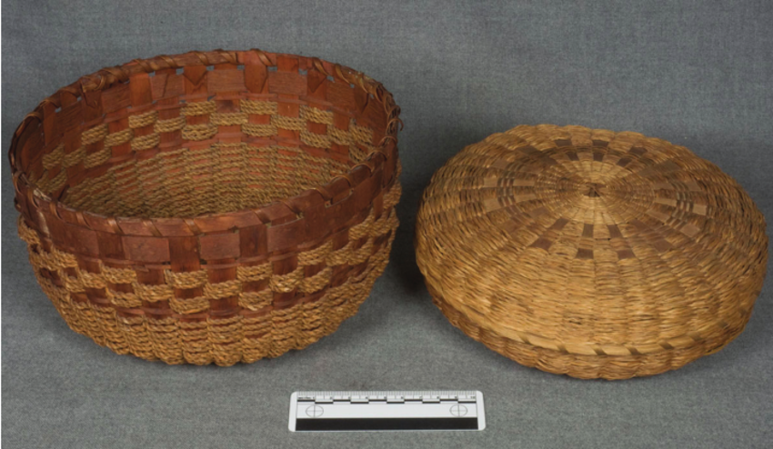

"Gloosekap came first of all into this country, into the land of the Wabanaki, next to the sunrise. There were no Indians here then. And in this way he made men: He took his bow and arrows and shot at trees, the basket trees, the ash. Then Indians came out of the bark of the ash trees.”

-Wabanaki creation story told by Molly Sepsis, published in Algonquin Legends by Charles G. Leland
Baskets are a fundamental part of the culture and traditions of the Wabanaki, who believe that basket making is a skill that has been passed from weaver to weaver, generation to generation, uninterrupted for thousands of years.
The Wabanaki made splint baskets of specific shapes and sizes to gather and prepare food and trap fish, both before and after European contact. Post-contact, many tribal people used basket making as a way to make a living outside of non-native towns and cities.
Wabanaki baskets are made primarily from long, thin strips of wood, or splints, of the brown ash tree. Known as the “basket tree,” the brown ash is considered sacred to many of the native peoples of the northeastern United States and Canada. The wood of the ash tree is also both strong and flexible, making it particularly well suited for weaving durable containers.
The emerald ash borer critically threatens the long-term survival of ash trees today.
Sources:

Mundell, Kathleen. North by Northeast: Wabanaki, Akwesasne Mohawk, and Tuscarora Traditional Arts. Tilbury House Publishers, 2008. Print. (page 29)
(from https://dawnlandvoices.org/collections/exhibits/show/along-the-basket-trail/overview)

“Essay: Wabanaki Basket Weaving.” Hood Museum of Art, Dartmouth College. (from https://www.naaer.hoodmuseum.dartmouth.edu/essay-wabanaki-basket-weaving)
Sample images may be copyright protected.

Bibliography

Bruchac, Jesse. “Pronunciation of Ndakinna.” Middlebury College. https://www.middlebury.edu/about/land-acknowledgement/-pronunciation-of-ndakinna-

Calloway, Colin G. The Western Abenakis of Vermont, 1600-1800: War, Migration, and the Survival of an Indian People. University of Oklahoma Press. 1990.

Doherty, Prudence et al. “Phase 1 and 2 Archaeological Studies, Richmond BRZ 1445(18).” Consulting Archaeology Program, University of Vermont, Report No. 137. February 1996.

Thomas, Peter A. et al. “Archaeological Site Identification, Evaluation and Mitigation of VT-CH-619 for Richmond TH 2407.” Consulting Archaeology Program, University of Vermont, Report No. 135. December 1995.

Wiseman, Frederick Matthew. The Voice of the Dawn: An Autohistory of the Abenaki Nation. UPNE 2001.

Western Abenaki language videos: http://westernabenaki.com/videos.php

Working Definition of Traditional Ecological Knowledge (US Fish & Wildlife Service: https://www.fws.gov/nativeamerican/pdf/tek-fact-sheet.pdf) Traditional Ecological Knowledge, also called by other names including Indigenous Knowledge or Native Science, (hereafter, TEK) refers to the evolving knowledge acquired by Indigenous and local peoples over hundreds or thousands of years through direct contact with the environment. This knowledge is specific to a location and includes the relationships between plants, animals, natural phenomena, landscapes and timing of events that are used for lifeways, including but not limited to hunting, fishing, trapping, agriculture, and forestry. TEK is an accumulating body of knowledge, practice, and belief, evolving by adaptive processes and handed down through generations by cultural transmission, about the relationship of living beings (human and non-human) with one another and with the environment. It encompasses the world view of Indigenous people which includes ecology, spirituality, human and animal relationships, and more.

